EXP I. INTRODUCTION

Oracle has many tools such as SQL * PLUS, Oracle Forms, Oracle Report Writer, Oracle Graphics etc.
- SQL * PLUS: The SQL * PLUS tool is made up of two distinct parts. These are
  - Interactive SQL: Interactive SQL is designed for create, access and manipulate data structures like tables and indexes.
  - PL/SQL: PL/SQL can be used to developed programs for different applications.
- Oracle Forms: This tool allows you to create a data entry screen along with the suitable menu objects. Thus it is the oracle forms tool that handles data gathering and data validation in a commercial application.
- Report Writer: Report writer allows programmers to prepare innovative reports using data from the oracle structures like tables, views etc. It is the report writer tool that handles the reporting section of commercial application.
- Oracle Graphics: Some of the data can be better represented in the form of pictures. The oracle graphics tool allows programmers to prepare graphs using data from oracle structures like tables, views etc.
SQL (Structured Query Language):
Structured Query Language is a database computer language designed for managing data in relational database management systems(RDBMS), and originally based upon Relational Algebra. Its scope includes data query and update, schema creation and modification, and data access control. SQL was one of the first languages for Edgar F. Codd's relational model in his influential 1970 paper, "A Relational Model of Data for Large Shared Data Banks"[3] and became the most widely used language for relational databases.
- IBM developed SQL in mid of 1970’s.
- Oracle incorporated in the year 1979.
- SQL used by IBM/DB2 and DS Database Systems.
- SQL adopted as standard language for RDBS by ASNI in 1989.

DATA TYPES:
CHAR (Size): This data type is used to store character strings values of fixed length. The size in brackets determines the number of characters the cell can hold. The maximum number of character is 255 characters.
  - VARCHAR (Size) / VERCHAR2 (Size): This data type is used to store variable length alphanumeric data. The maximum character can hold is 2000 character.
  - NUMBER (P, S): The NUMBER data type is used to store number (fixed or floating point). Number of virtually any magnitude may be stored up to 38 digits of precision. Number as large as 9.99 * 10 124. The precision (p) determines the number of places to the right of the decimal. If scale is omitted then the default is zero. If precision is omitted, values are stored with their original precision up to the maximum of 38 digits.
  - DATE: This data type is used to represent date and time. The standard format is dd-mm-yy as in 17-SEP-2009. To enter dates other than the standard format, use the appropriate functions. Date time stores date in the 24-Hours format. By default the time in a date field is 12:00:00 am, if no time portion is specified. The default date for a date field is the first day the current month.
  - LONG: This data type is used to store variable length character strings containing up to 2GB. Long data can be used to store arrays of binary data in ASCII format. LONG values cannot be indexed, and the normal character functions such as SUBSTR cannot be applied.
  - RAW: The RAW data type is used to store binary data, such as digitized picture or image. Data loaded into columns of these data types are stored without any further conversion. RAW data type can have a maximum length of 255 bytes. LONG RAW data type can contain up to 2GB.
interactive SQL:
syntax : verb(Parameter_1,Parameter_2,Parameter_3,........Parameter_n);
SQL language is sub-divided into several language elements, including:
  - Clauses, which are in some cases optional, constituent components of statements and queries.
  - Expressions, which can produce either scalar values or tables consisting of columns and rows of data.
  - Predicates which specify conditions that can be evaluated to SQL three-valued logic (3VL) Boolean truth values and which are used to limit the effects of statements and queries, or to change program flow.
  - Queries which retrieve data based on specific criteria.
  - Statements which may have a persistent effect on schemas and data, or which may control transactions, program flow, connections, sessions, or diagnostics.
  - SQL statements also include the semicolon (";") statement terminator. Though not required on every platform, it is defined as a standard part of the SQL grammar.
  - Insignificant white space is generally ignored in SQL statements and queries, making it easier to format SQL code for readability.
There are five types of SQL statements. They are:
1. data definition LANGUAGE (ddl)
2. data manipulation language (dml)
3. DATA RETRIEVAL LANGUAGE (DRL)
4. TRANSATIONAL CONTROL LANGUAGE (TCL)
5. DATA CONTROL LANGUAGE (DCL)
1. data definition LANGUAGE (ddl): The Data Definition Language (DDL) is used to create and destroy databases and database objects. These commands will primarily be used by database administrators during the setup and removal phases of a database project. Let's take a look at the structure and usage of four basic DDL commands:
1. CREATE 2. ALTER 3. DROP 4. RENAME
1. CREATE:
(a)create table: This is used to create a new relation and the corresponding
Syntax: create table relation_name
(field_1 data_type(Size),field_2 data_type(Size), .. . );
Example:
SQL>create table Student (sno NUMBER(3),sname char(10),class char(5));
(b)create TABLE..as select....: This is used to create the structure of a new relation from the structure of an existing relation.
Syntax: create table (relation_name_1, field_1,field_2,.....field_n) AS SELECT field_1,field_2,...........field_n from relation_name_2;
Example: SQL>create table std(rno,sname) as select sno,sname from student;
2. ALTER:
(a)ALTER TABLE ...ADD...: This is used to add some extra fields into existing relation.
Syntax: ALTER TABLE relation_name ADD(new field_1 data_type(size), new field_2 data_type(size),..);
Example : SQL>ALTER TABLE std ADD(Address CHAR(10));

(b)ALTER table...modify...: This is used to change the width as well as data type of fields of existing relations.
Syntax: alter table relation_name modify (field_1 newdata_type(Size), field_2 newdata_type(Size),....field_newdata_type(Size));
Example:SQL>alter table student modify(sname varchar(10),class varchar(5));
3. drop table: This is used to delete the structure of a relation. It permanently deletes the records in the table.
Syntax: drop table relation_name;
Example: SQL>drop table std;

4. Rename: It is used to modify the name of the existing database object.
Syntax: RENAME table old_relation_name TO new_relation_name;
Example: SQL>rename table std to std1;
5. TRUNCATE: This command will remove the data permanently. But structure will not be removed.
Syntax: TRUNCATE TABLE <Table name>
Example TRUNCATE TABLE student;

Difference between Truncate & Delete:-
- By using truncate command data will be removed permanently & will not get back where as by using delete command data will be removed temporally & get back by using roll back command.
- By using delete command data will be removed based on the condition where as by using truncate command there is no condition.
- Truncate is a DDL command & delete is a DML command.

2. data manipulation language (dml): The Data Manipulation Language (DML) is used to retrieve, insert and modify database information. These commands will be used by all database users during the routine operation of the database. Let's take a brief look at the basic DML commands:
1. INSERT 2. UPDATE 3. DELETE
1. insert into: This is used to add records into a relation. These are three type of insert into queries which are as
a) Inserting a single record
Syntax: insert into relationname(field_1,field_2,.field_n)values
(data_1,data_2,........data_n);
Example: SQL>insert into student(sno,sname,class,address)VALUES
(1,’Ravi’,’M.Tech’,’Palakol’);
b) Inserting all records from another relation
Syntax: insert into relation_name_1 select field_1,field_2,field_n
FROM relation_name_2 WHERE field_x=data;
Example: SQL>insert into std select sno,sname from student
where name = ‘Ramu‘;
c) Inserting multiple records
Syntax: insert into relation_name field_1,field_2,.....field_n) values
(&data_1,&data_2,........&data_n);
Example: SQL>insert into student(sno,sname,class,address)
VALUES(&sno,’&sname’,’&class’,’&address’);
Enter value for sno: 101
Enter value for name: Ravi
Enter value for class: M.Tech
Enter value for name: Palakol
2. update-set-WHERE: This is used to update the content of a record in a relation.
Syntax: SQL>update relation name set field_name1=data,field_name2=data,
where field_name=data;
Example: SQL>update student set sname = ‘kumar’ WHERE sno=1;
3. delete-from: This is used to delete all the records of a relation but it will retain the structure of that relation.
a) delete-from: This is used to delete all the records of relation.
Syntax: SQL>delete from relation_name;
example: SQL>delete from std;
b) delete -from-WHERE: This is used to delete a selected record from a relation.
Syntax: SQL>delete from relation_name WHERE condition;
Example: SQL>delete from student WHERE sno = 2;
3. DRL(DATA RETRIEVAL LANGUAGE): Retrieves data from one or more tables.
1. select from: To display all fields for all records.
Syntax : select * from relation_name;
Example : SQL> select * from dept;
DEPTNO DNAME LOC
-------- ----------- ----------
10 ACCOUNTING NEW YORK
20 RESEARCH DALLAS
30 SALES CHICAGO
40 OPERATIONS BOSTON
2. Select from: To display a set of fields for all records of relation.
Syntax: select a set of fields FROM relation_name;
Example: SQL> select deptno, dname from dept;
DEPTNO DNAME
------- ----------
10 ACCOUNTING
20 RESEARCH
30 SALES
3. select - from -WHERE: This query is used to display a selected set of fields for a selected set of records of a relation.
Syntax: select a set of fields from relation_name where condition;
Example: SQL> select * FROM dept WHERE deptno<=20;
DEPTNO DNAME LOC
------ ----------- ------------
10 ACCOUNTING NEW YORK
20 RESEARCH DALLAS
4. select - from -group BY: This query is used to group to all the records in a relation together for each and every value of a specific key(s) and then display them for a selected set of fields the relation.
Syntax: select a set of fields FROM relation_name GROUP BY field_name;
Example: SQL> SELECT EMPNO, SUM (SALARY) FROM EMP GROUP BY EMPNO;
EMPNO SUM (SALARY)
------ ----------
1 3000
2 4000
3 5000
4 6000
4 rows selected.
5. select - from -order by: This query is used to display a selected set of fields from a relation in an ordered manner base on some field.
Syntax: select a set of fields FROM relation_name
order by field_name;
Example: SQL> SELECT empno,ename,job FROM emp ORDER BY job;
EMPNO ENAME JOB
------ --------- --------
4 RAVI MANAGER
2 aravind Manager
1 sagar clerk
3 Laki clerk
4rows selected.
6. join using select - from - order by: This query is used to display a set of fields from two relations by matching a common field in them in an ordered manner based on some fields.
Syntax: select a set of fields from both relations from relation_1, relation_2 WHERE relation_1.field_x = relation_2.field_y order by field_z;
Example: SQL>SELECT empno,ename,job,dname FROM emp,dept
WHERE emp.deptno = 20 ORDER BY job;
EMPNO ENAME JOB DNAME
------ ------ ------- ----------
7788 SCOTT ANALYST ACCOUNTING
7902 FORD ANALYST ACCOUNTING
------
7566 JONES MANAGER OPERATIONS
7566 JONES MANAGER SALES
20 rows selected.
7. join using select - from - group by: This query is used to display a set of fields from two relations by matching a common field in them and also group the corresponding records for each and every value of a specified key(s) while displaying.
Syntax: select a set of fields from both relations FROM relation_1,relation_2 WHERE relation_1.field-x=relation_2.field-y group by field-z;
Example: SQL> SELECT empno,SUM(SALARY) FROM emp,dept
WHERE emp.deptno =20 GROUP BY empno;
EMPNO SUM (SALARY)
------- --------
7369 3200
7566 11900
7788 12000
7876 4400
8. union: This query is used to display the combined rows of two different queries, which are having the same structure, without duplicate rows.
Syntax: SELECT field_1,field_2,....... FROM relation_1 WHERE (Condition) UNION SELECT field_1,field_2,....... FROM relation_2 WHERE (Condition);
Example:
SQL> SELECT * FROM STUDENT;
SNO SNAME
----- -------
1 kumar
2 ravi
3 ramu

SQL> SELECT * FROM STD;
SNO SNAME
----- -------
3 ramu
5 lalitha
9 devi
1 kumar

SQL> SELECT * FROM student UNION SELECT * FROM std;
SNO SNAME
---- ------
1 kumar
2 ravi
3 ramu
5 lalitha
9 devi
9. interset: This query is used to display the common rows of two different queries, which are having the same structure, and to display a selected set of fields out of them.
Syntax: select field_1,field_2,.. FROM relation_1 WHERE
(Condition) INTERSECT SELECT field_1,field_2,.. FROM relation_2 WHERE(Condition);
Example : SQL> SELECT * FROM student INTERSECT SELECT * FROM std;
SNO SNAME
---- -------
1 Kumar
10. minus: This query is used to display all the rows in relation_1,which are not having in the relation_2.
Syntax: select field_1,field_2,......FROM relation_1
WHERE(Condition) MINUS SELECT field_1,field_2,.....
FROM relation_2 WHERE(Conditon);
SQL> SELECT * FROM student MINUS SELECT * FROM std;
SNO SNAME
---- -------
2 RAVI
3 RAMU
3. TRANSATIONAL CONTROL LANGUAGE (T.C.L):
A transaction is a logical unit of work. All changes made to the database can be referred to as a transaction. Transaction changes can be mode permanent to the database only if they are committed a transaction begins with an executable SQL statement & ends explicitly with either role back or commit statement.

1. COMMIT: This command is used to end a transaction only with the help of the commit command transaction changes can be made permanent to the database.

Syntax: SQL>COMMIT;
Example: SQL>COMMIT;
2. SAVE POINT: Save points are like marks to divide a very lengthy transaction to smaller once. They are used to identify a point in a transaction to which we can latter role back. Thus, save point is used in conjunction with role back.

Syntax: SQL>SAVE POINT ID;
Example: SQL>SAVE POINT xyz;
3. ROLE BACK: A role back command is used to undo the current transactions. We can role back the entire transaction so that all changes made by SQL statements are undo (or) role back a transaction to a save point so that the SQL statements after the save point are role back.
Syntax: ROLE BACK( current transaction can be role back)
ROLE BACK to save point ID;

Example: SQL>ROLE BACK;
SQL>ROLE BACK TO SAVE POINT xyz;
4. DATA CONTROL LANGUAGE (D.C.L):
DCL provides uses with privilege commands the owner of database objects (tables), has the soul authority ollas them. The owner (data base administrators) can allow other data base uses to access the objects as per their requirement
1. GRANT: The GRANT command allows granting various privileges to other users and allowing them to perform operations with in their privileges
For Example, if a uses is granted as ‘SELECT’ privilege then he/she can only view data but cannot perform any other DML operations on the data base object GRANTED privileges can also be withdrawn by the DBA at any time
Syntax: SQL>GRANT PRIVILEGES on object_name To user_name;
Example: SQL>GRANT SELECT, UPDATE on emp To hemanth;
2. REVOKE: To with draw the privileges that has been GRANTED to a uses, we use the REVOKE command

Syntax: SQL>REVOKE PRIVILEGES ON object-name FROM user_name;
Example: SQL>REVOKE SELECT, UPDATE ON emp FROM ravi;
1. Creation, altering and dropping of tables and inserting rows into a table (use constraints while creating tables) examples using SELECT command.
1. CREATE:
(a)create table: This is used to create a new relation
Syntax: create table relation_name
(field_1 data_type(Size),field_2 data_type(Size), .. . );
Example:
SQL>create table Student (sno NUMBER(3) PRIMARY KEY ,sname
char(10),class char(5));
2. ALTER:
(a)ALTER TABLE ...ADD...: This is used to add some extra fields into existing relation.
Syntax: ALTER TABLE relation_name ADD(new field_1 data_type(size), new field_2 data_type(size),..);
Example : SQL>ALTER TABLE std ADD(Address CHAR(10));
(b)ALTER table...modify...: This is used to change the width as well as data type of fields of existing relations.
Syntax: alter table relation_name modify (field_1 newdata_type(Size), field_2 newdata_type(Size),....field_newdata_type(Size));
Example: SQL>alter table student modify(sname varchar(10),class
varchar(5));
3. drop table: This is used to delete the structure of a relation. It permanently deletes the records in the table.
Syntax: drop table relation_name;
Example: SQL>drop table std;
4. INSERT:
Syntax: insert into relation_name field_1,field_2,.....field_n) values
(&data_1,&data_2,........&data_n);
Example: SQL>insert into student(sno,sname,class,address)
VALUES(&sno,’&sname’,’&class’,’&address’);
Enter value for sno: 101
Enter value for name: SIRISHA
Enter value for class: CSE
Enter value for address: Palakol

5. select from: To display all fields for all records.
Syntax : select * from relation_name;
Example : SQL> select * from student;
SNO SNAME CLASS ADDRESS
---- -------- ------ ----- 101 SIRISHA CSE PALAKOL
102 DEVAKI CSE NARSAPUR
103 KUMAR CAD BHIMAVARAM
104 RAVI VLSI PALAKOL
2. Select from: To display a set of fields for all records of relation.
Syntax: select a set of fields FROM relation_name;
Example: SQL> select sno, sname from student;
SNO SNAME
---- --------
101 SIRISHA
102 DEVAKI
103 KUMAR
104 RAVI
3. select - from -WHERE: This query is used to display a selected set of fields for a selected set of records of a relation.
Syntax: select a set of fields from relation_name where condition;
Example: SQL> select * FROM student WHERE class=’CSE’;
SNO SNAME CLASS ADDRESS
---- -------- ------ -------
101 SIRISHA CSE PALAKOL
102 DEVAKI CSE NARSAPUR
There are 5 constraints available in ORACLE:
1. NOT NULL: When a column is defined as NOTNULL, then that column becomes a mandatory column. It implies that a value must be entered into the column if the record is to be accepted for storage in the table.
Syntax:
CREATE TABLE Table_Name(column_name data_type(size) NOT NULL, );
Example:
CREATE TABLE student (sno NUMBER(3)NOT NULL, name CHAR(10));
2. UNIQUE: The purpose of a unique key is to ensure that information in the column(s) is unique i.e. a value entered in column(s) defined in the unique constraint must not be repeated across the column(s). A table may have many unique keys.
Syntax:
CREATE TABLE Table_Name(column_name data_type(size) UNIQUE, ….);
Example:
CREATE TABLE student (sno NUMBER(3) UNIQUE, name CHAR(10));
3. CHECK: Specifies a condition that each row in the table must satisfy. To satisfy the constraint, each row in the table must make the condition either TRUE or unknown (due to a null).
Syntax:
CREATE TABLE Table_Name(column_name data_type(size) CHECK(logical expression), ….);
Example: CREATE TABLE student (sno NUMBER (3), name CHAR(10),class CHAR(5),CHECK(class IN(‘CSE’,’CAD’,’VLSI’));
4. PRIMARY KEY: A field which is used to identify a record uniquely. A column or combination of columns can be created as primary key, which can be used as a reference from other tables. A table contains primary key is known as Master Table.
- It must uniquely identify each record in a table.
- It must contain unique values.
- It cannot be a null field.
- It cannot be multi port field.
- It should contain a minimum no. of fields necessary to be called unique.
Syntax:
CREATE TABLE Table_Name(column_name data_type(size) PRIMARY KEY, ….);
Example:
CREATE TABLE faculty (fcode NUMBER(3) PRIMARY KEY, fname CHAR(10));
5. FOREIGN KEY: It is a table level constraint. We cannot add this at column level. To reference any primary key column from other table this constraint can be used. The table in which the foreign key is defined is called a detail table. The table that defines the primary key and is referenced by the foreign key is called the master table.
Syntax: CREATE TABLE Table_Name(column_name data_type(size)
FOREIGN KEY(column_name) REFERENCES table_name);
Example:
CREATE TABLE subject (scode NUMBER (3) PRIMARY KEY,
subname CHAR(10),fcode NUMBER(3),
FOREIGN KEY(fcode) REFERENCE faculty );
Defining integrity constraints in the alter table command:
Syntax: ALTER TABLE Table_Name ADD PRIMARY KEY (column_name);
Example: ALTER TABLE student ADD PRIMARY KEY (sno);
(Or)
Syntax: ALTER TABLE table_name ADD CONSTRAINT constraint_name
PRIMARY KEY(colname)
Example: ALTER TABLE student ADD CONSTRAINT SN PRIMARY KEY(SNO)
Dropping integrity constraints in the alter table command:
Syntax: ALTER TABLE Table_Name DROP constraint_name;
Example: ALTER TABLE student DROP PRIMARY KEY;
(or)
Syntax: ALTER TABLE student DROP CONSTRAINT constraint_name;
Example: ALTER TABLE student DROP CONSTRAINT SN;

3) Queries using Aggregate functions (COUNT, SUM, AVG, MAX and MIN), GROUP BY, HAVING and Creation and dropping of Views.

Aggregative operators: In addition to simply retrieving data, we often want to perform some computation or summarization. SQL allows the use of arithmetic expressions. We now consider a powerful class of constructs for computing aggregate values such as MIN and SUM.
1. Count: COUNT following by a column name returns the count of tuple in that column. If DISTINCT keyword is used then it will return only the count of unique tuple in the column. Otherwise, it will return count of all the tuples (including duplicates) count (*) indicates all the tuples of the column.
Syntax: COUNT (Column name)
Example: SELECT COUNT (Sal) FROM emp;
2. SUM: SUM followed by a column name returns the sum of all the values in that column.
Syntax: SUM (Column name)
Example: SELECT SUM (Sal) From emp;
3. AVG: AVG followed by a column name returns the average value of that column values.
Syntax: AVG (n1,n2..)
Example: Select AVG(10, 15, 30) FROM DUAL;
4. MAX: MAX followed by a column name returns the maximum value of that column.
Syntax: MAX (Column name)
Example: SELECT MAX (Sal) FROM emp;
SQL> select deptno,max(sal) from emp group by deptno;
DEPTNO MAX(SAL)
------ --------
10 5000
20 3000
30 2850
SQL> select deptno,max(sal) from emp group by deptno having max(sal)<3000;
DEPTNO MAX(SAL)
----- --------
30 2850
5. MIN: MIN followed by column name returns the minimum value of that column.
Syntax: MIN (Column name)
Example: SELECT MIN (Sal) FROM emp;
SQL>select deptno,min(sal) from emp group by deptno having min(sal)>1000;
DEPTNO MIN(SAL)
----- --------
10 1300
VIEW: In SQL, a view is a virtual table based on the result-set of an SQL statement.
A view contains rows and columns, just like a real table. The fields in a view are fields from one or more real tables in the database.
You can add SQL functions, WHERE, and JOIN statements to a view and present the data as if the data were coming from one single table.

A view is a virtual table, which consists of a set of columns from one or more tables. It is similar to a table but it doest not store in the database. View is a query stored as an object.
Syntax: create view view_name AS SELECT set of fields FROM relation_name WHERE (Condition)
1. Example:
SQL>create view employee as select empno,ename,job from emp
where job = ‘clerk’;
view created.
sql> select * from employee;
empno ename job
---- ------ -------
7369 smith clerk
7876 adams clerk
7900 james clerk
7934 miller clerk
2.Example:
CREATE VIEW [Current Product List] AS
SELECT ProductID,ProductName
FROM Products
WHERE Discontinued=No
drop view: This query is used to delete a view , which has been already created.
Syntax: drop VIEW view_name;
Example : SQL> DROP VIEW EMPLOYEE;
View dropped
4. Queries using Conversion functions (to_char, to_number and to_date), string functions (Concatenation, lpad, rpad, ltrim, rtrim, lower, upper, initcap, length, substr and instr), date functions (Sysdate, next_day, add_months, last_day, months_between, least, greatest, trunc, round, to_char, to_date)

1. Conversion functions:
To_char: TO_CHAR (number) converts n to a value of VARCHAR2 data type, using the optional number format fmt. The value n can be of type NUMBER, BINARY_FLOAT, or BINARY_DOUBLE.
SQL>select to_char(65,'RN')from dual;
LXV
To_number : TO_NUMBER converts expr to a value of NUMBER data type.
SQL> Select to_number('1234.64') from Dual;
1234.64
To_date: TO_DATE converts char of CHAR, VARCHAR2, NCHAR, or NVARCHAR2 data type to a value of DATE data type.
SQL>SELECT TO_DATE('January 15, 1989, 11:00 A.M.')FROM DUAL;
TO_DATE('
---------
15-JAN-89
2. String functions:
Concat: CONCAT returns char1 concatenated with char2. Both char1 and char2 can be any of the datatypes
SQL>SELECT CONCAT(‘ORACLE’,’CORPORATION’)FROM DUAL;
ORACLECORPORATION
Lpad: LPAD returns expr1, left-padded to length n characters with the sequence of characters in expr2.
SQL>SELECT LPAD(‘ORACLE’,15,’*’)FROM DUAL;
*********ORACLE
Rpad: RPAD returns expr1, right-padded to length n characters with expr2, replicated as many times as necessary.
SQL>SELECT RPAD (‘ORACLE’,15,’*’)FROM DUAL;
ORACLE*********
Ltrim: Returns a character expression after removing leading blanks.
SQL>SELECT LTRIM(‘SSMITHSS’,’S’)FROM DUAL;
MITHSS
Rtrim: Returns a character string after truncating all trailing blanks
SQL>SELECT RTRIM(‘SSMITHSS’,’S’)FROM DUAL;
SSMITH
Lower: Returns a character expression after converting uppercase character data to lowercase.
SQL>SELECT LOWER(‘DBMS’)FROM DUAL;
dbms
Upper: Returns a character expression with lowercase character data converted to uppercase
SQL>SELECT UPPER(‘dbms’)FROM DUAL;
DBMS
Length: Returns the number of characters, rather than the number of bytes, of the given string expression, excluding trailing blanks.
SQL>SELECT LENGTH(‘DATABASE’)FROM DUAL;
8
Substr: Returns part of a character, binary, text, or image expression.
SQL>SELECT SUBSTR(‘ABCDEFGHIJ’3,4)FROM DUAL;
CDEF
Instr: The INSTR functions search string for substring. The function returns an integer indicating the position of the character in string that is the first character of this occurrence.
SQL>SELECT INSTR('CORPORATE FLOOR','OR',3,2)FROM DUAL;
14
3. Date functions:
Sysdate:
SQL>SELECT SYSDATE FROM DUAL;
29-DEC-08
next_day:
SQL>SELECT NEXT_DAY(SYSDATE,’WED’)FROM DUAL;
05-JAN-09
add_months:
SQL>SELECT ADD_MONTHS(SYSDATE,2)FROM DUAL;
28-FEB-09
last_day:
SQL>SELECT LAST_DAY(SYSDATE)FROM DUAL;
31-DEC-08
months_between:
SQL>SELECT MONTHS_BETWEEN(SYSDATE,HIREDATE)FROM EMP;
4
Least:
SQL>SELECT LEAST('10-JAN-07','12-OCT-07')FROM DUAL;
10-JAN-07
Greatest:
SQL>SELECT GREATEST('10-JAN-07','12-OCT-07')FROM DUAL;
10-JAN-07
Trunc:
SQL>SELECT TRUNC(SYSDATE,'DAY')FROM DUAL;
28-DEC-08
Round:
SQL>SELECT ROUND(SYSDATE,'DAY')FROM DUAL;
28-DEC-08
to_char:
SQL> select to_char(sysdate, "dd\mm\yy") from dual;
24-mar-05.
to_date:
SQL> select to_date(sysdate, "dd\mm\yy") from dual;
24-mar-o5.

EXP-II Simple queries: selection, projection, sorting on a simple table
- Creating The Tables

- Create table EMPLOYEE with the following attributes and then insert the following data in to EMPLOYEE table.
FNAME MINIT LNAME SSN BDATE ADDRESS SEX SAL SUPERSSN DNO
---------------------------------------------------------------------------------------------------------------------------------------------------------------------------------------------------
John B Smith 123456789 09-JAN-1965 731 Fondren, Houston, TX M 30000 333445555 5
Franklin T Wong 333445555 08-DEC-1955 638 Voss, Houston, TX M 40000 888665555 5
Alicia J Zelaya 999887777 19-JUL-1968 3321, Castle, Spring, TX F 25000 987654321 4
Jennifer S Wallace 987654321 20-JUN-1941 291, Berry, Bellaire, TX F 43000 888665555 4
Ramesh K Narayan 666884444 15-SEP-1962 975 Fire Oak, Humble, TX M 38000 333445555 5
Joyce A English 453453453 31-JUL-1972 5631 Rice, Houston, TX F 25000 333445555 5
Ahmad V Jabbar 987987987 29-MAR-1969 980 Dallas, Houston, TX M 25000 987654321 4
James E Borg 888665555 10-NOV-37 450 Stone, Houston, Tx M 55000 1
Ans: Create table employee (fname varchar(15) NOT NULL,minit char(5),lname varchar2(15),ssn varchar2(9) NOT NULL,bdate date,address varchar2(30),sex char(3),salary decimal(10,2), superssn varchar2(9),dno number(7));
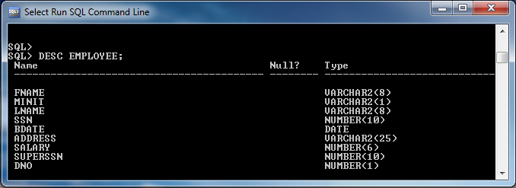
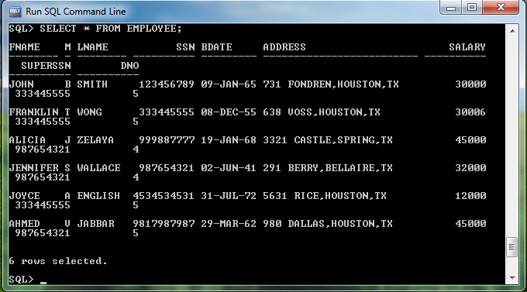
2. Create table DEPARTMENT with the following attributes and then insert the following data into DEPARTMENT table.
DNAME DNUMBER MGRSSN MGRSTARTDATE
------------------------------------------------------------------------------------------------
Research 5 333445555 22-MAY-1988
Administration 4 987654321 01-JAN-1995
Headquarters 1 888665555 19-JUN-1981
Ans: Create table department (dname varchar2(15) NOT NULL,dnumber number(7),
mgrssn varchar2(9),mgrstartdate date );
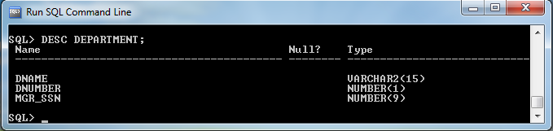
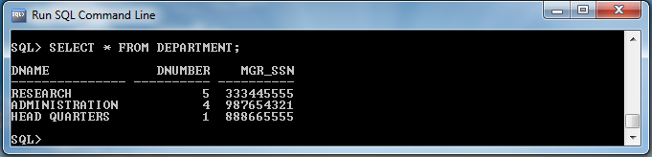
3. Create table DEPT_LOCATIONS with the following attributes and insert the following data into DEPT_LOCATIONS table.
DNUMBER DLOCATION
---------------------------------------------
1 Houston
4 Stafford
5 Bellaire
5 Sugarland
5 Houston
Ans: Create table dept_locations( dnumber number(7),dlocation varchar2(15));
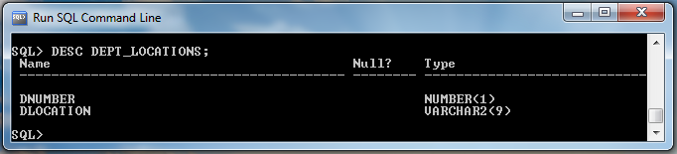
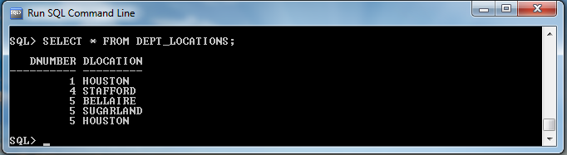
4.Create table PROJECT with the following attributes and insert the following data into PROJECT table.
PNAME PNUMBER PLOCATION DNUM
------------------------------------------------------------------------------
ProductX 1 Bellaire 5
ProductY 2 Sugarland 5
ProductZ 3 Houston 5
Computerization 10 Stafford 4
Reorganization 20 Houston 1
Newbenefits 30 Stafford 4

Ans: create table project( pname varchar2(15) NOT NULL,pnumber number(7),
plocation varchar2(15),dnum number(4) );
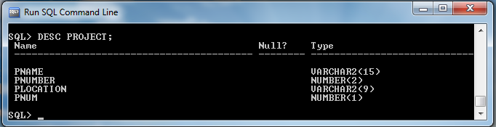
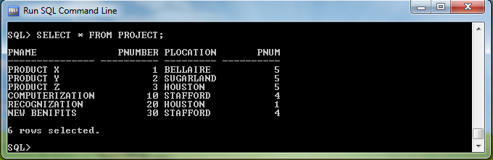
5.Create table DEPENDENT with the following attributes and insert the following data into DEPENDENT table.
ESSN DEPENDENT_NAME SEX BDATE RELATIONSHIP
-----------------------------------------------------------------------------------------------------------------------------
333445555 Alice F 05-APR-86 DUAGHTER
333445555 Theodore M 25-OCT-83 SON
333445555 Joy F 03-MAY-58 SPOUSE
987654321 Abner M 28-FEB-42 SPOUSE
123456789 Michael M 04-JAN-88 SON
123456789 Alice F 30-DEC-88 DAUGHTER
123456789 Elizabeth F 05-MAY-67 SPOUSE

Ans: create table dependent( essn varchar2(9),dependent_name varchar2(15),
sex char(3),bdate date,relationship varchar2(12 );

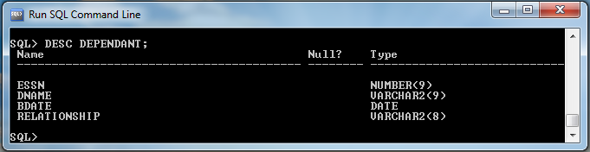
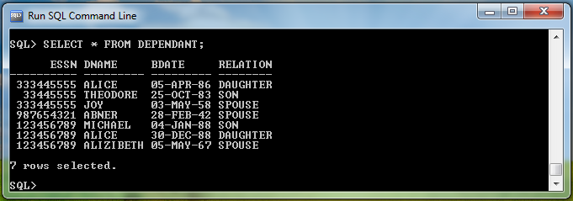
6. Create table WORKS_ON with the following attributes and then insert the following data into WORKS_ON table.
ESSN PNO HOURS
------------------------------------------------
123456789 1 32.5
123456789 2 7.5
666884444 3 40
453453453 1 20
453453453 2 20
333445555 2 10
333445555 3 10
333445555 10 10
333445555 20 10
999887777 30 30
999887777 10 10
987987987 10 35
987987987 30 5
987654321 30 20
987654321 20 15
888665555 20

Ans: create table works_on(essn varchar2(9,pno number(3),hours decimal(4,1) );
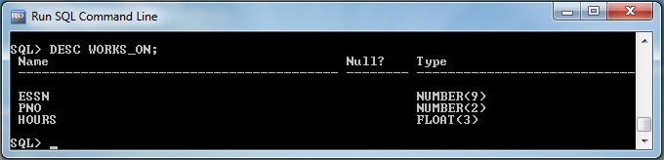
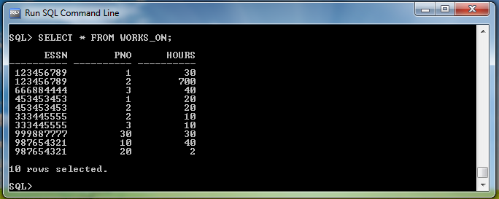
- Assigning Key Attributes to Created Tables
- Create table employee (fname varchar(15) NOT NULL,minit char(5),lname varchar2(15) NOT NULL,ssn varchar2(9) NOT NULL,bdate date,address varchar2(30),sex char(3),salary decimal(10,2),superssn varchar2(9),dno number(7) NOT NULL,PRIMARY KEY(ssn) );
(Or)
Alter Table Employee add Primary key (ssn);
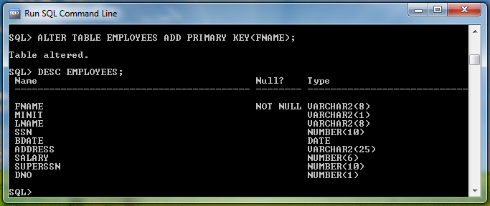
- Create table department (dname varchar2(15) NOT NULL,dnumber number(7) NOT NULL, mgrssn varchar2(9),mgrstartdate date,PRIMARY KEY(dnumber), UNIQUE(dname) );
(Or)
Alter Table department add Primary key (dnumber);

- Create table dept_locations( dnumber number(7) NOT NULL,dlocation varchar2(15) NOT NULL, PRIMARY KEY(dnumber,dlocation) );
(Or)
Alter Table dept_locations add Primary key (dnumber,dlocation);

- create table project( pname varchar2(15) NOT NULL,pnumber number(7) NOT NULL,plocation varchar2(15),dnum number(4) NOT NULL,PRIMARY KEY(pnumber),UNIQUE(pname) );
(Or)
Alter Table project add Primary key (pnumber);

- create table dependent( essn varchar2(9) NOT NULL,dependent_name varchar2(15) NOT NULL,sex char(3),bdate date,relationship varchar2(12),PRIMARY KEY(essn,dependent_name) );
(Or)
Alter Table dependent add Primary key (essn,dependent_name);

- create table works_on(essn varchar2(9) NOT NULL,pno number(3) NOT NULL,hours decimal(4,1) ,PRIMARY KEY(essn,pno) );
(Or)
Alter Table works_on add Primary key (essn,pno);

c) Simple queries:
1.write a query to display emp table.
SQL> desc emp;
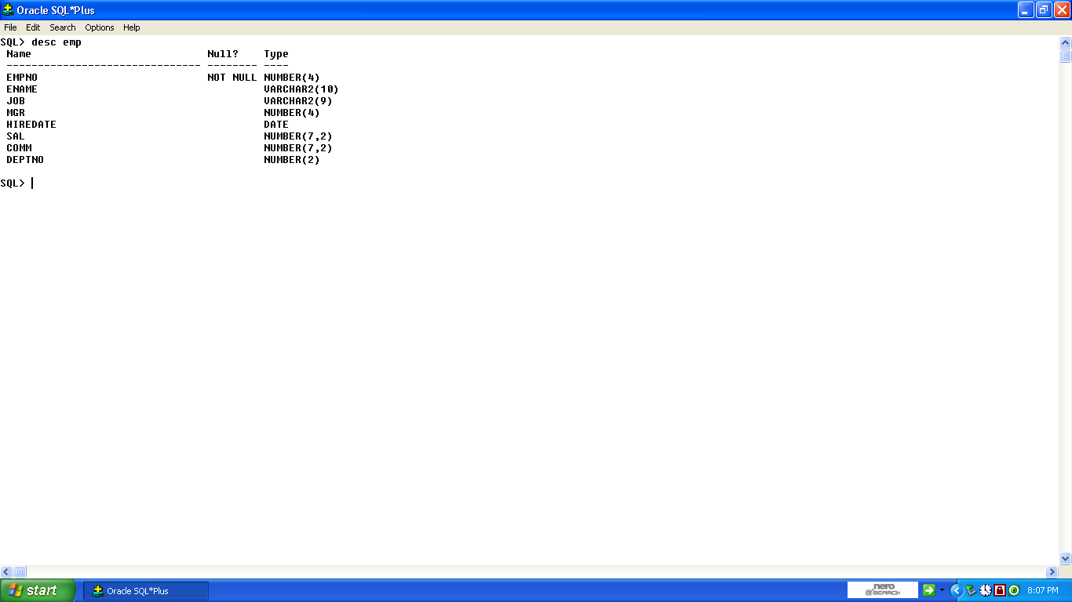
2. List all employee values.
SQL>select * from emp;
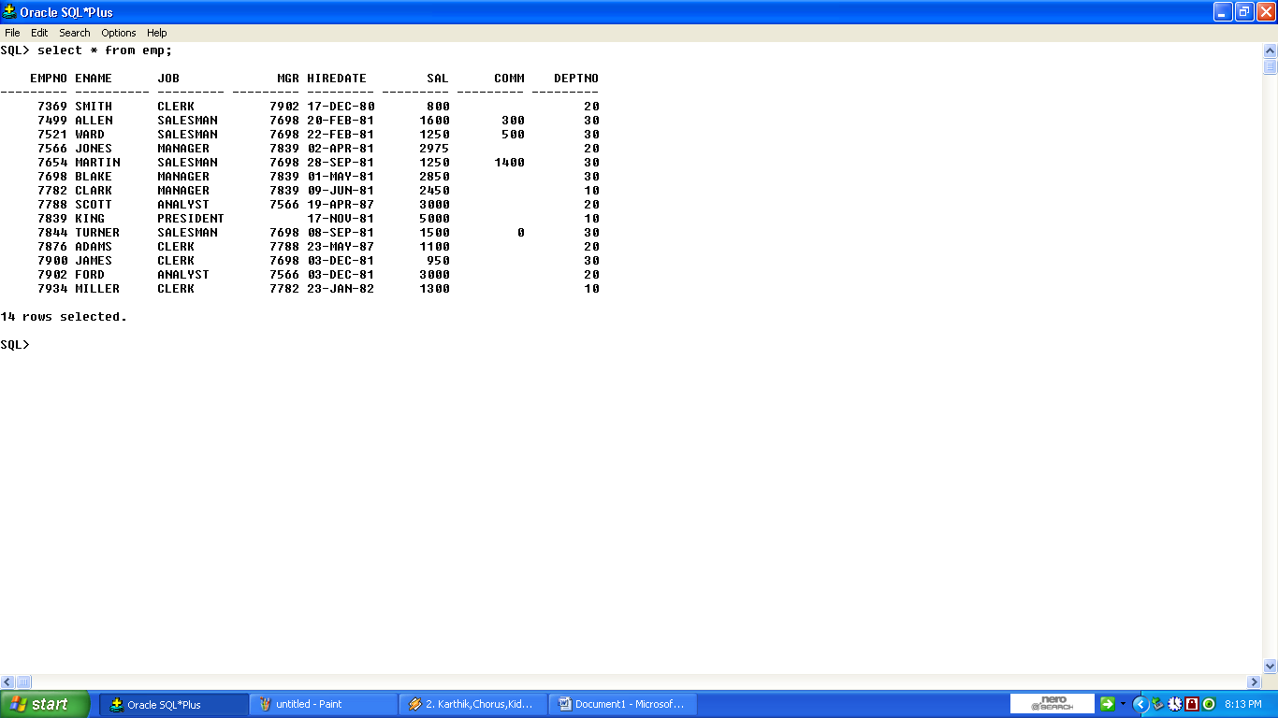
3. List empno,empname and salary.
SQL>Select empno,ename,sal from emp;
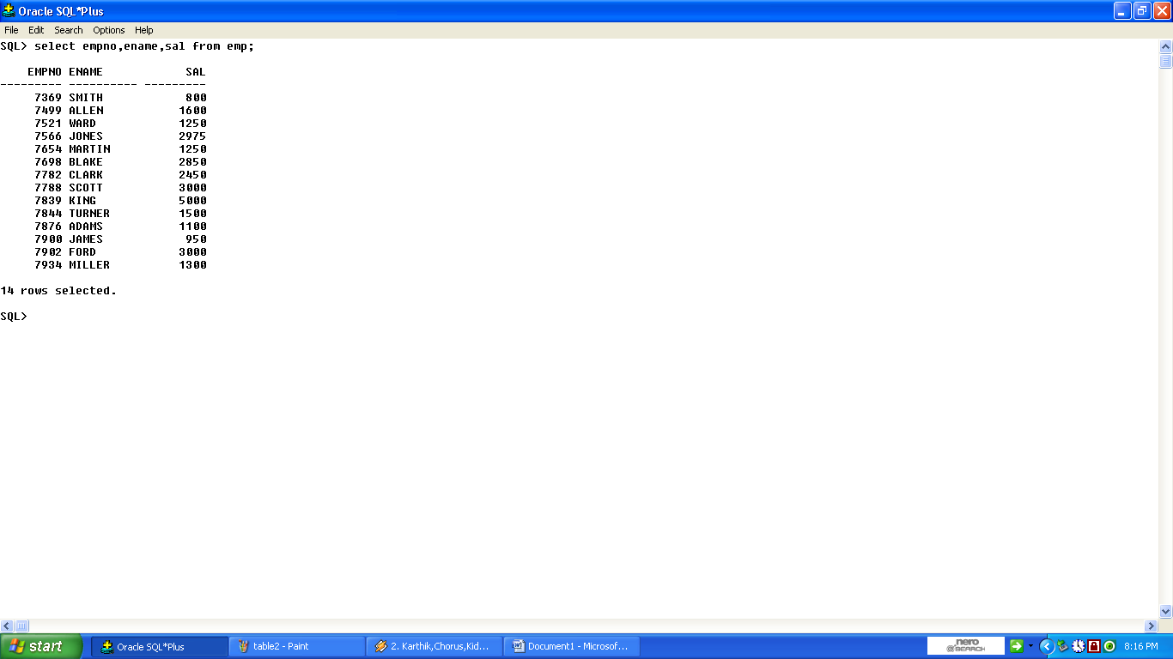
4.List the names of all MANAGERS.
SQL>Select empno,ename,job from emp where job=’ MANAGERS’;
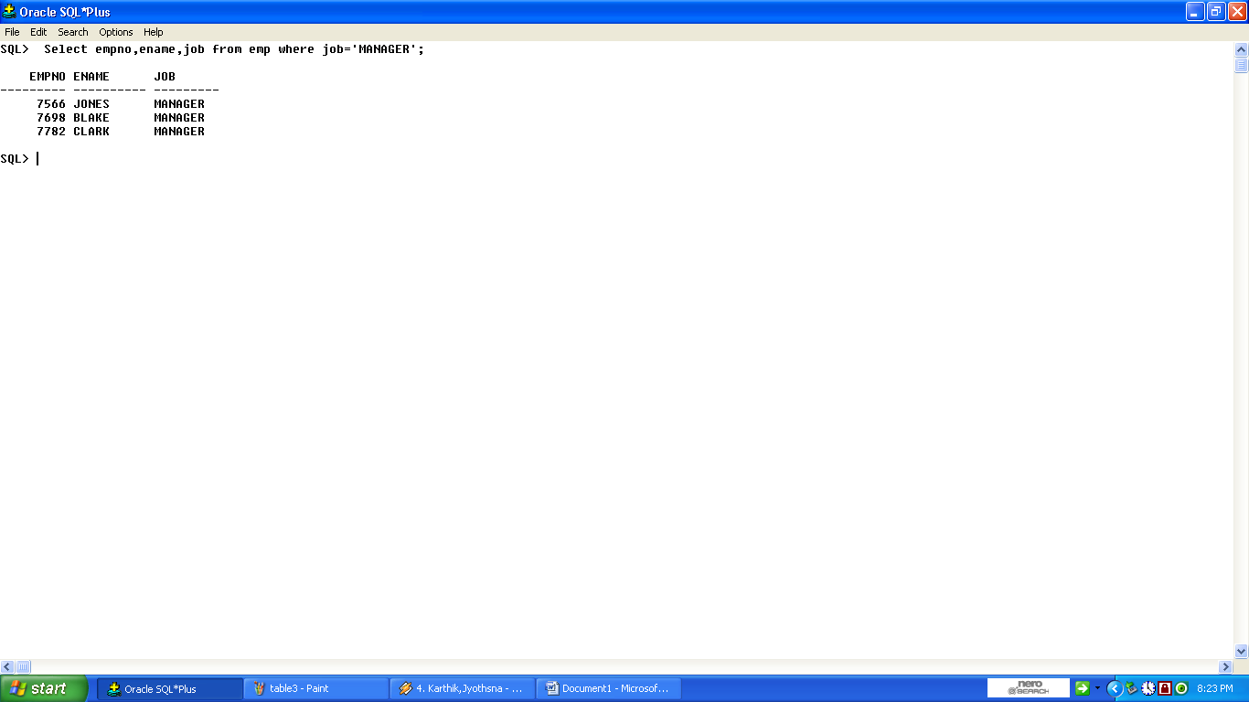
5.List all clerks in deptno. 30.
SQL> select empno, ename,job from emp where job =’CLERK’ and deptno=30;
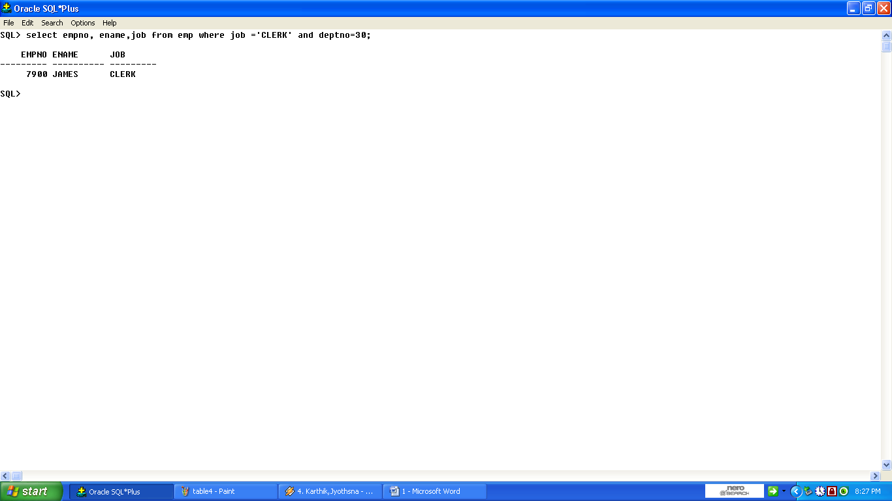
6.List all employee names whose mgr no is 7698.
SQL>select * from emp where mgr=7698;
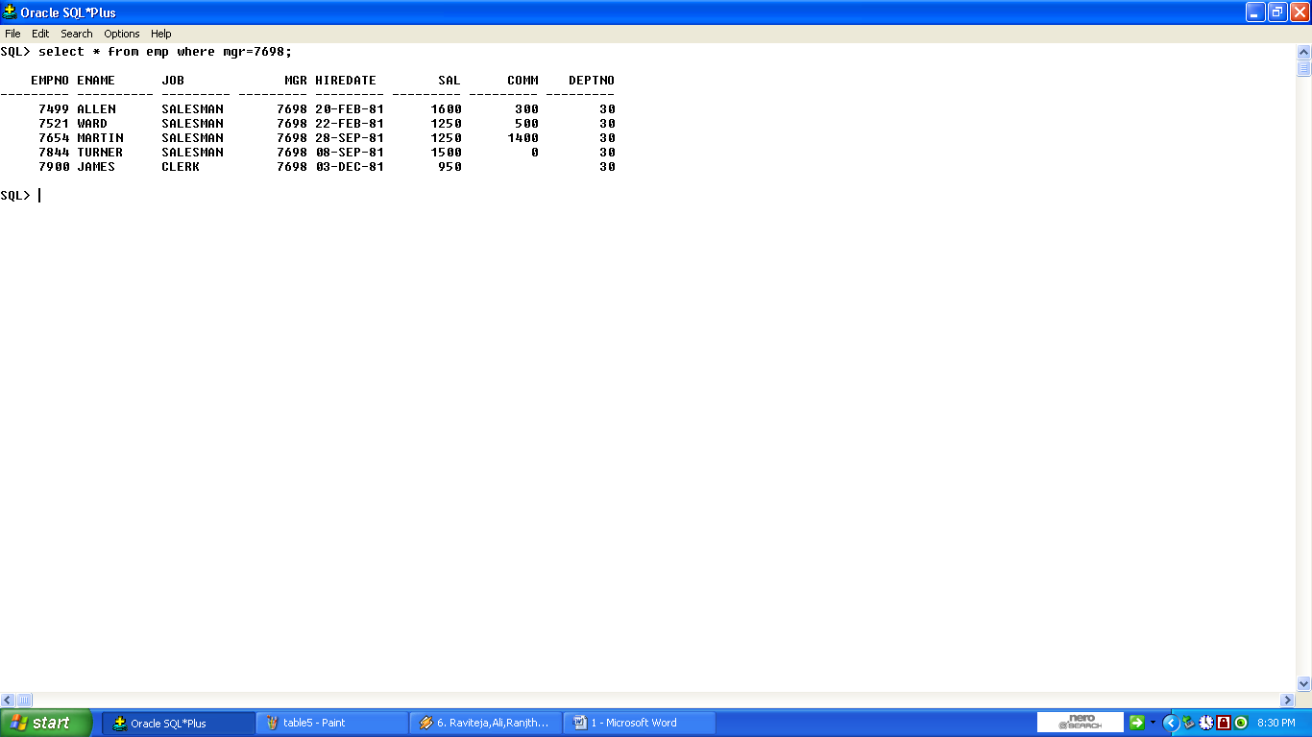
7.List jobs dept 20.
SQL> select distint(job) from emp where deptno=20;
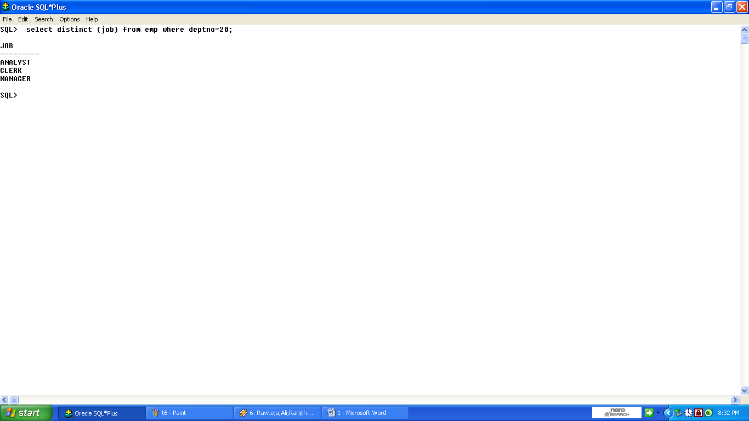
8.List employee names whose salary is between 2000 and 3000.
SQL>Select ename,sal from emp where sal between 2000 and 3000;
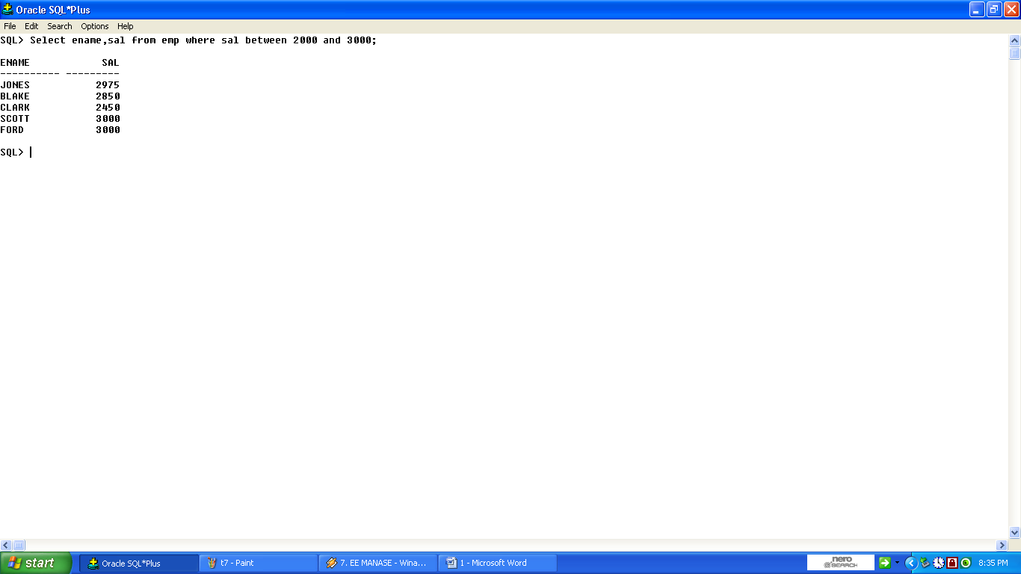
9.List employee in the dependent 10,20.
SQL>select * from emp where deptno in(10,20);
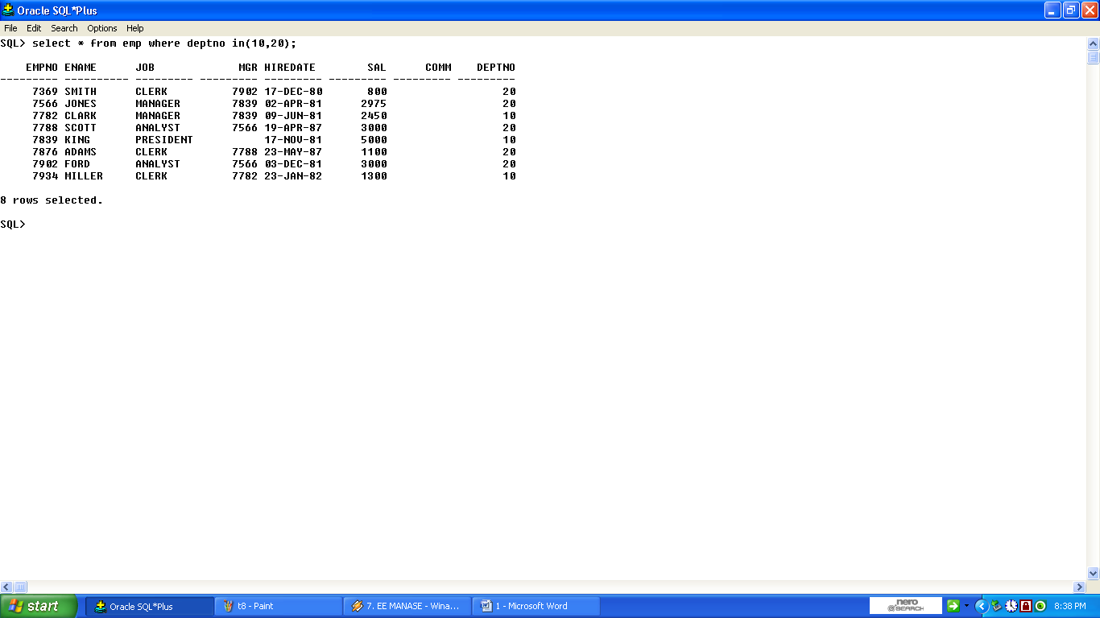
10.list employee names which begin with S.
SQL>select ename from emp where ename like ‘S%’;
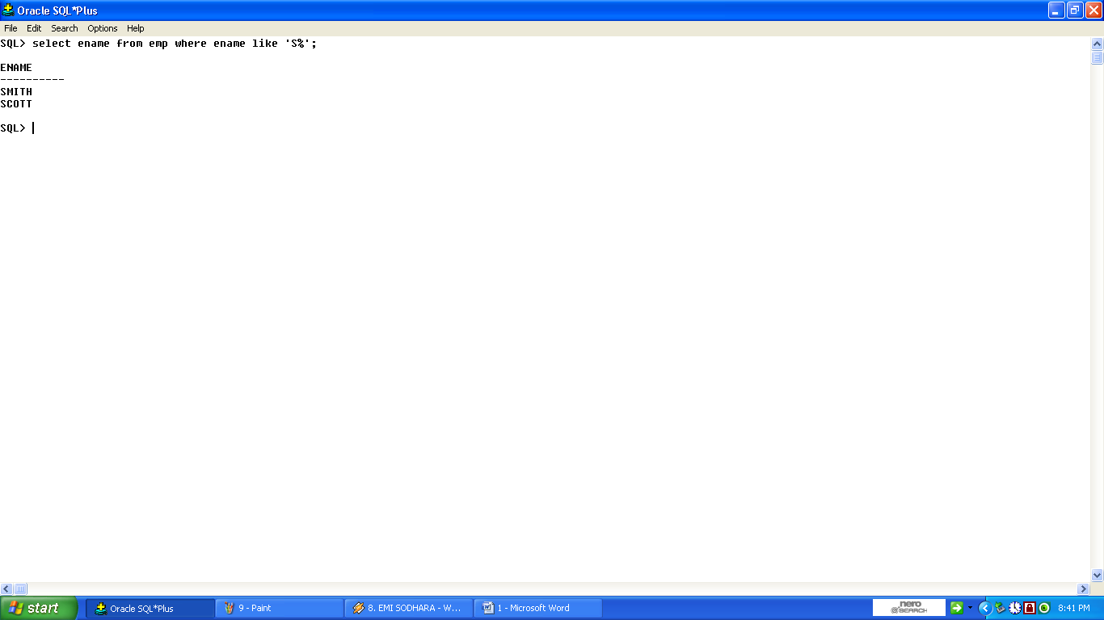
11.List employee names having ‘A’ in their names.
SQL>select ename from emp where ename like ‘%A%’;
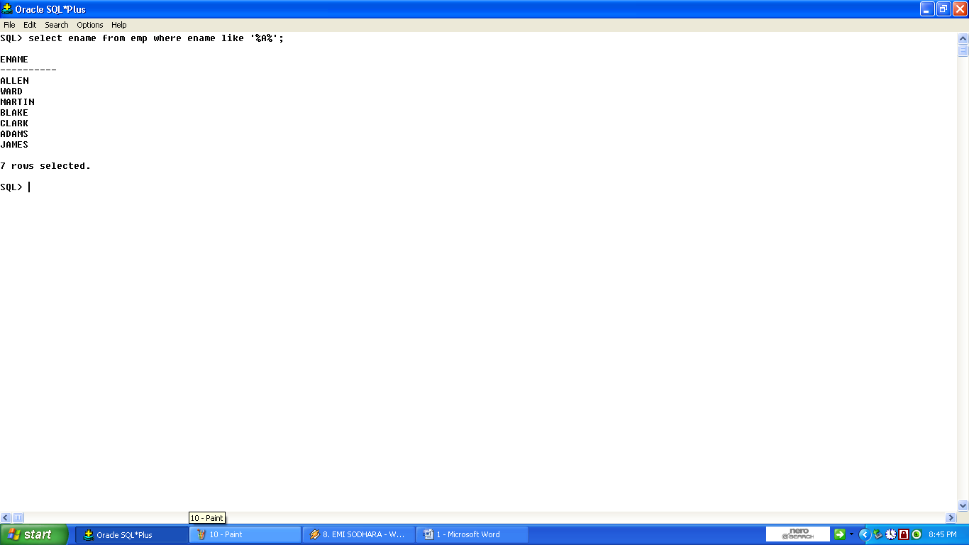
12.List employee who have joined in JAN.
SQL>select ename,to_char(hiredate,’MON’) mon from emp where to_char(hiredate,’MON’)=’JAN’;
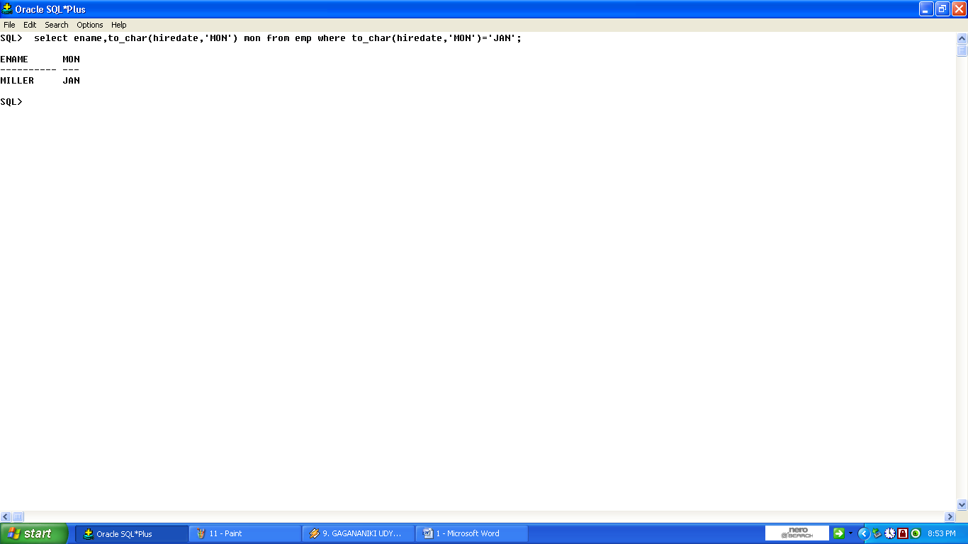
13.List employees who have joined in the year 81.
SQL>select ename,to_char(hiredate,’YYYY’) from emp where to_char(hiredate,’YYYY’)=1981;
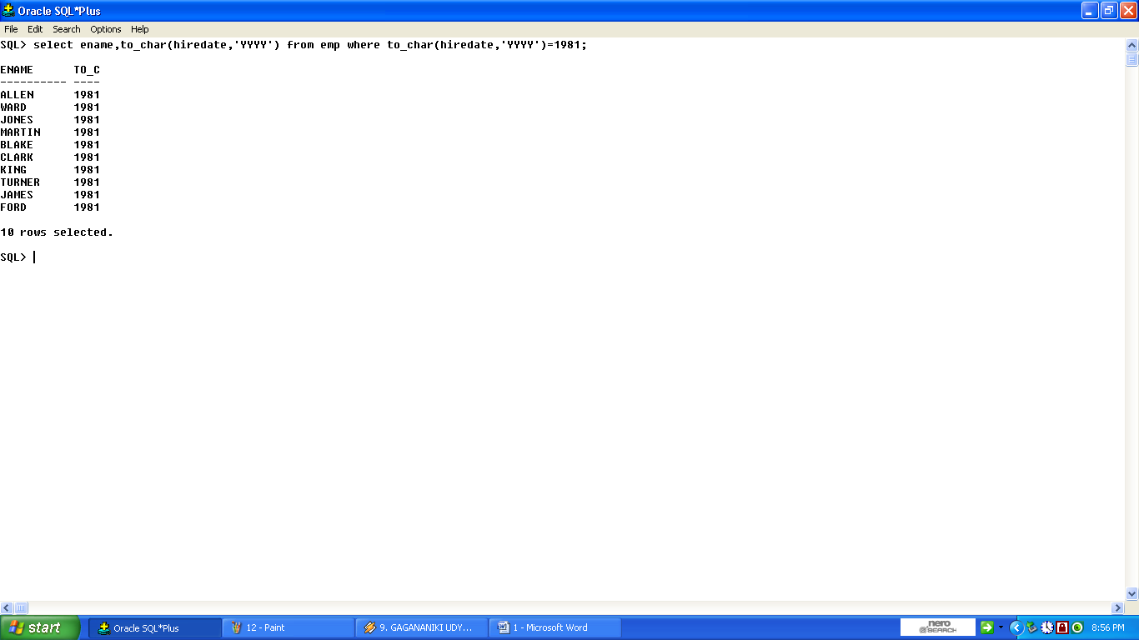
14.List all distinct jobs.
SQL> select distinct(job) from emp;
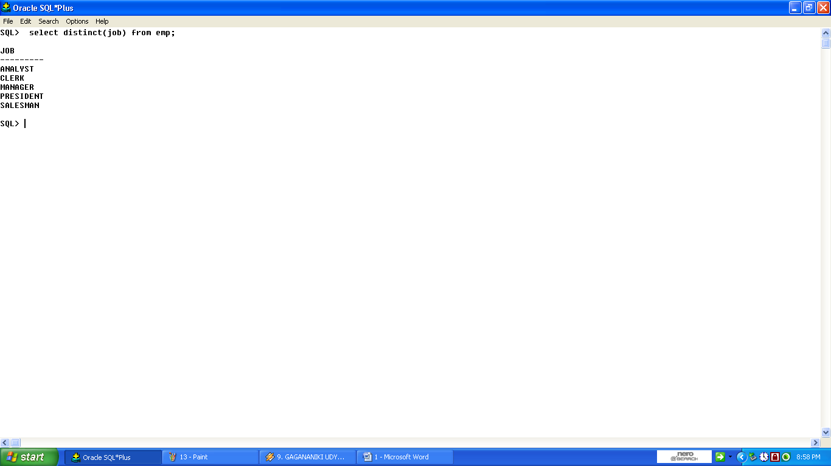
15.List employee names in alphabetical order.
SQL>select ename from emp order by ename;
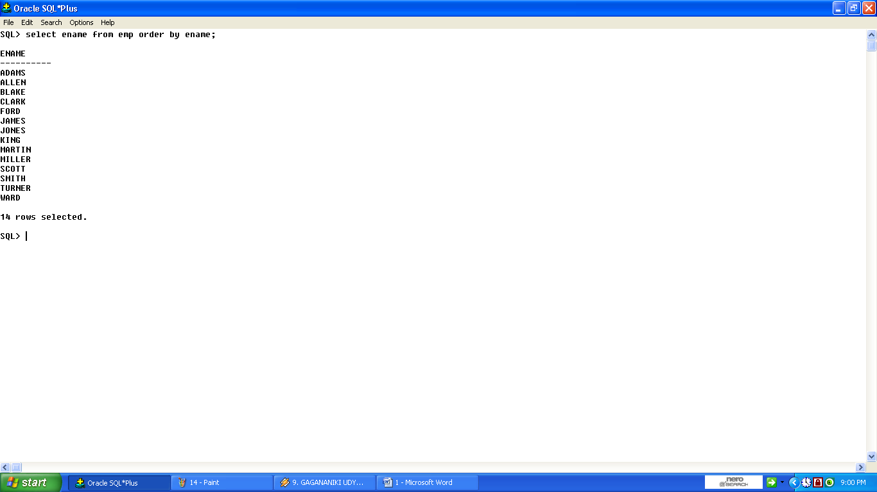
16.List employee names alphabetically department by deptno.
SQL>select ename,deptno from emp order by deptno;
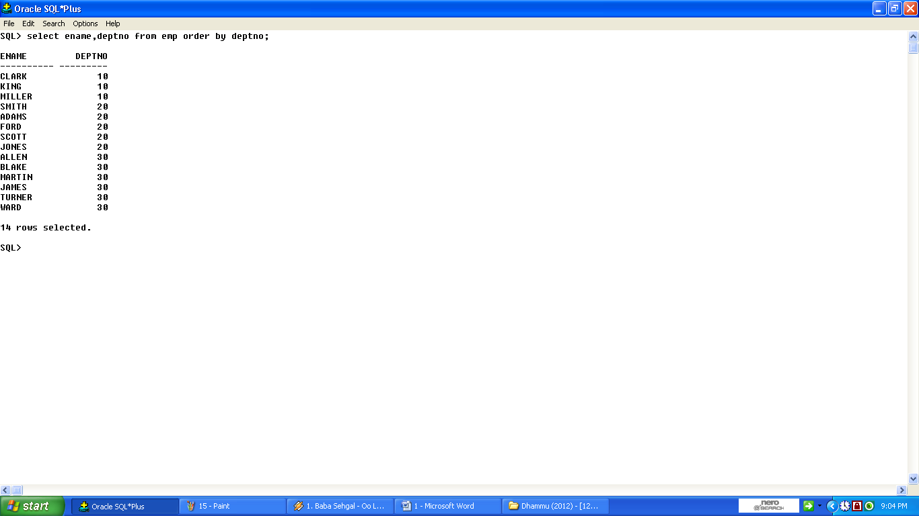
17.List employee numbers,name sal,DA(15% OF SAL) and PF (10% of sal).
SQL>select empno,ename sal,(sal*0.15)DA,(SAL*0.1) PF from emp;
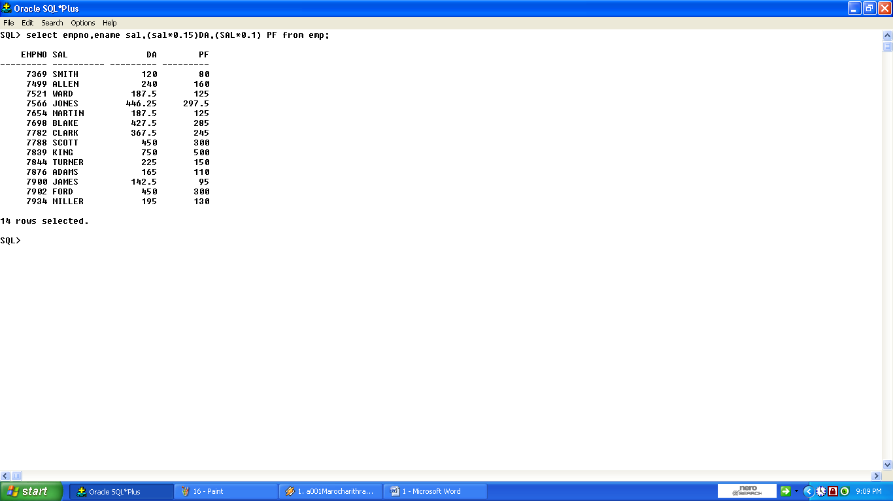
18.List employee names having an experience more than15 years.
SQL>select ename,round(months_between(sysdate,hiredate)/12)exp from emp where round (months_between(sysdate,hiredate)/12)>24;
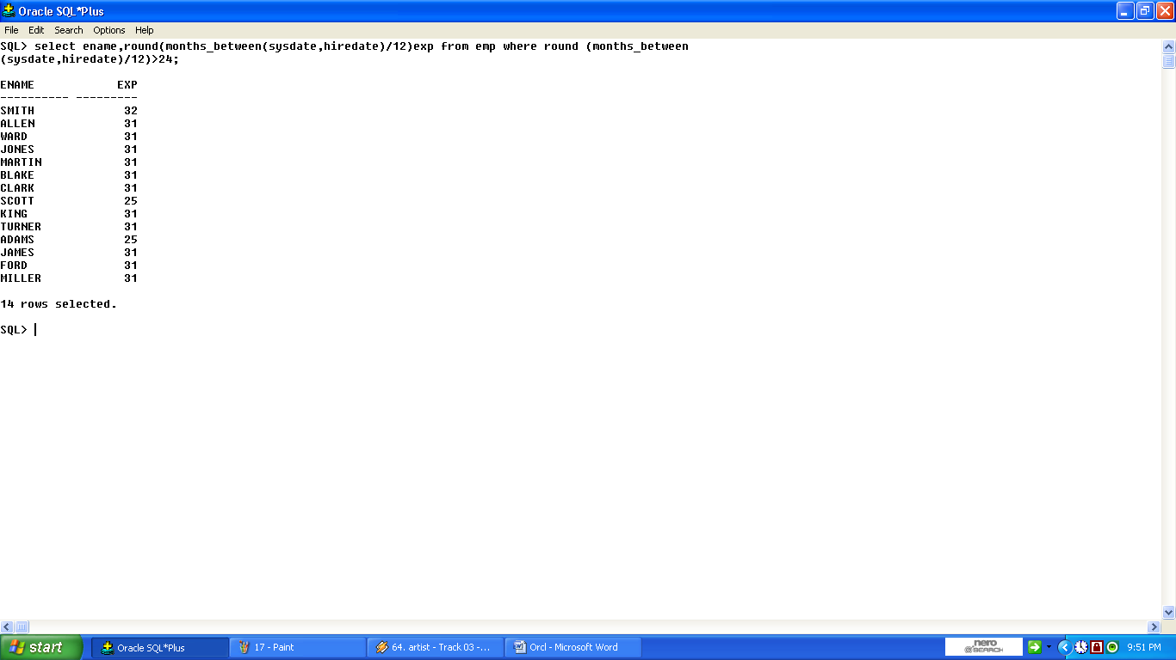
19.List employee names whose commission is NULL.
SQL>select ename from emp where comm is null;
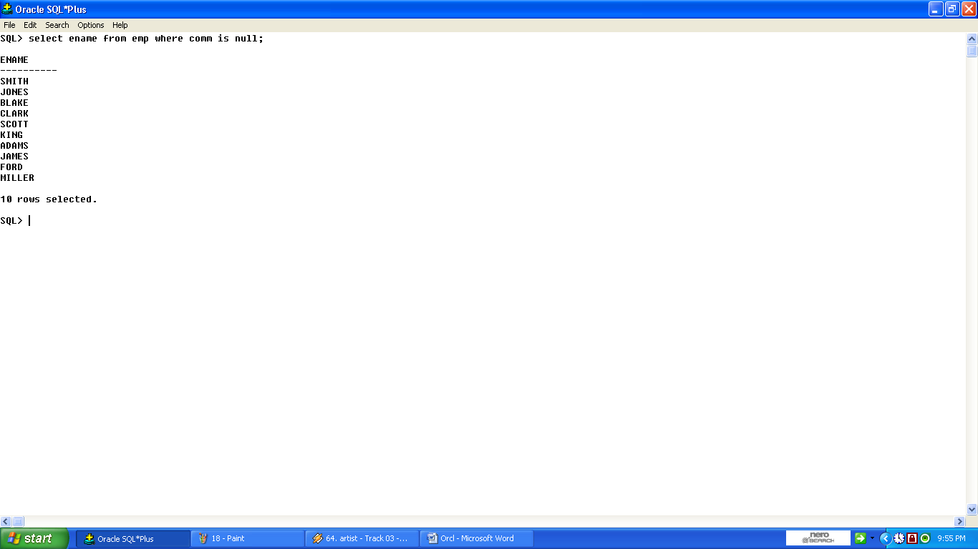
20.List employee who do not report to anybody.
SQL>select ename,mgr from emp where mgr is null;
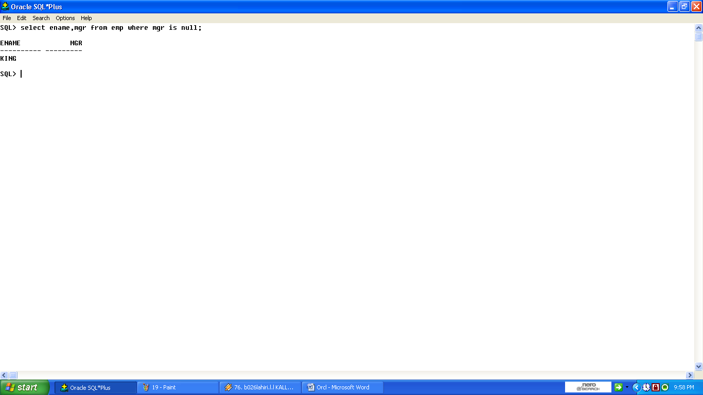
21.List maximum sal,minimum sal,average sal,
SQL>select max(sal),min(sal),avg(sal) from emp;
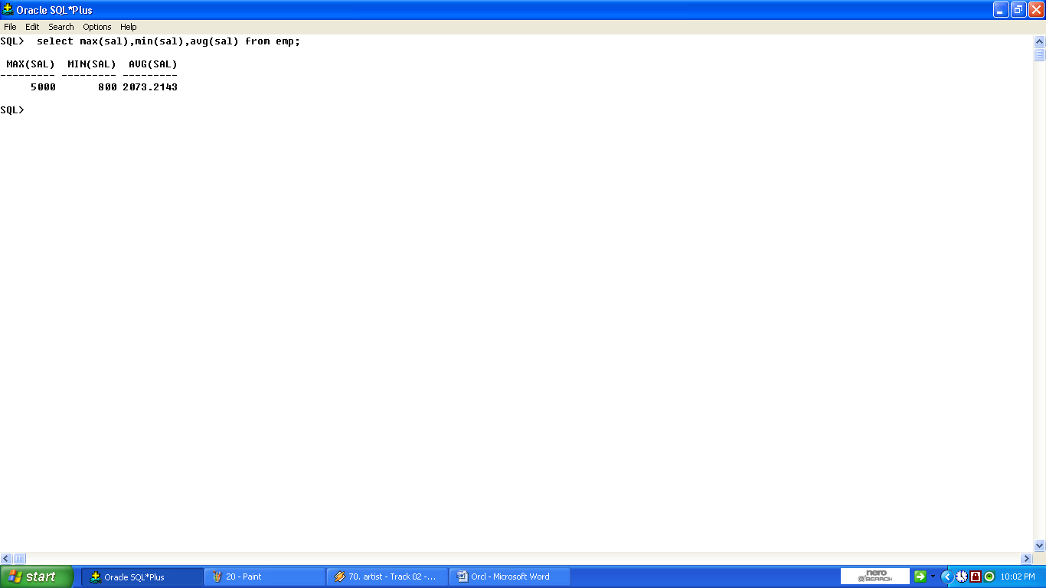
22.List the numbers of people and average slary in deptno 30.
SQL>select count(*),avg (sal) from emp where deptno=30;
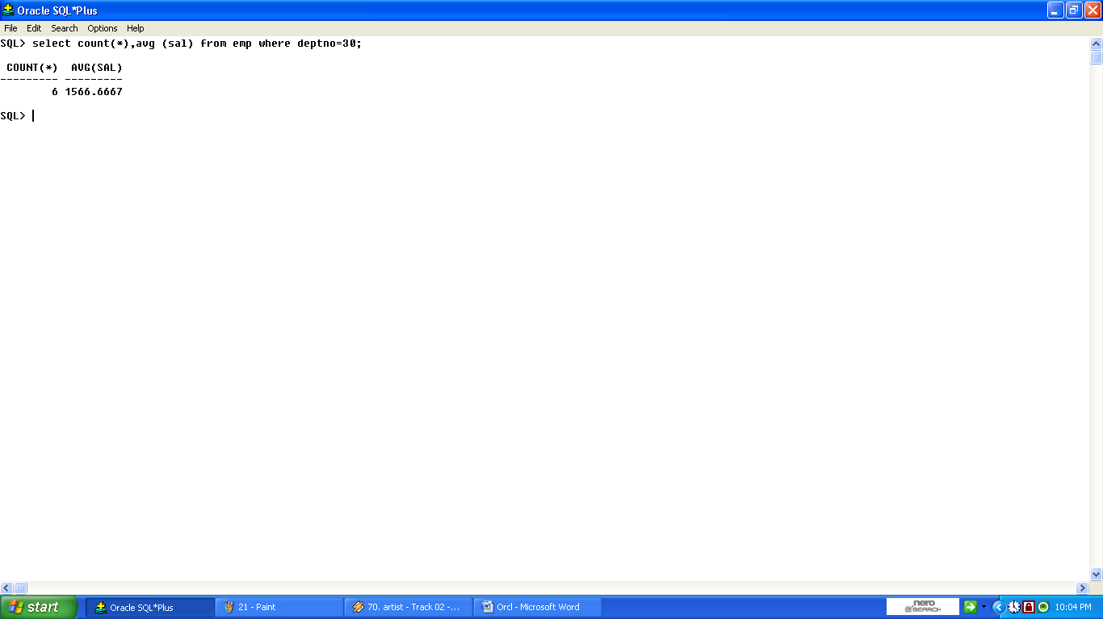
23.List maximum sal and minimum sal in the designation SALESMAN and CLERK.
SQL> select count(*),max(sal),avg(sal) from emp where job in(‘SALESMAN’,’CLERK’);
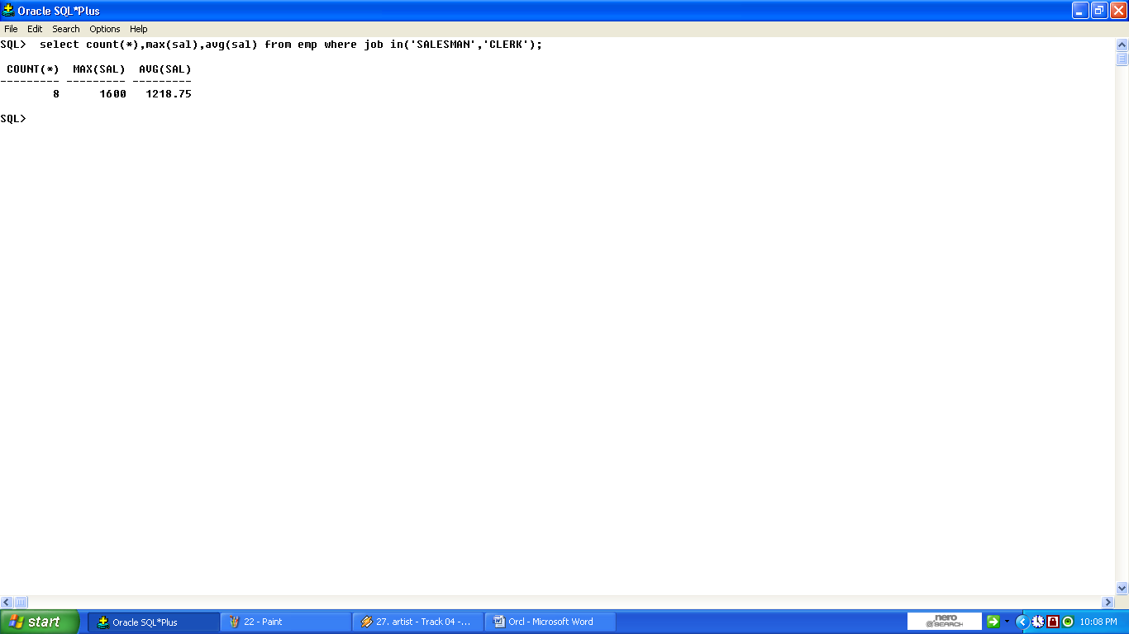
24.List the numbers of people and average salary of employee joined in 81,82 and 83.
SQL>select count (*),avg(sal) from emp where to_char(hiredate,’YY’)in(81,82,83);
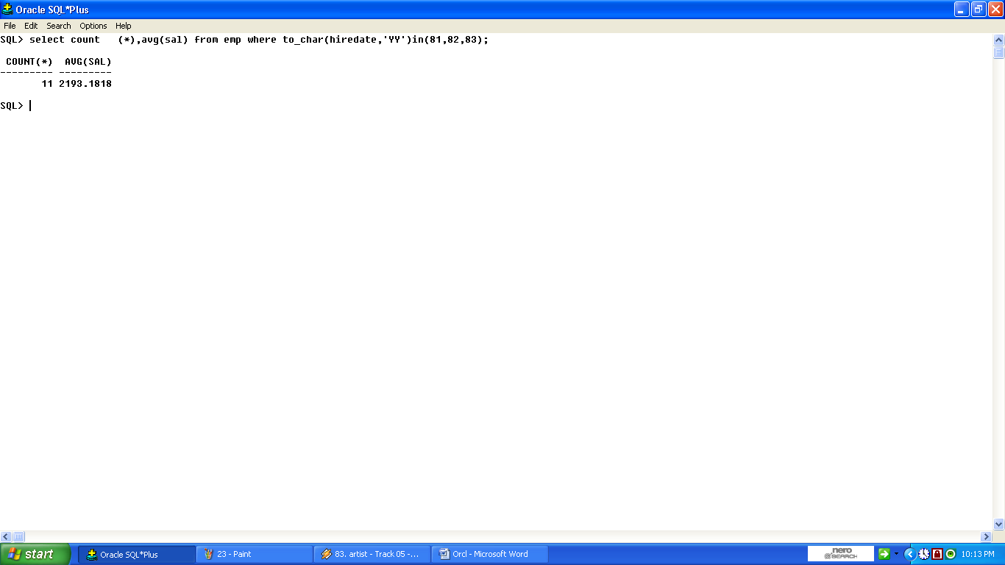
25.List jobs that are unique to deptno 20 .
SQL>select distinct(job) from emp where deptno=20;
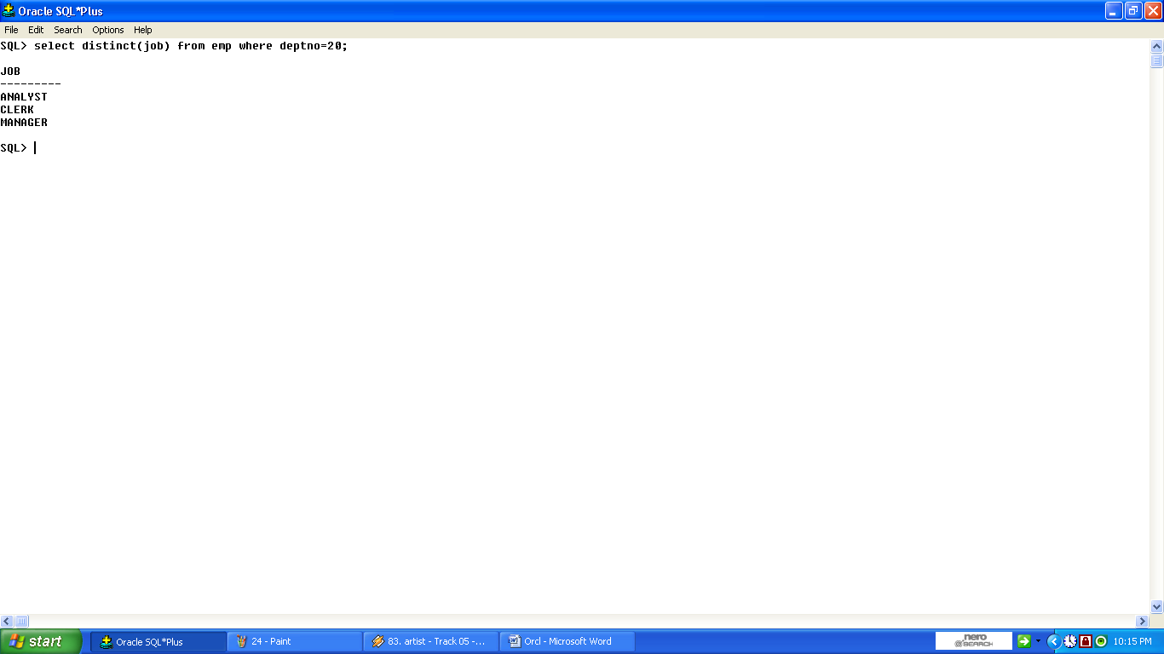
26.List employee names and their joining date in the folloeing formats
A.SMITH 17th DEC NINETEEEN EIGHTY
B.SMITH SEVENTEENTH DEC NINTEEN EIGHTY
C.SMITH week day of joining
D.SMITH 17/12/80
A.select to_char(hiredate,’ddth mon year’) from emp where ename like ‘SMITH’;
B. select to_char(hiredate,’ddspth mon year’) from emp where ename like ‘SMITH’;
C. select to_char(hiredate,’day’) from emp where ename like ‘SMITH’;
D. select to_char(hiredate,’dd/mm/yy’) from emp where ename like ‘SMITH’;
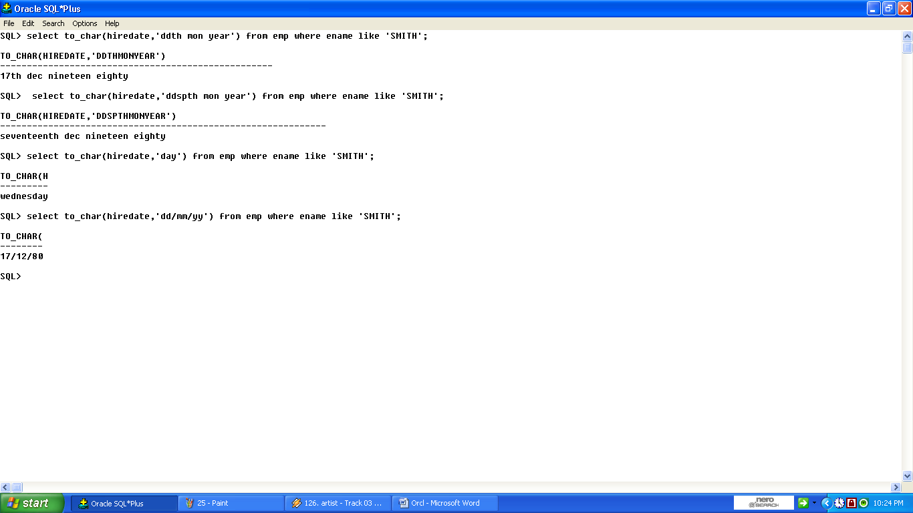
27.List employee names and their experience in yesrs.
SQL>select ename,round(months_between(sysdate,hiredate)/12) exp from ;
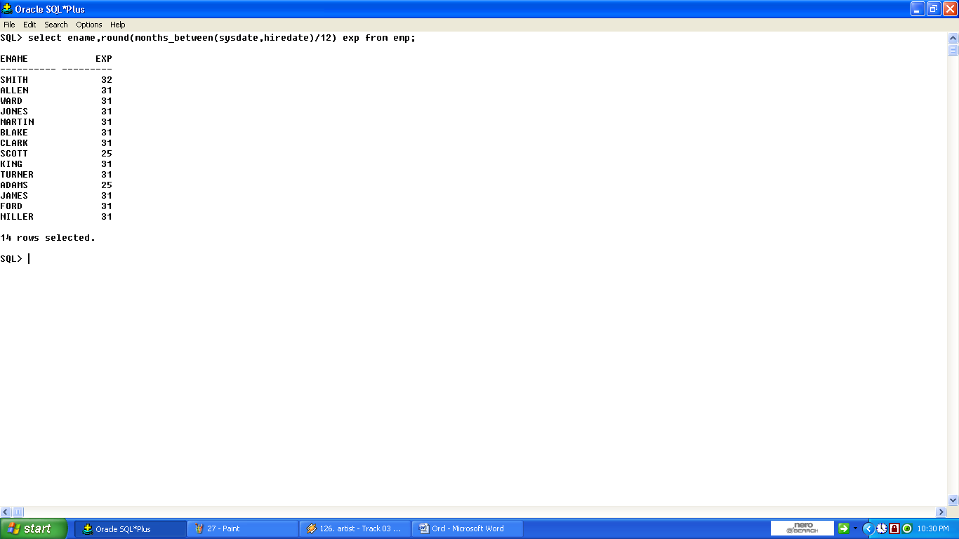
28.Display a given date as a string in different formats.
SQL>select to_char(sysdate,’ddspth month year’) from dual;
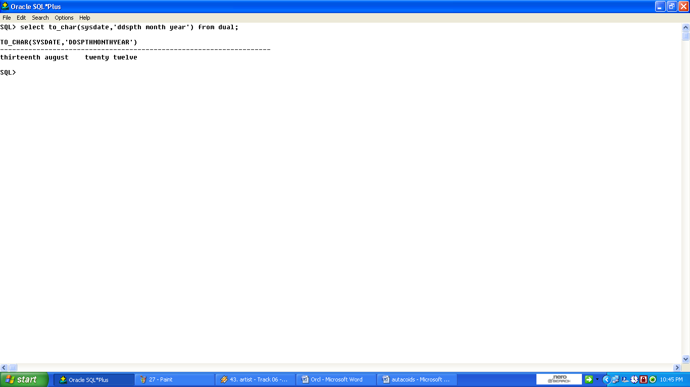
29. List employee names with length of the names sorted on length.
SQL>select ‘sri’||ename||’guru’ from emp;
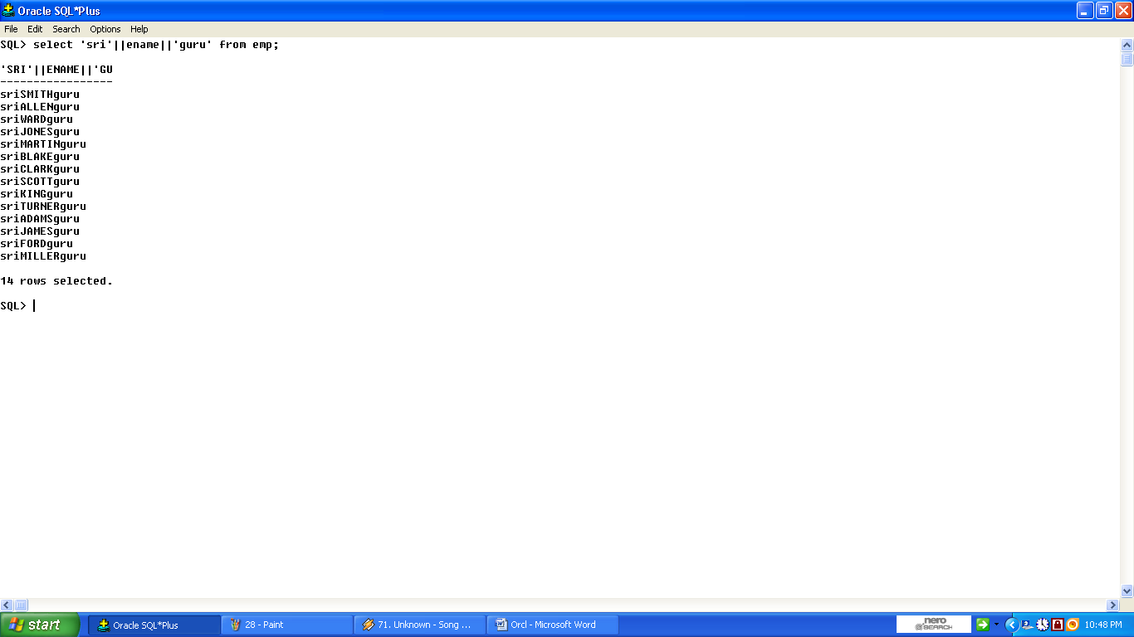
30.List employee names with length of the name sorted on lengrh.
SQL>select ename,to_char(hiredate,’month’) from emp;
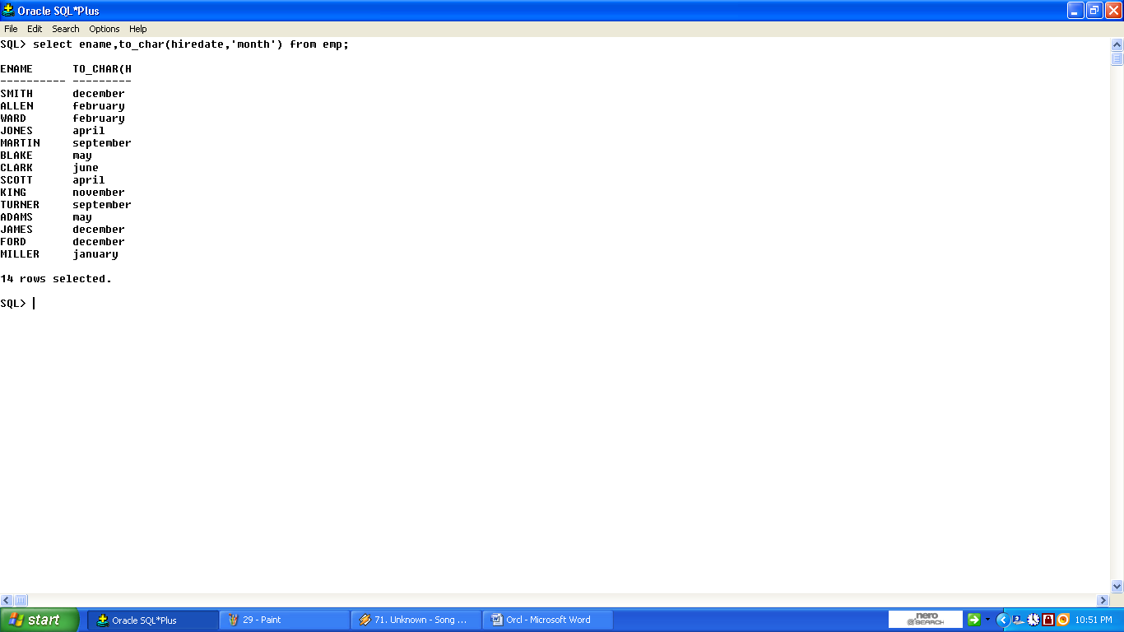
31.List employee names with length of the name sorted on lengrh.
SQL>select ename||’---------‘||job||’--------‘|| sal from emp;
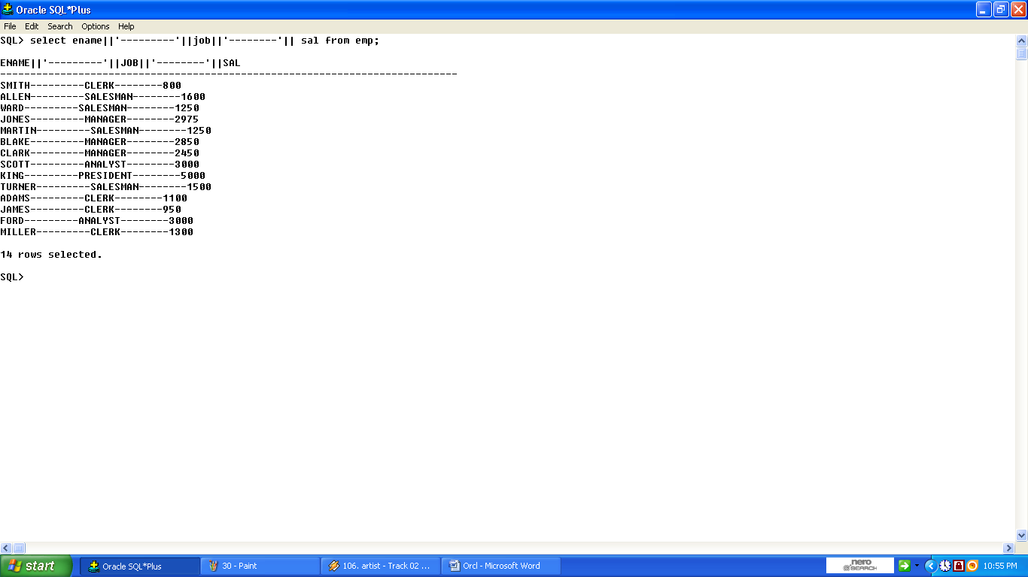

32.List employee names and the string with out first character and last character in their name.
SQL>select ename,instr(ename,’I’) from emp;
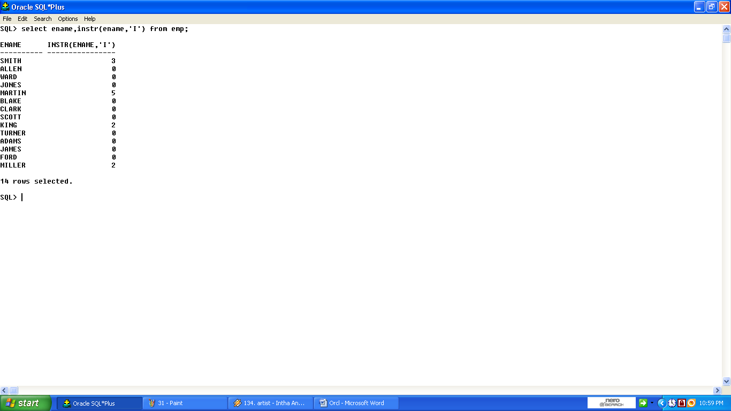
33.SQL>select deptno,min(sal),max(sal),avg(sal) from emp where deptno in(10,30) group by deptno;
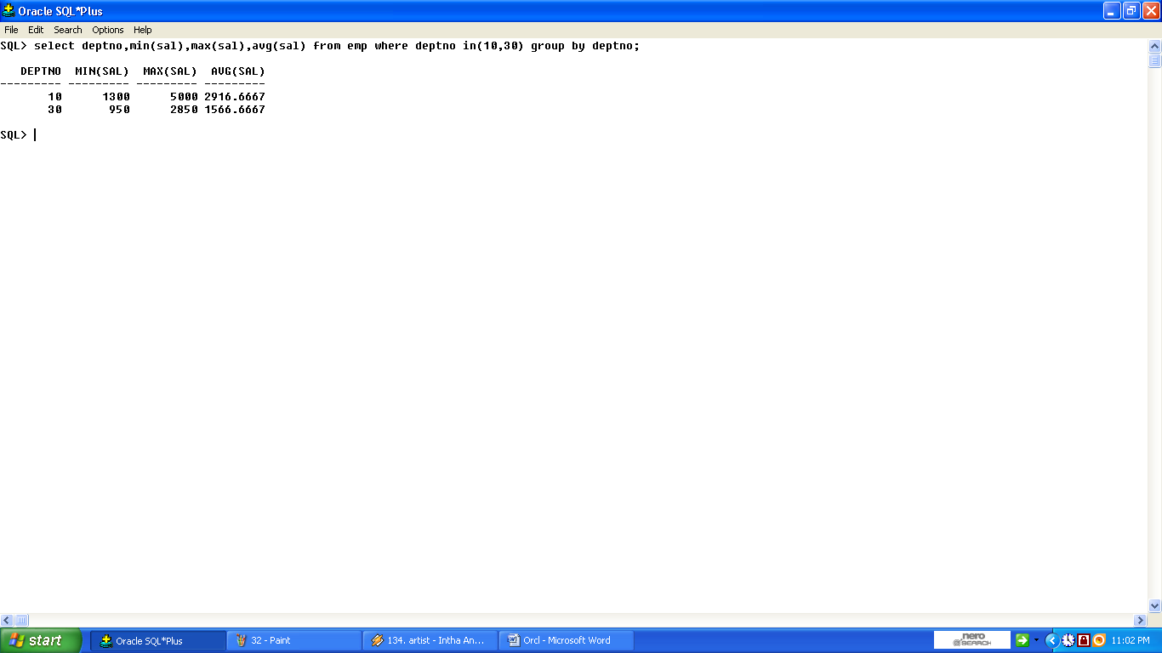
34.SQL>select deptno,min(sal),max(sal),avg(sal) from emp group by deptno;
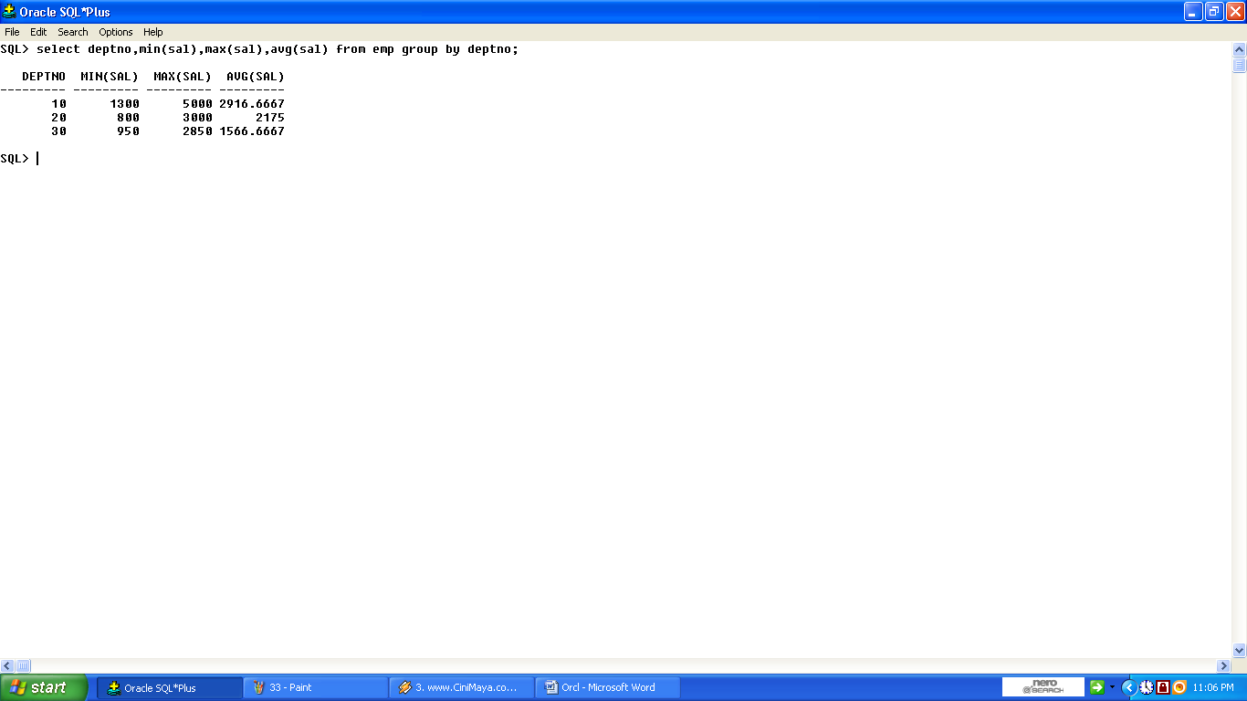
35.SQL>select job,min(sal),max(sal),avg(sal) from emp group by job;
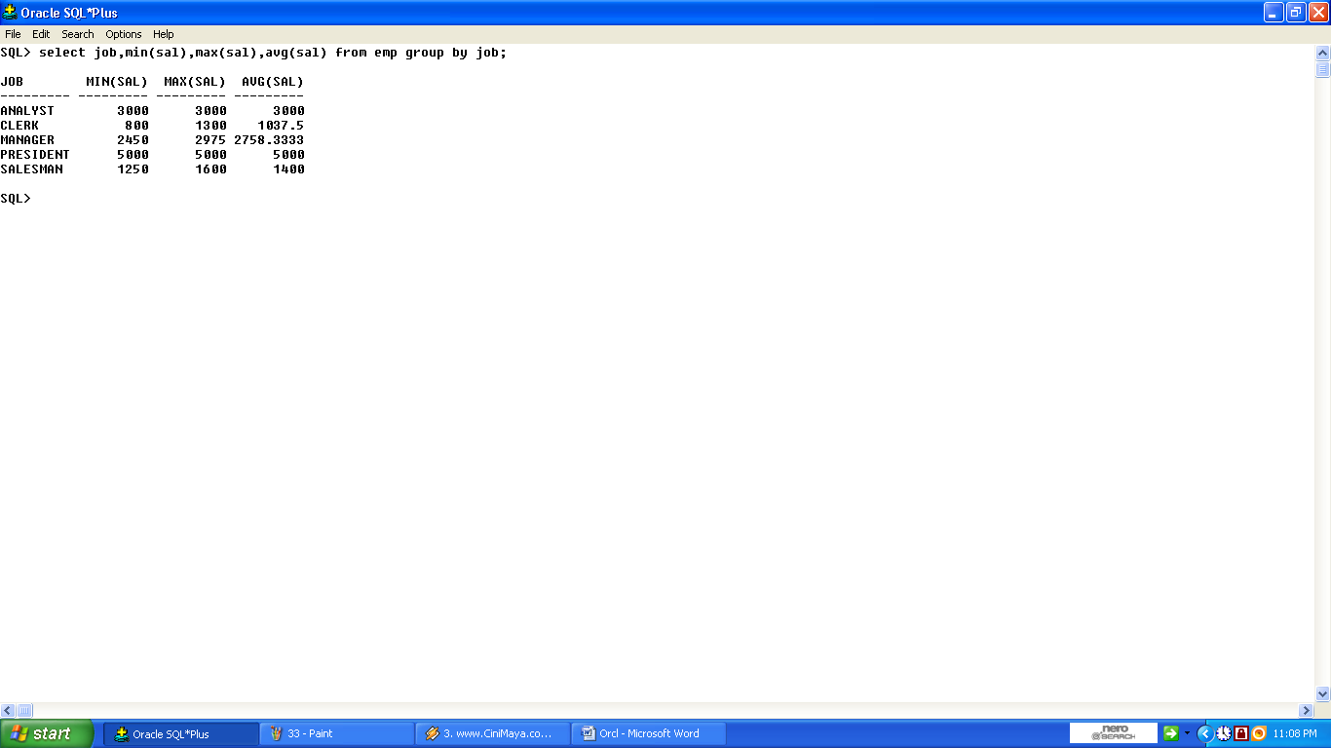
36.SQL>select deptno,min(sal),max(sal),count(8) from emp group by deptno having count(*)>=2;
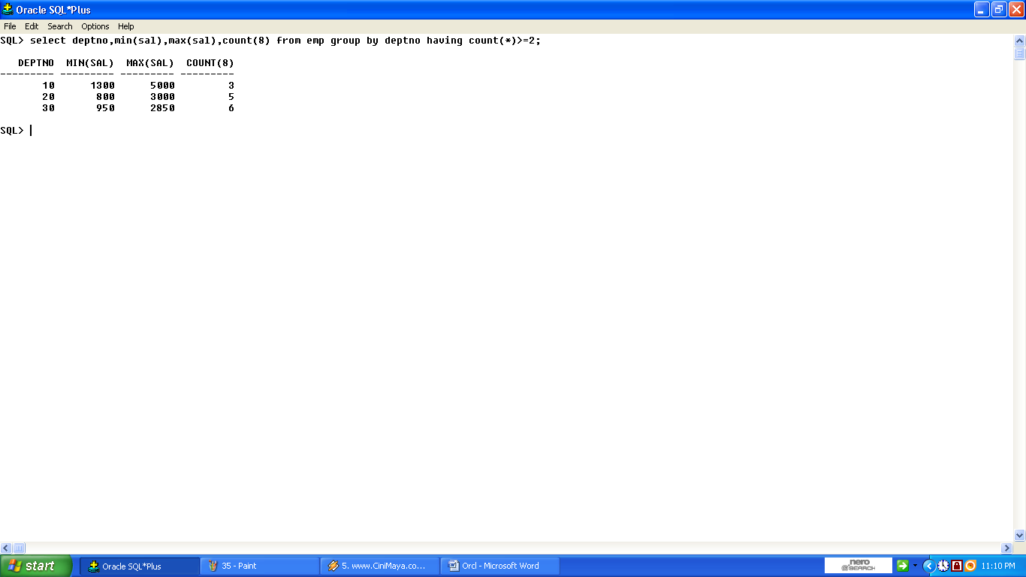
37.List employee names and dept names with which they are associated.
SQL>select ename,dname from emp,dept where emp.deptno=dept.deptno;
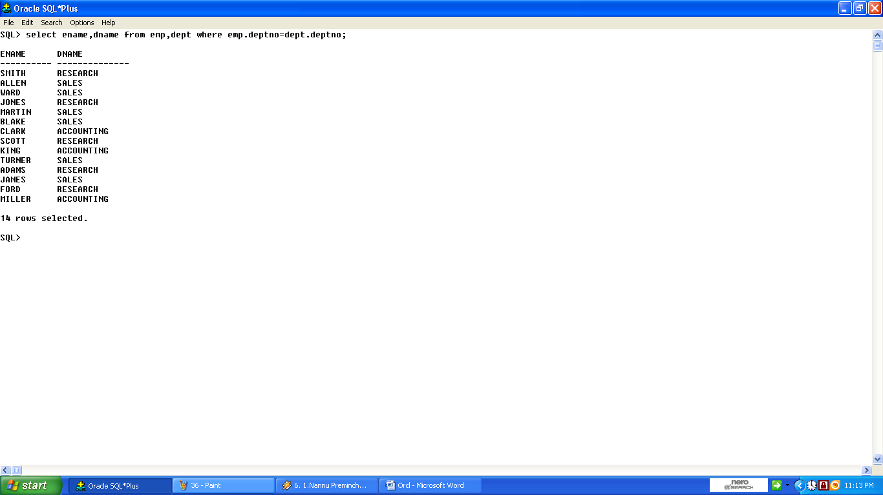
D) Sql Operators (Simple-complex conditions):
1)Between,And:
SELECT FNAME, SALARY FROM EMPLOYEE WHERE SALARY BETWEEN 20000 AND 30000;
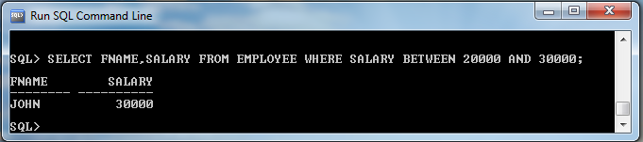
2)Like:
1. SELECT FNAME FROM EMPLOYEE WHERE LNAME LIKE’S%’;
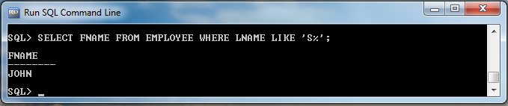
- Write a query to retrieve all employees who were born during the 1950s
.SQL> select * from employee where bdate like '%5_';
FNAME M LNAME SSN BDATE ADDRESS S SALARY SUPERSSN DNO
--------------- - --------------- --------- --------- ------------------------------ - ---------- --------- ----------
Franklin T Wong 333445555 08-DEC-55 638 Voss, Houston, TX M 40000 888665555 5
3)IN:
SELECT FNAME FROM EMPLOYEE WHERE DNO IN(1,4,5);
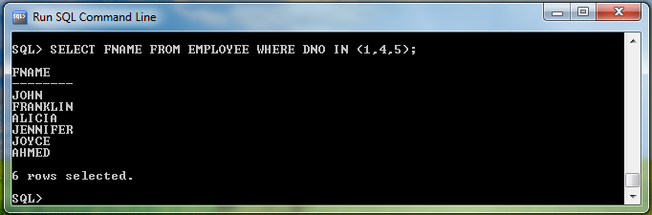
4) NOT:
SELECT FNAME FROM EMPLOYEE WHERE DNO NOT IN(1,2,3);
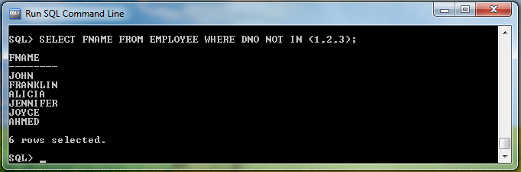
E) ASC-DESC ordering combinations:
1) Write a query to retrieve names and salaries of employees in the descending order of their salaries.
A.) select fname,salary from employee order by salary desc;
SQL> /
FNAME SALARY
--------------- ----------
Ramesh 38000
James 55000
Jennifer 43000
John 30000
Joyce 25000
Franklin 40000
Ahmad 25000
7 rows selected.
2) Write a query to retrieve names and salaries of employees in the Ascending order of their names.
A.) select fname,salary from employee order by salary Asc;
SQL> FNAME SALARY
--------------- ----------
Ahmad 25000
Franklin 40000
John 30000
Joyce 25000
Ramesh 38000
5 rows selected.
F) Renaming attributes:
1) Rename Employee table to Employees?
A) Rename Employee to Employees;
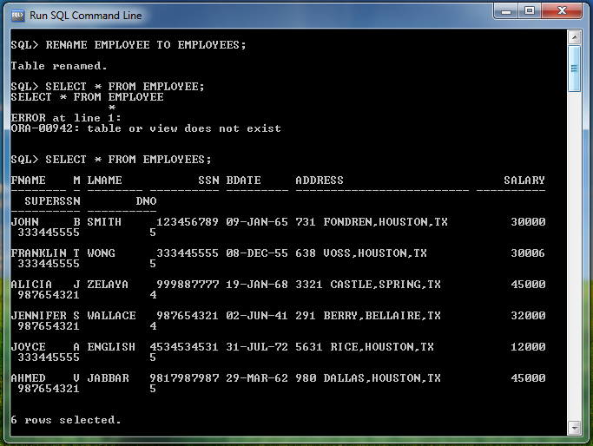
G) Delete command:
Delete from employees where ssn=123456789;
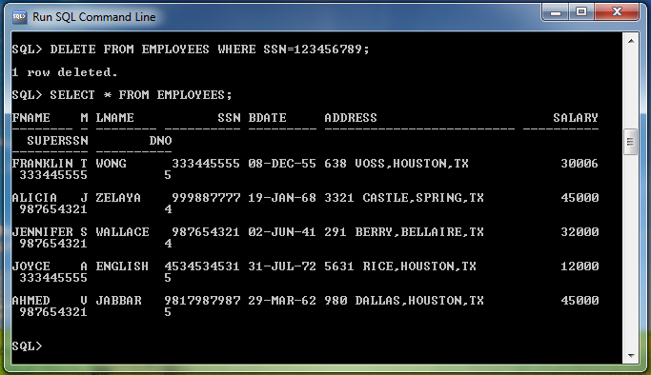

H) ALTER: Used to modify or add or delete an attribute
1. To add a column for department table
Alter table department add dspl varchar2(5);
Table altered
Name | Null? | Type
DNAME |  | VARCHAR2(5)
DNO |  | NUMBER(4)
DLOC |  | VARCHAR2(8)
DSPL |  | VARCHAR2(5)
2. To modify already exsisting column
Alter table department modify dloc varchar2(10);
Table altered
Name | Null? | Type
DNAME |  | VARCHAR2(5)
DNO |  | NUMBER(4)
DLOC |  | VARCHAR2(10)
DSPL |  | VARCHAR2(5)
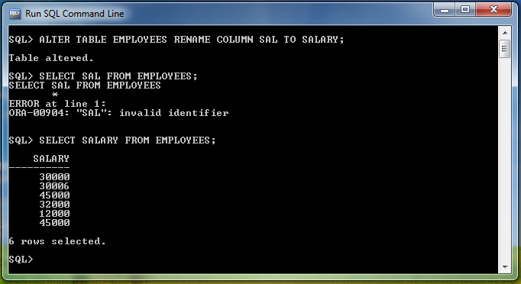
3. To delete a column
Alter table dept drop column dspl;
Table altered
Name | Null? | Type
DNAME |  | VARCHAR2(5)
DNO |  | NUMBER(4)
DLOC |  | VARCHAR2(10)

I) DROP: used to delete a table.

Syntax: Drop table tablename;
Ex:
Drop table department;
Table deleted.

J) SQL FUNCTIONS:
These functions are used to manipulating data items and returning the results.
- Group functions or Aggregate functions.
- Single Row or scalar function.
Group functions or Aggregate functions:
These functions operated a set of values or rows
- Sum()
- Avg()
- Min()
- Max()
- Count()
Sum():used to find out the sum of the salary of employees.
Ex:List the sum of the salary of employees
Select sum(sal) from emp;
Avg():it find out the average salaries of employees.
Ex:List the average salary of the employees
Select avg(sal) from emp;
Min():used to find out the minimum salary of an employee in the given table.
Ex:list out the minimum salary of an employee in the emp table.
Select min(sal) from emp;
Max():used to find out the maximum salary of an employee in the given table.
Ex:list out the maxiimum salary of an employee in the emp table.
Select max(sal) from emp;
Count():used to list out the number of values in a particular table.
Ex:
1.List the numbers of jobs.
select count (job) from emp;
2.List the numbers of people and average salary in deptno 30.
select count(*),avg(sal) from emp where deptno=30;

Single Row or scalar function:These functions are operated a single row at a time.
Abs(): find the absolute value.
Select abs(10) from dual;
ABS(10)
10

Power():find the power.
Select power(2,3) from dual;
POWER(2,3)
8

Sqrt():find the square root of a given value.
Select sqrt(9) from dual;
SQRT(9)
3

Round()-find the round of the value.
Select round(12.35,1) from dual;
ROUND(12.35,1)
12.4
Truncate():find the truncate value.
Select trunc(12.35,1) from dual;
TRUNC(12.35,1)
12.3

Exp():used to find the exponential of given number.
Select exp(3) from dual;
EXP(3)
20.0855

Greastest():find out the greater value.
Select greatest(10,20,30) from dual;
GREATEST(10,20,30)
30

Least():find out the leastervalue.
Select least(10,20,30) from dual;
LEAST(10,20,30)
10

Mod():fina tha module of given numbers.
Select mod(3,2) from dual;
MOD(3,2)
1
Floor():find the floor value.
Select floor(12.56) from dual;
FLOOR(12.56)
12
Sign():find the sign of a number.
Select sign(-10) from dual;
SIGN(-10)
-1
Select sign(10) from dual;
SIGN(10)
1

Log():find logarthemic value.
Select log(3,2) from dual;
LOG(3,2)
.630929754

In these function we are using date functions also there are listed below:
Select months_between(’26-jun-06’,’25-may-06’) from dual;
MONTHS_BETWEEN('26-JUN-09','25-MAY-09')
1.03225806
Select add_months('26-jun-06',5') from dual;
ADD_MONTH
26-NOV-06
Select next_day('26-jun-09','monday') from dual;
NEXT_DAY(
29-JUN-09
Select last_day('26-jun-09') from dual;
LAST_DAY(
30-JUN-09

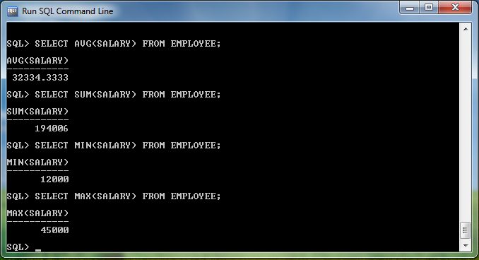
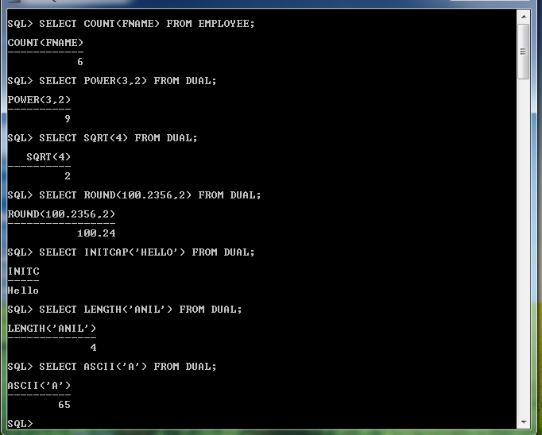

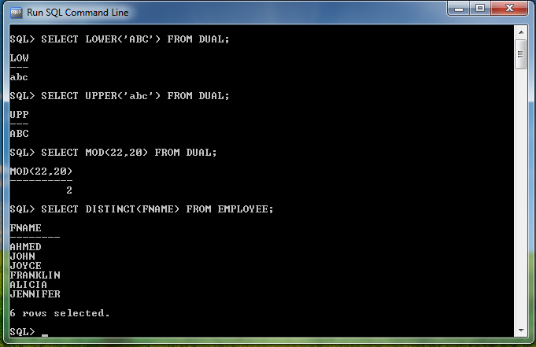

EXP-III Multi-table queries (JOIN OPERATIONS)
- Write a query to retrieve name and address of all employees who work for the ‘Research’ department.
FNAME ADDRESS
--------------- ------------------------------
John 731 fondren, Houston, TX
Joyce 6531 Rice, Houston, TX
Ramesh 975, Fire Oak, Humble, TX
Franklin 638 Voss, Houston, TX

- Write a query to retrieve employee’s first and last name and first and last name of his or her immediate supervisor.
SQL>select e1.fname,e1.lname,e2.fname "supervisor fname",e2.lname "supervisor lname" from employee e1,employee e2 where e1.superssn=e2.ssn

FNAME LNAME supervisor fnam supervisor lnam
--------------- --------------- --------------- ---------------
John Smith Franklin Wong
Ramesh Narayan Franklin Wong
Joyce English Franklin Wong
Franklin Wong James Borg
Jennifer Wallace James Borg
Alicia Zelaya Jennifer Wallace
Ahmad Jabbar Jennifer Wallace
OR
(USING OUTER JOIN )
SQL>select e1.fname ,e1.lname, e2.fname "supervisor fname", e2.lname "supervisor lname" from employee e1,employee e2 where e1.superssn= e2.ssn(+)
FNAME LNAME supervisor fnam supervisor lnam
--------------- --------------- --------------- ---------------
John Smith Franklin Wong
Ramesh Narayan Franklin Wong
Joyce English Franklin Wong
Franklin Wong James Borg
Jennifer Wallace James Borg
Alicia Zelaya Jennifer Wallace
Ahmad Jabbar Jennifer Wallace
James Borg

8 rows selected.
NOTE: + is specified in above using ‘outer join’ to an attribute in join condition where we don’t have null value.
Ex: ssn don’t have null value but superssn has. So, I gave (+) to ssn.

- Write a query to retrieve list of employees and the projects they are working on, ordered by department and with in each department, ordered alphabetically by last name, first name.
SQL>select e.ssn,e.fname,e.lname,w.pno,e.dno from employee e,works_on w where e.ssn=w.essn order by dno,fname,lname;
SSN FNAME LNAME PNO DNO
--------- --------------- --------------- --------- ---------
888665555 James Borg 20 1
987987987 Ahmad Jabbar 10 4
987987987 Ahmad Jabbar 30 4
999887777 Alicia Zelaya 30 4
999887777 Alicia Zelaya 10 4
987654321 Jennifer Wallace 30 4
987654321 Jennifer Wallace 20 4
333445555 Franklin Wong 2 5
333445555 Franklin Wong 3 5
333445555 Franklin Wong 10 5
333445555 Franklin Wong 20 5
123456789 John Smith 1 5
123456789 John Smith 2 5
453453453 Joyce English 1 5

16 rows selected.
- For every project located in ‘Stafford’, list the project number, the controlling department number and the department manager’s last name, birth date.
SQL>select p.pnumber,p.dnum,e.lname,e.bdate from employee e,department d,project p where p.plocation='Stafford' and p.dnum=d.dnumber and d.mgrssn=e.ssn

PNUMBER DNUM LNAME BDATE
-------- --------- --------------- ---------
10 4 Wallace 20-JUN-41
30 4 Wallace 20-JUN-41

- Find the sum of the salaries of all employees, the maximum salary, the minimum salary and the average salary.
SQL> select sum(salary),max(salary),min(salary),avg(salary) from employee

SUM(SALARY) MAX(SALARY) MIN(SALARY) AVG(SALARY)
----------- ----------- ----------- -----------
281000 55000 25000 35125

- Find the sum of the salaries of all employees, the maximum salary, the minimum salary and the average salary of all employees of the ‘Research’ department.
SQL>select sum(salary),max(salary),min(salary),avg(salary) from employee e,department d where d.dname='Research' and d.dnumber=e.dno

SALARY) MAX(SALARY) MIN(SALARY) AVG(SALARY)
------- ----------- ----------- -----------
133000 40000 25000 33250

- Count the number of employees working in the ‘Research’ department.
SQL>select count(*) from employee e,department d where d.dname='Research' and d.dnumber=e.dno

COUNT(*)
---------
4
- For each department, retrieve the department number, the number of employees in the department and their average salary.

SQL>select dno,count(dno),avg(salary) from employee group by dno
DNO COUNT(DNO) AVG(SALARY)
--------- ---------- -----------
1 1 55000
4 3 31000
5 4 33250 count(*) also works

- For each project, retrieve the project number, Project name and the number of employees who work on that project.
SQL>select pno,pname,count(pno) "Employees working" from project p,works_on w where p.pnumber=w.pno group by pno,pname
PNO PNAME Employees working
--------- --------------- -----------------
1 ProductX 2
2 ProductY 3
3 ProductZ 2
10 Computerization 3
20 Reorganization 3
30 Newbenefits 3
6 rows selected.
- For each project on which more than two employees work, retrieve the project number, project name and the number of employees who work on the project.
SQL>select pno,pname,count(pno) from project p,works_on w where p.pnumber=w.pno group by pno,pname having count(pno)>2

PNO PNAME COUNT(PNO)
--------- --------------- ----------
2 ProductY 3
10 Computerization 3
20 Reorganization 3
30 Newbenefits 3
- For each project, retrieve the project number, Project name and the number of employees from department 5 who work on the project.
SQL>select pno,pname,count(pno) "Employees in dept:5" from employee e,project p,works_on w where w.pno=p.pnumber and w.essn=e.ssn and dno=5 group by pno,pname

PNO PNAME Employees in dept:5
---------- --------------- -------------------
1 ProductX 2
2 ProductY 3
3 ProductZ 2
10 Computerization 1
20 Reorganization 1

NOTE: “for each” given in problem implies to use group by clause.
count (any attribute)=count(*)
Ex: count(pno)=count(*)

EXP-IV Nested queries
- Write a nested query to retrieve the name of each employee who has a dependent with the same first name and same sex as the employee.
A. SQL>select fname from employee e1 where ssn in ( select ssn from dependant d
where e1.fname=d.dependent_name and e1.sex=d.sex and e1.ssn=d.essn)
output:
no rows selected

- [Using exists]
A . SQL>select fname from employee e1 where exists ( select ssn from dependant d
where e1.fname=d.dependent_name and e1.sex=d.sex and e1.ssn=d.essn)
OUTPUT:
No rows selected
- Write a query to show resulting salaries if every employee working on ‘ProductX’ project is given a 10 percent raise.
A . SQL> select ssn,salary+.1*salary "10 % raise of salary" from employee where ssn in ( select essn
from works_on w
where pno in (select pnumber
from project
where pname='ProductX'));
OUTPUT:
SSN 10 % raise of salary
--------- --------------------
123456789 33000
453453453 27500

- For each department that has more than two employees, retrieve the department number and the number of its employees who are making more than or equal to $30,000.
A . SQL> select dno,dname,count(*) from employee e,department d where e.dno=d.dnumber and salary>=30000 and dno in( select e2.dno from employee e2 group by e2.dno having count(*) >2) group by dno,dname
OUTPUT:
DNO DNAME COUNT(*)
---------- --------------- ----------
4 Administration 1
5 Research 3
- Write a nested query to retrieve the names of employees who have no dependents.
SQL> select fname from employee e1 where e1.ssn not in(select essn from dependant d where e1.ssn=d.essn)
OUTPUT:
FNAME
---------------
Alicia
Ramesh
Joyce
Ahmad
James

- Write a nested query to list the names of managers who have at least one dependent.
A . SQL> select fname from employee,department where mgrssn=ssn and exists( select * from dependant where mgrssn=essn)
OUTPUT:
FNAME
---------------
Franklin
Jennifer
- Write a nested query to retrieve the names of all employees who have two or more dependents.
A: SQL>
select fname from employee where ssn in( select essn from dependant where essn=ssn group by(essn) having count(*)>2)
OUTPUT:
FNAME
---------------
John
Franklin

- Write a nested query to retrieve the SSNs of all employees who work on project number 1, 2 or 3.
A: SQL>
select ssn from employee where ssn in( select distinct essn from works_on
where pno in(1,2,3))

OUTPUT:
SSN
---------
123456789
333445555
453453453
666884444
NOTE: ‘distinct’ may or mayn’t be present
- Write a nested query to retrieve the names of all employees whose salary is greater than the salary of all the employees in department 5.
A: SQL> select fname from employee where salary > all (select salary from employee
where dno=5)
OUTPUT:
FNAME
---------------
Jennifer
James

Note: while doing nested queries consider the output as inner and apply conditions one by one with each condition satisfying in one condition.

EXP-V Set Oriented Operations
- Write a query to make a list of all project numbers for projects that involve an employee whose last name is ‘Smith’, either as a worker or as a manager of the department that controls the project.
SQL> select pnumber from project p where pnumber in(select pno from works_on w,employee e where w.essn=e.ssn and e.lname='Smith')UNION(select pnumber from project p1, department d,employee e where e.lname='Smith' and p1.dnum=d.dnumber
and e.dno=d.dnumber)

OUTPUT:
PNUMBER
----------
1
2
3

- Write a query to retrieve the SSNs of employees who worked on projects 1 and 2 but not on 3.
SQL> select ssn from employee e where e.ssn in ( (select distinct essn from works_on w,employee e where w.essn=e.ssn and w.pno=1) UNION ( select distinct essn from works_on w,employee e where w.essn=e.ssn and w.pno=2) MINUS( select distinct essn
from works_on w,employee e where w.essn=e.ssn and w.pno=3))

OUTPUT:
SSN
---------
123456789
453453453

- Write a query to retrieve the names of employee who worked on all the projects controlled by department 5.
SQL>
- Without using a nested query, retrieve the names of employees who have no dependents.

SQL> select fname from employee e where e.ssn in ((select ssn from employee) MINUS (select distinct essn from dependant))

OUTPUT:

FNAME
---------------
Joyce
Ramesh
James
Ahmad
Alicia

- SELECT * FROM student UNION SELECT * FROM std;

SNO SNAME
---- ------
1 kumar
2 ravi
3 ramu
5 lalitha
9 devi

- SELECT * FROM student UNIONALL SELECT * FROM std;

SNO SNAME
---- ------
1 kumar
2 ravi
3 ramu
5 lalitha
9 devi

- SQL> SELECT * FROM student INTERSECT SELECT * FROM std;

SNO SNAME
---- -------
1 Kumar

- SELECT * FROM student MINUS SELECT * FROM std;

SNO SNAME
---- -------
2 RAVI
3 RAMU

EXP-VI DDL & TCL Commands
data definition LANGUAGE (ddl): The Data Definition Language (DDL) is used to create and destroy databases and database objects. These commands will primarily be used by database administrators during the setup and removal phases of a database project. Let's take a look at the structure and usage of four basic DDL commands:
1. CREATE 2. ALTER 3. DROP 4. RENAME
1. CREATE:
(a)create table: This is used to create a new relation and the corresponding
Syntax: create table relation_name
(field_1 data_type(Size),field_2 data_type(Size), .. . );

Example:
SQL>create table Student (sno NUMBER(3),sname char(10),class char(5));

(b)create TABLE..as select....: This is used to create the structure of a new relation from the structure of an existing relation.
Syntax: create table (relation_name_1, field_1,field_2,.....field_n) AS SELECT field_1,field_2,...........field_n from relation_name_2;
Example: SQL>create table std(rno,sname) as select sno,sname from student;

2. ALTER:
(a)ALTER TABLE ...ADD...: This is used to add some extra fields into existing relation.
Syntax: ALTER TABLE relation_name ADD(new field_1 data_type(size), new field_2 data_type(size),..);
Example : SQL>ALTER TABLE std ADD(Address CHAR(10));

(b)ALTER table...modify...: This is used to change the width as well as data type of fields of existing relations.
Syntax: alter table relation_name modify (field_1 newdata_type(Size), field_2 newdata_type(Size),....field_newdata_type(Size));
Example:SQL>alter table student modify(sname varchar(10),class varchar(5));
3. drop table: This is used to delete the structure of a relation. It permanently deletes the records in the table.
Syntax: drop table relation_name;
Example: SQL>drop table std;

4. Rename: It is used to modify the name of the existing database object.
Syntax: RENAME table old_relation_name TO new_relation_name;
Example: SQL>rename table std to std1;
5. TRUNCATE: This command will remove the data permanently. But structure will not be removed.
Syntax: TRUNCATE TABLE <Table name>
Example TRUNCATE TABLE student;

Difference between Truncate & Delete:-
- By using truncate command data will be removed permanently & will not get back where as by using delete command data will be removed temporally & get back by using roll back command.
- By using delete command data will be removed based on the condition where as by using truncate command there is no condition.
- Truncate is a DDL command & delete is a DML command.

TRANSATIONAL CONTROL LANGUAGE (T.C.L):
A transaction is a logical unit of work. All changes made to the database can be referred to as a transaction. Transaction changes can be mode permanent to the database only if they are committed a transaction begins with an executable SQL statement & ends explicitly with either role back or commit statement.

1. COMMIT: This command is used to end a transaction only with the help of the commit command transaction changes can be made permanent to the database.

Syntax: SQL>COMMIT;
Example: SQL>COMMIT;

2. SAVE POINT: Save points are like marks to divide a very lengthy transaction to smaller once. They are used to identify a point in a transaction to which we can latter role back. Thus, save point is used in conjunction with role back.

Syntax: SQL>SAVE POINT ID;
Example: SQL>SAVE POINT xyz;

3. ROLE BACK: A role back command is used to undo the current transactions. We can role back the entire transaction so that all changes made by SQL statements are undo (or) role back a transaction to a save point so that the SQL statements after the save point are role back.

Syntax: ROLE BACK( current transaction can be role back)
ROLE BACK to save point ID;

Example: SQL>ROLE BACK;
SQL>ROLE BACK TO SAVE POINT xyz;
GRAND & REVOKE(DCL)
GRANT: The GRANT command allows granting various privileges to other users and allowing them to perform operations with in their privileges
For Example, if a uses is granted as ‘SELECT’ privilege then he/she can only view data but cannot perform any other DML operations on the data base object GRANTED privileges can also be withdrawn by the DBA at any time

Syntax: SQL>GRANT PRIVILEGES on object_name To user_name;
Example: SQL>GRANT SELECT, UPDATE on emp To hemanth;

2. REVOKE: To with draw the privileges that has been GRANTED to a uses, we use the REVOKE command

Syntax: SQL>REVOKE PRIVILEGES ON object-name FROM user_name;
Example: SQL>REVOKE SELECT, UPDATE ON emp FROM ravi;

VIEW: In SQL, a view is a virtual table based on the result-set of an SQL statement.
A view contains rows and columns, just like a real table. The fields in a view are fields from one or more real tables in the database.
You can add SQL functions, WHERE, and JOIN statements to a view and present the data as if the data were coming from one single table.
A view is a virtual table, which consists of a set of columns from one or more tables. It is similar to a table but it doest not store in the database. View is a query stored as an object.
Syntax: create view view_name AS SELECT set of fields FROM relation_name WHERE (Condition)
1. Example:
SQL>create view employee as select empno,ename,job from emp
where job = ‘clerk’;
view created.
sql> select * from employee;
empno ename job
---- ------ -------
7369 smith clerk
7876 adams clerk
7900 james clerk
7934 miller clerk
2.Example:
CREATE VIEW [Current Product List] AS
SELECT ProductID,ProductName
FROM Products
WHERE Discontinued=No

drop view: This query is used to delete a view , which has been already created.
Syntax: drop VIEW view_name;
Example : SQL> DROP VIEW EMPLOYEE;
View dropped

EXP-VII PL/SQL INTRODUCTION
PL/SQL stands for Procedural Language extension of SQL. PL/SQL is a combination of SQL along with the procedural features of programming languages. It was developed by Oracle Corporation in the early 90’s to enhance the capabilities of SQL.
Oracle uses a PL/SQL engine to processes the PL/SQL statements. A PL/SQL code can be stored in the client system (client-side) or in the database (server-side).
Advantages of PL/SQL:
- Block Structures: PL SQL consists of blocks of code, which can be nested within each other. Each block forms a unit of a task or a logical module. PL/SQL Blocks can be stored in the database and reused.
- Procedural Language Capability: PL SQL consists of procedural language constructs such as conditional statements (if else statements) and loops like (FOR loops).
- Better Performance: PL SQL engine processes multiple SQL statements simultaneously as a single block, thereby reducing network traffic.
- Error Handling: PL/SQL handles errors or exceptions effectively during the execution of a PL/SQL program. Once an exception is caught, specific actions can be taken depending upon the type of the exception or it can be displayed to the user with a message.
Syntax of PL/SQL program:
Declare
Variable declaration;
Begin
Executable statements;
end;
Conditional Statements in PL/SQL
As the name implies, PL/SQL supports programming language features like conditional statements, iterative statements.
The programming constructs are similar to how you use in programming languages like Java and C++. In this section I will provide you syntax of how to use conditional statements in PL/SQL programming.
IF THEN ELSE STATEMENT:
1) IF condition THEN
Statement 1;
ELSE
Statement 2;
END IF;
2) IF condition 1 THEN
Statement 1;
Statement 2;
ELSIF condtion2 THEN
Statement 3;
ELSE
Statement 4;
END IF

Loops in PL/SQL
There are three types of loops in PL/SQL:
- Simple Loop
- While Loop
- For Loop
1. Simple Loop: A Simple Loop is used when a set of statements is to be executed at least once before the loop terminates. An EXIT condition must be specified in the loop, otherwise the loop will get into an infinite number of iterations. When the EXIT condition is satisfied the process exits from the loop.
Syntax: LOOP
Statements;
EXIT;
{or EXIT WHEN condition ;}
END LOOP;

2. While Loop: A WHILE LOOP is used when a set of statements has to be executed as long as a condition is true. The condition is evaluated at the beginning of each iteration. The iteration continues until the condition becomes false.
Syntax: WHILE <condition>
LOOP statements;
END LOOP;
3. FOR Loop: A FOR LOOP is used to execute a set of statements for a predetermined number of times. Iteration occurs between the start and end integer values given. The counter is always incremented by 1. The loop exits when the counter reaches the value of the end integer.
Syntax:
FOR counter IN val1..val2
LOOP statements;
END LOOP;
VIII PL/SQL PROGRAMMING 1
- Programs using named and unnamed blocks
Examples:
- Write PL/SQL code for finding specific Employee salary in given table.
DECLARE
VAR_SALARY NUMBER(16);
VAR_EMPNO NUMBER(16):=7839;
BEGIN
SELECT SAL INTO VAR_SALARY FROM EMP WHERE EMPNO=VAR_EMPNO;
DBMS_OUTPUT.PUT_LINE(VAR_SALARY);
DBMS_OUTPUT.PUT_LINE('THE EMPLOYEE OF'|| ' '|| VAR_EMPNO || 'HAS SALARY'||
' ' || VAR_SALARY);
END;
/
Output:
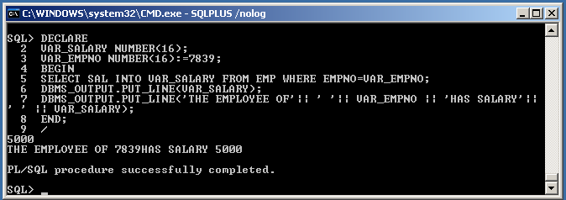
- Write PL/SQL code for finding Even Numbers.
BEGIN
FOR I IN 1..100 LOOP
IF MOD(I,2)=0 THEN
DBMS_OUTPUT.PUT_LINE(I);
END IF;
END LOOP;
END;
/
Output:
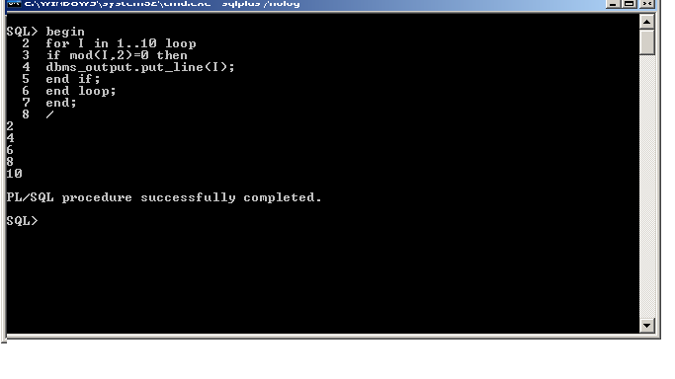
- Write PL/SQL code to find Largest of three numbers.
DECLARE
A NUMBER;
B NUMBER;
C NUMBER;
BEGIN
A:=&A;
B:=&B;
C:=&C;
IF A=B AND B=C AND C=A THEN
DBMS_OUTPUT.PUT_LINE('ALL ARE EQUAL');
ELSE IF A>B AND A>C THEN
DBMS_OUTPUT.PUT_LINE('A IS GREATER');
ELSE IF B>C THEN
DBMS_OUTPUT.PUT_LINE('B IS GREATER');
ELSE
DBMS_OUTPUT.PUT_LINE('C IS GREATER');
END IF;
END IF;
END IF;
END;
/

Output:
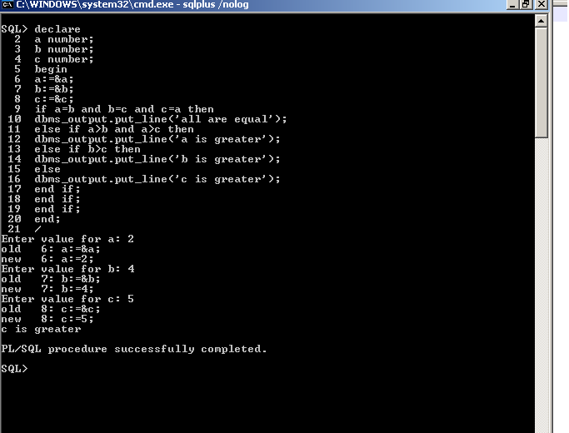
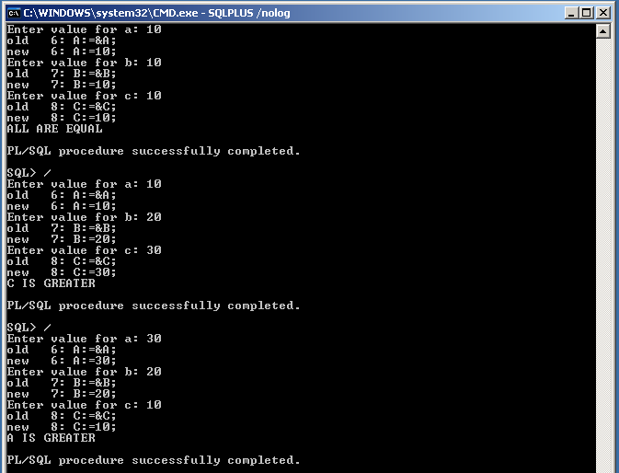
- Write PL/SQL code to find Factorial of a given number.
DECLARE
N NUMBER(2);
I NUMBER(2);
F NUMBER(5):=1;
BEGIN
N:=&N;
FOR I IN 1..N LOOP
F:=F*I;
END LOOP;
DBMS_OUTPUT.PUT_LINE('THE FACTORIAL VALUE IS =' || F);
END;
/
Output:
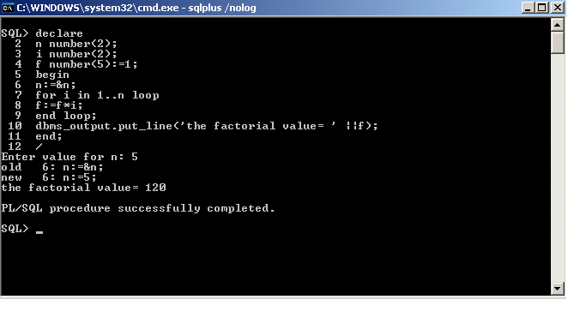
- Write PL/SQL code to Read number and prints its Multiplication Table.
DECLARE
T NUMBER(3):=3;
BEGIN
T:=&T;
FOR I IN 1..3 LOOP
DBMS_OUTPUT.PUT_LINE(T||'X'||I||'='||I*T);
END LOOP;
END;
/
Output:
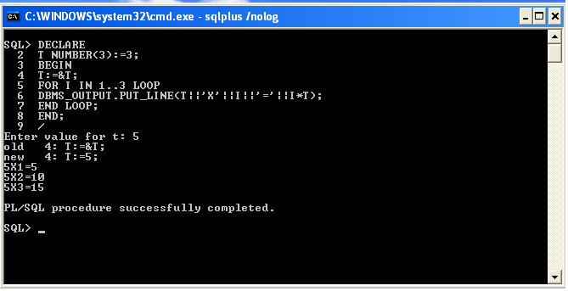
- Write PL/SQL code to find given number is Prime or not.
DECLARE
N NUMBER;
I NUMBER;
PR NUMBER(2):=1;
BEGIN
N:=&N;
FOR I IN 2..N/2 LOOP
IF MOD(N,I)=0 THEN
PR:=0;
END IF;
END LOOP;
IF PR=1 THEN
DBMS_OUTPUT.PUT_LINE('THE GIVEN NUMBER IS PRIME'||N);
ELSE
DBMS_OUTPUT.PUT_LINE('THE GIVEN NO IS NOT PRIME'||N);
END IF;
END;
/
Output:
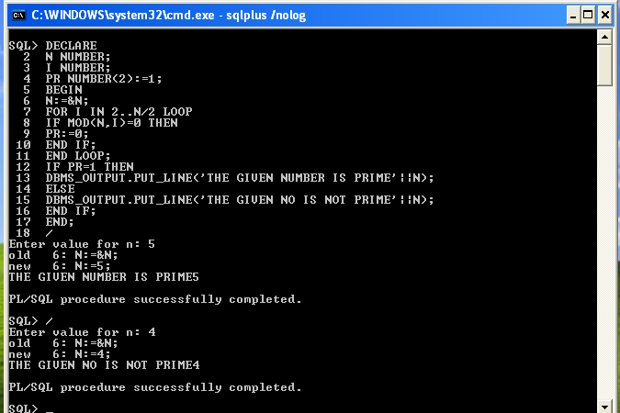
- Write PL/SQL code to accept the text and reverse the text and test whether the given character is Palandrome or not.
DECLARE
G VARCHAR2(20);
R VARCHAR2(20);
BEGIN
G:='&G';
DBMS_OUTPUT.PUT_LINE('THE GIVEN TEXT :'||G);
FOR I IN REVERSE 1..LENGTH(G) LOOP
R:=R||SUBSTR(G,I,1);
END LOOP;
DBMS_OUTPUT.PUT_LINE('THE REVERSED TEXT:'||R);
IF R=G THEN
DBMS_OUTPUT.PUT_LINE('THE GIVEN TEXT IS PALINDROME');
ELSE
DBMS_OUTPUT.PUT_LINE('THE GIVEN TEXT IS NOT PALINDROME');
END IF;
END;
/
Output:
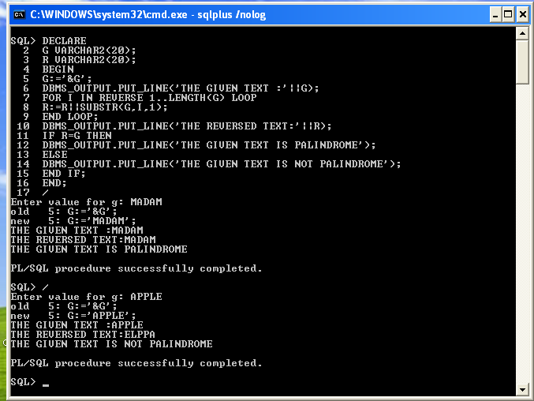
- Write PL/SQL code to find Reverse of a given number.
DECLARE
A NUMBER;
REV NUMBER;
D NUMBER;
BEGIN
A:=&A;
REV:=0;
WHILE A>0
LOOP
D:=MOD(A,10);
REV:=(REV * 10) + D;
A:=TRUNC(A/10);
END LOOP;
DBMS_OUTPUT.PUT_LINE('NO IS'||REV);
END;
/
Output:
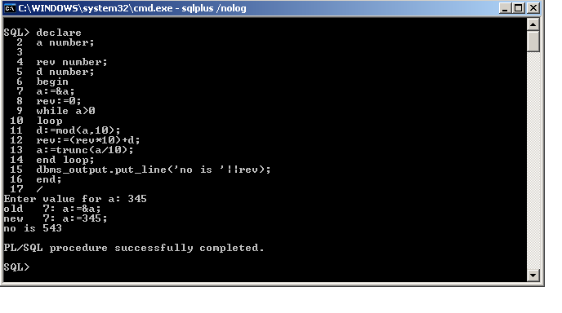
- Write PL/SQL code to generate Fibonacci series for given number.
DECLARE
A NUMBER;
B NUMBER;
C NUMBER;
N NUMBER;
I NUMBER;
BEGIN
N:=&N;
A:=0;
B:=1;
DBMS_OUTPUT.PUT_LINE(A);
DBMS_OUTPUT.PUT_LINE(B);
FOR I IN 1..N-2
LOOP
C:=A+B;
DBMS_OUTPUT.PUT_LINE(C);
A:=B;
B:=C;
C:=A+B;
END LOOP;
END;
/
Output:
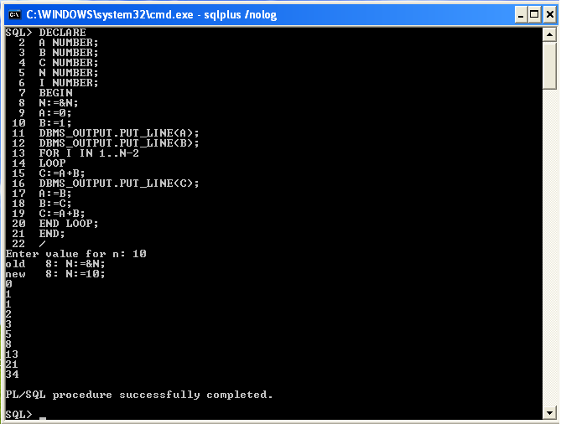
- Write PL/SQL code to find Armstrong numbers from 1 to 500.
DECLARE
A NUMBER;
B NUMBER;
BEGIN
FOR I IN 1..500 LOOP
A:=I;
B:=0;
LOOP
EXIT WHEN A<=0;
B:=B+POWER(MOD(A,10),3);
A:=TRUNC(A/10);
END LOOP;
IF B=I THEN
DBMS_OUTPUT.PUT_LINE(I||'IS ARMSTRONG NUMBER');
END IF;
END LOOP;
END;
/
Output:
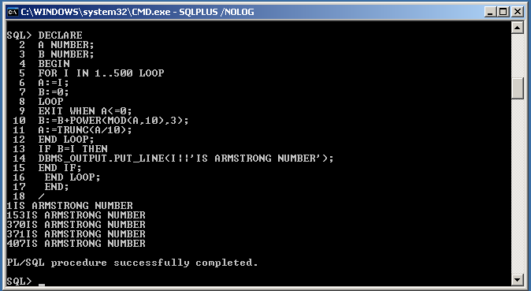
- Write PL/SQL code to print the numbers in this form 1
1 2
123
DECLARE
I NUMBER;
J NUMBER;
N NUMBER;
BEGIN
N:=&N;
FOR I IN 1..N LOOP
FOR J IN 1..I LOOP
DBMS_OUTPUT.PUT(J);
END LOOP;
DBMS_OUTPUT.PUT_LINE('');
END LOOP;
END;
/

Output:
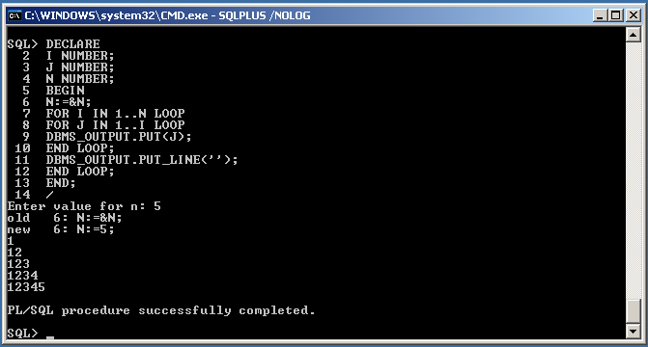
- Write PL/SQL code to print the numbers in this form 0 0 0 0 0
1 2 3 4 5
2 4 6 8 10
DECLARE
I NUMBER;
J NUMBER;
K NUMBER;
BEGIN
FOR I IN 0..5 LOOP
FOR J IN 1..5 LOOP
K:=I*J;
DBMS_OUTPUT.PUT(K);
END LOOP;
DBMS_OUTPUT.PUT_LINE('');
END LOOP;
END;
/
Output:

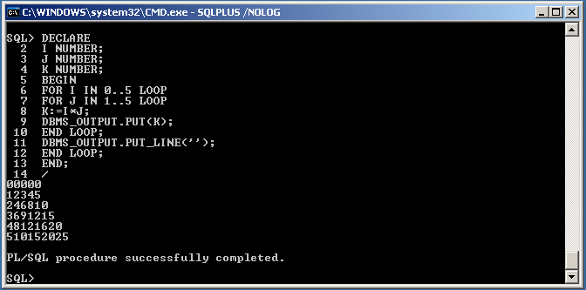

- Write PL/SQL code to print the numbers in this form 1
- 2 1
1 2 3 2 1
1 2 1
1
DECLARE
I NUMBER;
J NUMBER;
K NUMBER;
M NUMBER;
N NUMBER;
BEGIN
N:=&N;
FOR I IN 1..N LOOP
FOR J IN 1..N-I LOOP
DBMS_OUTPUT.PUT('~');
END LOOP;
FOR K IN 1..I LOOP
DBMS_OUTPUT.PUT(K);
END LOOP;
FOR K IN REVERSE 1..I-1 LOOP
DBMS_OUTPUT.PUT(K);
END LOOP;
DBMS_OUTPUT.PUT_LINE('');
END LOOP;
FOR I IN REVERSE 1..N-1 LOOP
FOR J IN 1..N-I LOOP
DBMS_OUTPUT.PUT('~');
END LOOP;
FOR K IN 1..I LOOP
DBMS_OUTPUT.PUT(K);
END LOOP;
FOR K IN REVERSE 1..I-1 LOOP
DBMS_OUTPUT.PUT(K);
END LOOP;
DBMS_OUTPUT.PUT_LINE('');
END LOOP;
END;
/
Output:
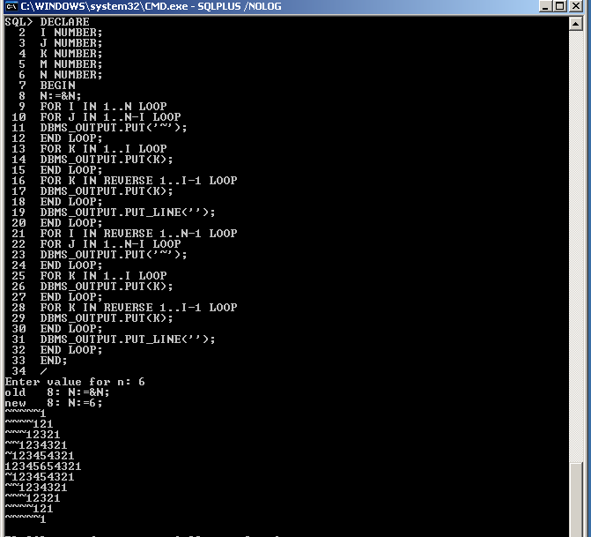

- Write PL/SQL code to Insert values in created tables.
DECLARE
PID NUMBER(6);
BEGIN
PID:=20;
INSERT INTO PRODUCT VALUES(PID,'TV');
PID:=PID+1;
INSERT INTO PRODUCT VALUES(PID,'VCR');
COMMIT;
END;
/
Output:
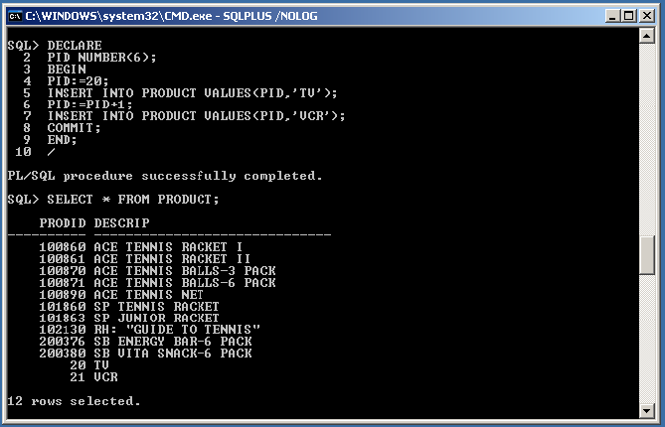

- Programs using Cursors, Cursor loops and records

- Write PL/SQL code to UPDATE values in created tables by using Implicit Cursors.

DECLARE
VAR_ROWS NUMBER(5);
BEGIN
UPDATE EMP SET SAL=SAL+100;
IF SQL%NOTFOUND THEN
DBMS_OUTPUT.PUT_LINE('NONE OF THE SALARIES WERE UPDATED');
ELSE IF SQL%FOUND THEN
VAR_ROWS:=SQL%ROWCOUNT;
DBMS_OUTPUT.PUT_LINE('SALARIES FOR'||VAR_ROWS||'EMPLOYEES ARE UPDATED');
END IF ;
END IF;
END;
/
Output:
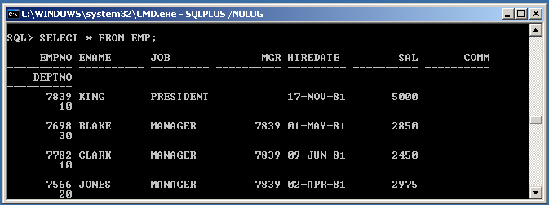
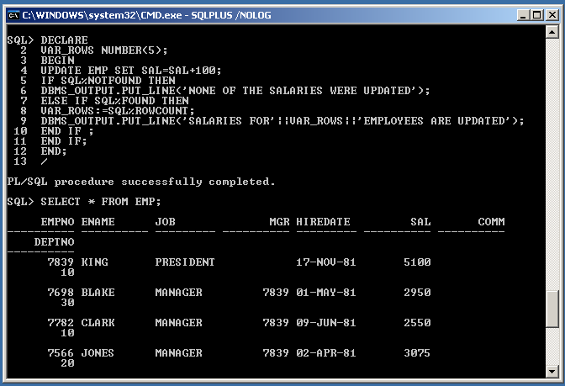
- Write PL/SQL code to display Employee details using Explicit Cursors.
DECLARE
CURSOR EMP_CUR IS SELECT * FROM EMP;
EMP_REC EMP%ROWTYPE;
BEGIN
OPEN EMP_CUR;
LOOP
FETCH EMP_CUR INTO EMP_REC;
EXIT WHEN EMP_CUR%NOTFOUND;
DBMS_OUTPUT.PUT_LINE(EMP_REC.EMPNO || ' ' ||EMP_REC.ENAME || ' '
||EMP_REC.SAL);
END LOOP;
CLOSE EMP_CUR;
END;
/
Output:
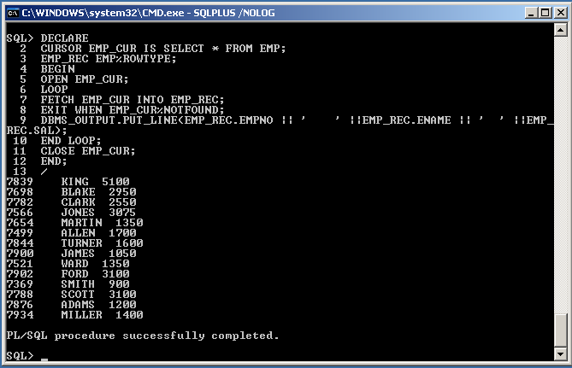
- Write PL/SQL code in Cursor to display employee names and salary.
DECLARE
CURSOR CL IS SELECT * FROM EMP;
BEGIN
FOR I IN CL
LOOP
DBMS_OUTPUT.PUT_LINE(I.ENAME||' '||I.SAL);
END LOOP;
END;
/
Output:
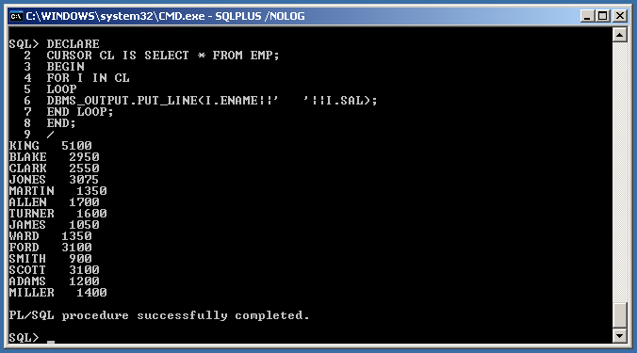
- Write PL/SQL Programs in Cursors using two cursors at a time.
DECLARE
CURSOR D IS SELECT * FROM DEPT;
CURSOR E(DNO NUMBER) IS SELECT * FROM EMP WHERE DEPTNO=DNO;
BEGIN
FOR DEPT IN D
LOOP
DBMS_OUTPUT.PUT_LINE('DEPARTMENT NUMBER'|| DEPT.DEPTNO);
DBMS_OUTPUT.PUT_LINE('...........');
FOR EMP IN E(DEPT.DEPTNO)
LOOP
DBMS_OUTPUT.PUT_LINE('MR'||' '||EMP.ENAME||' '|| 'IS WORKING IN DEPARTMENT '||DEPT.DNAME||' '|| 'AT'||' '||DEPT.LOC||' AS ' ||EMP.JOB);
END LOOP;
END LOOP;
END;
/
Output:
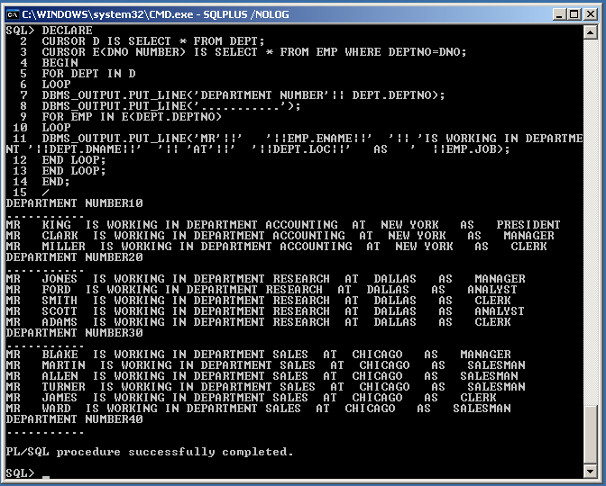
- Write PL/SQL Programs in Cursors using Loops.
- DECLARE
CURSOR ALL_EMPS IS SELECT EMPNO,ENAME FROM EMP ORDER BY EMPNO;
EMP1 ALL_EMPS%ROWTYPE;
BEGIN
OPEN ALL_EMPS;
LOOP
EXIT WHEN ALL_EMPS%NOTFOUND;
FETCH ALL_EMPS INTO EMP1;
DBMS_OUTPUT.PUT_LINE(EMP1.ENAME||' '||EMP1.EMPNO);
END LOOP;
CLOSE ALL_EMPS;
END;
/
Output:
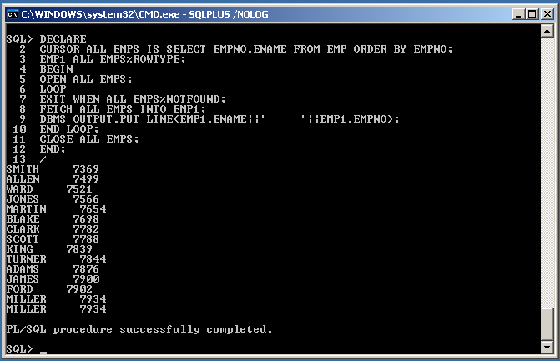
- DECLARE
CURSOR C_EMPLOYEE IS
SELECT EMPNO,ENAME,JOB,SAL,DEPTNO FROM EMP WHERE
EMPNO=7839;
V_EMPLOYEEDATA C_EMPLOYEE%ROWTYPE;
BEGIN
OPEN C_EMPLOYEE;
FETCH C_EMPLOYEE INTO V_EMPLOYEEDATA;
WHILE C_EMPLOYEE%FOUND LOOP
DBMS_OUTPUT.PUT_LINE(V_EMPLOYEEDATA.ENAME||'
'||V_EMPLOYEEDATA.EMPNO||'
'||V_EMPLOYEEDATA.SAL);
FETCH C_EMPLOYEE INTO V_EMPLOYEEDATA;
END LOOP;
CLOSE C_EMPLOYEE;
COMMIT;
END;
/
Output:
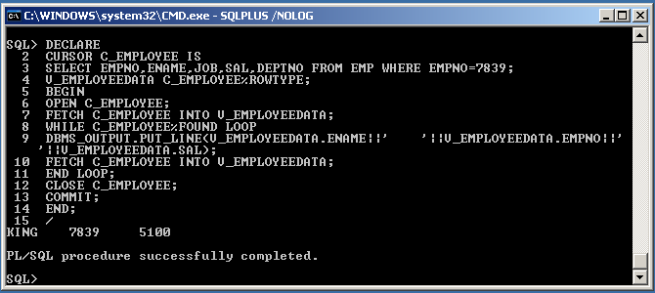
- To write a Cursor to display the list of employees who are Working as a Managers or Analyst.
DECLARE
cursor c(jb varchar2) is select ename from emp where job=jb;
em emp.job%type;
BEGIN
open c('MANAGER');
dbms_output.put_line(' EMPLOYEES WORKING AS MANAGERS ARE:');
loop
fetch c into em;
exit when c%notfound;
dbms_output.put_line(em);
end loop;
close c;
open c('ANALYST');
dbms_output.put_line(' EMPLOYEES WORKING AS ANALYST ARE:');
loop
fetch c into em;
exit when c%notfound;
dbms_output.put_line(em);
end loop;
close c;
END;
/
Output:
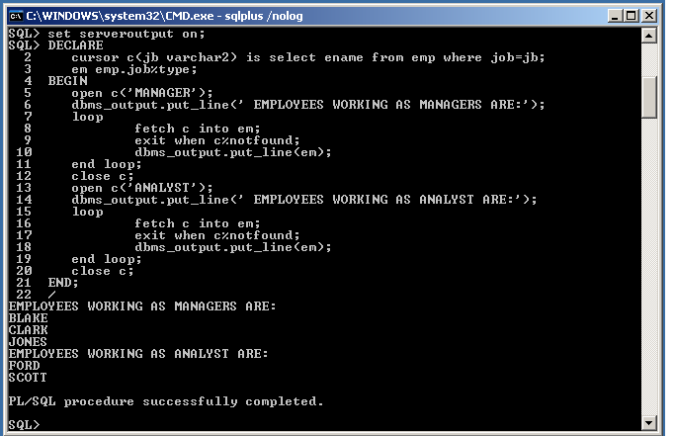
- Write pl/sql code in cursor by using while loop.
set serveroutput on;
Declare
cursor c_emp is
select sal,ename from emp where sal=5200;
v_empdata c_emp%rowtype;
Begin
open c_emp;
fetch c_emp INTO v_empdata;
while c_emp%found loop
dbms_output.put_line(v_empdata.sal);
fetch c_emp INTO v_empdata;
end loop;
close c_emp;
commit;
end;
/
Output:
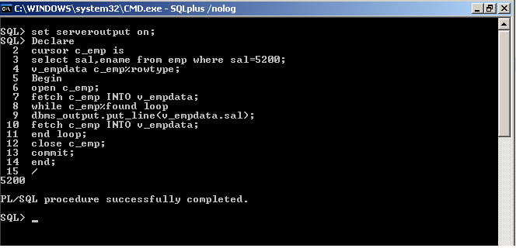

EXP-IX PL/SQL Programming II
    - Creating stored procedures and functions
- Write PL/SQL code in Procedure to find Reverse number
CREATE OR REPLACE PROCEDURE REVNUM(NUM NUMBER)
IS
REV INTEGER(6);
NUM1 NUMBER(6);
BEGIN
NUM1:=NUM;
REV:=0;
WHILE NUM1>0
LOOP
REV:=REV*10+MOD(NUM1,10);
NUM1:=TRUNC(NUM1/10);
END LOOP;
DBMS_OUTPUT.PUT_LINE(REV);
END REVNUM;
/
Output:
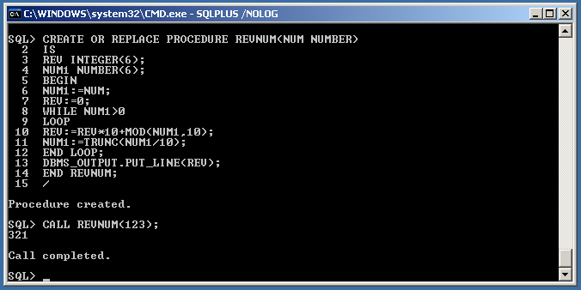

- Write PL/SQL code in Procedure to find Factorial of a given number by using call procedure.
a) CREATE OR REPLACE PROCEDURE FACT(A IN NUMBER,B OUT NUMBER) IS
F NUMBER(4):=1;
BEGIN
FOR I IN 1..A
LOOP
F:=F*I;
END LOOP;
B:=F;
END;
/
b) DECLARE
X NUMBER(4):=&X;
Y NUMBER;
BEGIN
FACT(X,Y);
DBMS_OUTPUT.PUT_LINE('FACTORIAL OF' ||' '||X||' ' ||'IS'||' '||Y);
END;
/
Output:
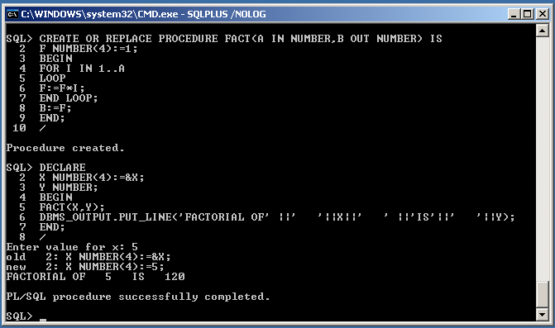
- Write a Procedure to check the given number is prime or not by using call procedure.

PROCEDURE DEFINITION:
CREATE or REPLACE PROCEDURE isprimepro(num in number,chec out number) IS
temp NUMBER;

BEGIN
temp:=num;
FOR itr IN 2..(num-1)

LOOP

IF(mod(num,itr)=0) THEN
chec:=1;

END IF;

END LOOP;
END;
/

PL/SQL BLOCK TO CALL THE PROCEDURE:

DECLARE
chec NUMBER;
given_number NUMBER;

BEGIN
given_number:=&given_number;
isprimepro(given_number,chec);
IF chec=1 THEN
dbms_output.put_line('number is not prime');

ELSE
dbms_output.put_line('number is prime');

END IF;

END;

/
Output:
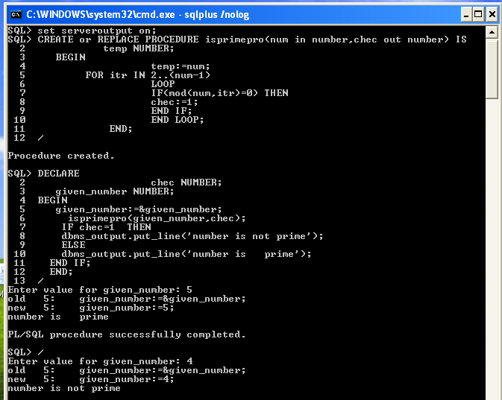
- Write a procedure to retrieve the salary of a particular employee
CREATE OR REPLACE PROCEDURE RET_SAL(EMPNUM NUMBER) IS
VSAL EMP.SAL%TYPE;
BEGIN
SELECT SAL INTO VSAL FROM EMP WHERE EMPNO = EMPNUM;
DBMS_OUTPUT.PUT_LINE('SALARY OF '|| EMPNUM || ' IS '|| VSAL);
END;
/
Output:
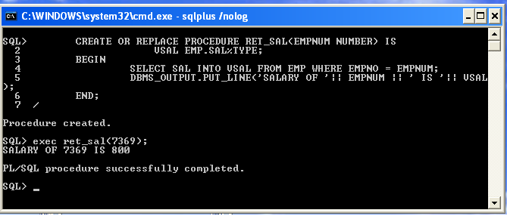

5 Write a procedure to work with Arthimetic operations.

create or replace procedure arith( a number,b number,c char) is
d number(4);
ex exception;
begin
if c='+' then
d:=a+b;
else if c='-' then
d:=a-b;
else if c='*' then
d:=a*b;
else if c='/' then
d:=a/b;
else if c='%' then
d:=mod(a,b);
else
raise ex;
end if;
end if;
end if;
end if;
end if;
dbms_output.put_line(a||' '||c||' '||b||' ='||d);
exception
when ex then
dbms_output.put_line('not a valid operator');
when zero_divide then
dbms_output.put_line('denominatar should not be zero');
when others then
dbms_output.put_line('sql error');
end;
/
Output:
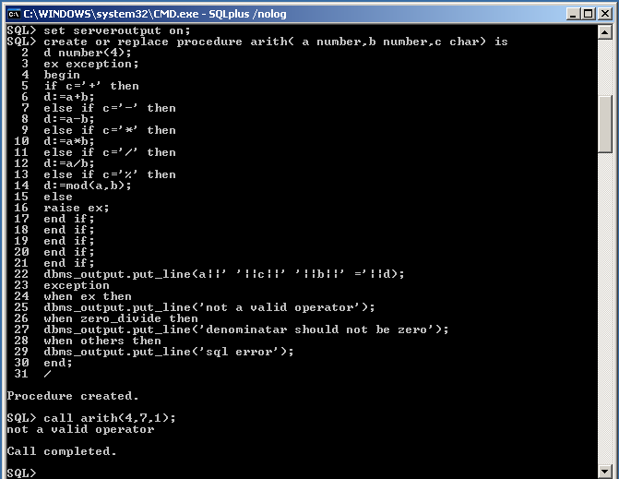

Functions:
- Write a Function to check the given number is prime or not.

FUNCTION DEFINITION :

CREATE or REPLACE FUNCTION isprime(num in number) RETURN

number IS
temp NUMBER;

BEGIN
temp:=num;
FOR itr IN 2..(num-1)

LOOP

IF (mod(temp,itr)=0) THEN
return 1;

END IF;

END LOOP;
return 0;

END;

/

PL/SQL BLOCK TO CALL THE FUNCTION:

DECLARE
given_number NUMBER;
prime_check NUMBER;

BEGIN
given_number:=&given_number;
prime_check:=isprime(given_number);

IF prime_check=0 THEN
dbms_output.put_line('NUMBER IS PRIME');

ELSE
dbms_output.put_line('NUMBER IS NOT PRIME');

END IF;

END;

/
Output:

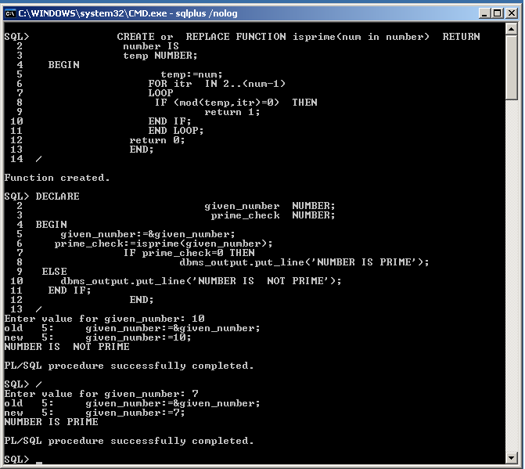
- Write pl./sql code in Function for Factorialnumber.

(a) set serveroutput on;

create or replace Function FunFact(a number) return number IS

f number(4):=1;

begin

for i in 1..a

loop

f:=f*i;

end loop;

return f;

end;

/
(b) set serveroutput on;
Declare
n number(2):=&n;
r number(4);
Begin
r:=FunFact(n);
dbms_output.put_line('factorial of'||n||'is:'||r);
end;
/
Output:
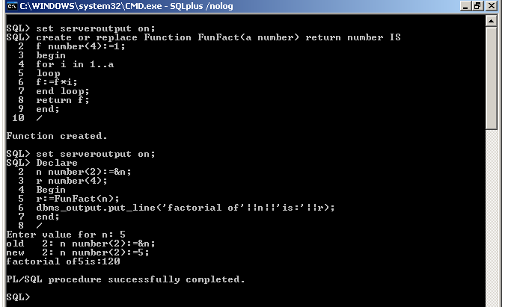
(ii) Error handling and Exception
1) Write a PL/SQL block to handle the following BUILT-IN EXCEPTIONS.
DECLARE
M NUMBER(4);
MYERROR EXCEPTION;
BEGIN
SELECT COMM INTO M FROM EMP WHERE EMPNO=7839;
IF M IS NULL THEN
RAISE MYERROR;
END IF;
EXCEPTION
WHEN NO_DATA_FOUND THEN
DBMS_OUTPUT.PUT_LINE('ERROR OF DATA');
WHEN TOO_MANY_ROWS THEN
DBMS_OUTPUT.PUT_LINE('ERROR OF TOO MANY ROWS');
WHEN MYERROR THEN
DBMS_OUTPUT.PUT_LINE('ERROR FOUND NULL');
END;
/
Output:
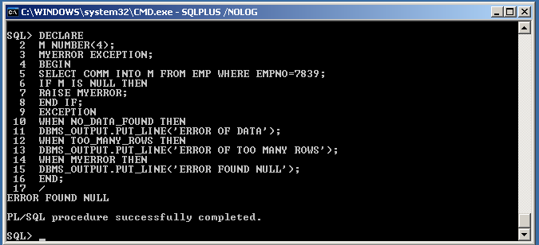

    - Triggers
- Write pl/sql code for before insert Trigger program
Steps for doing Trigger Program
a. First create a table called Person(Don’t insert any values into created table)
b.Write code for Trigger and run the trigger program
c.Insert values into the created table after sucessfully completion of trigger program and see the trigger output.
(a) CREATE TABLE PERSON1(ID INTEGER,NAME VARCHAR2(30),DOB DATE,PRIMARY
KEY(ID));
(b) CREATE OR REPLACE TRIGGER PERSON_INSERT_BEFORE
BEFORE INSERT ON PERSON1 FOR EACH ROW
BEGIN
DBMS_OUTPUT.PUT_LINE('BEFORE INSERT OF'||:NEW.NAME);
END;
/
(c) INSERT INTO PERSON1 VALUES(1,’JOHN DOE’,SYSDATE);
Output:
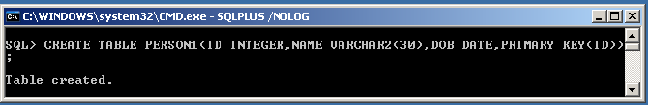

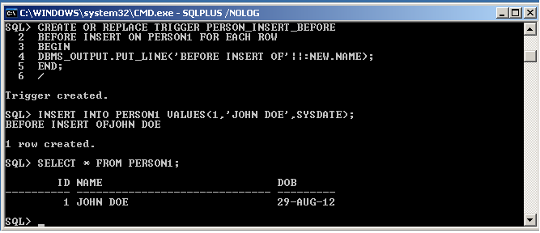

- Write pl/sql code for After inser Trigger
(a) CREATE OR REPLACE TRIGGER PERSON_INSERT_AFTER
AFTER INSERT ON PERSON1 FOR EACH ROW
BEGIN
DBMS_OUTPUT.PUT_LINE('AFTER INSERT OF'||:NEW.NAME);
END;
/
(b) INSERT INTO PERSON1 VALUES(2,’JAME DOE’,SYSDATE);
Output:
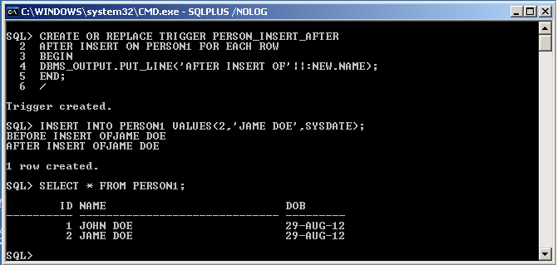
- Write pl/sql code for Before Update statement Trigger
(a) CREATE OR REPLACE TRIGGER PERSON_UPDATE_BEFORE
BEFORE UPDATE ON PERSON1
BEGIN
DBMS_OUTPUT.PUT_LINE('BEFORE UPDATING SOME PERSONS');
END;
/
(b) UPDATE PERSON1 SET DOB=’21-MAY-2000’;
Output:

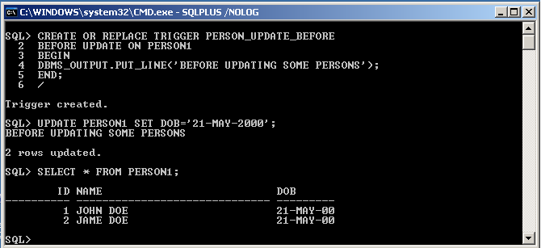
- Write pl/sql code for each row Before update Trigger.
(a) CREATE OR REPLACE TRIGGER PERSON_UPDATE_BEFORE
BEFORE UPDATE ON PERSON1 FOR EACH ROW
BEGIN
DBMS_OUTPUT.PUT_LINE('BEFORE UPDATING
'||TO_CHAR(:OLD.DOB,'HH:MI:SS')||'TO'||TO_CHAR(:NEW.DOB,'HH:MI:SS'));
END;
/
(b) UPDATE PERSON1 SET DOB=’1-sep-1988’;
Output:
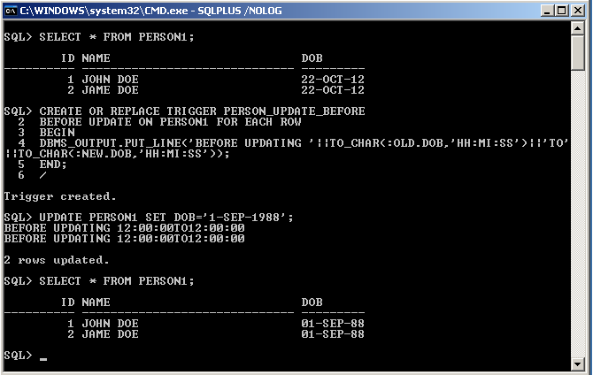
- Write pl/sql code for If Statement Trigger.
(a) CREATE OR REPLACE TRIGGER PERSON_BIUD
BEFORE INSERT OR UPDATE OR DELETE ON PERSON1 FOR EACH ROW
BEGIN
IF INSERTING THEN
DBMS_OUTPUT.PUT_LINE('INSERTING PERSON:'||:NEW.NAME);
ELSE IF UPDATING THEN
DBMS_OUTPUT.PUT_LINE('UPDATING PERSON:'||:OLD.NAME||'TO'||:NEW.NAME);
ELSE IF DELETING THEN
DBMS_OUTPUT.PUT_LINE('DELETING PERSON:'||:OLD.NAME);
END IF;
END IF;
END IF;
END;
/
(b) INSERT INTO PERSON1 VALUES(4,’CSE’,’2-SEP-2009’);
(C) UPDATE PERSON1 SET NAME=’COMPUTER’ WHERE NAME=’CSE’;
(D) DELETE PERSON1 WHERE NAME=’COMPUTER’;
(E) SELECT * FROM PERSON1;
Output:
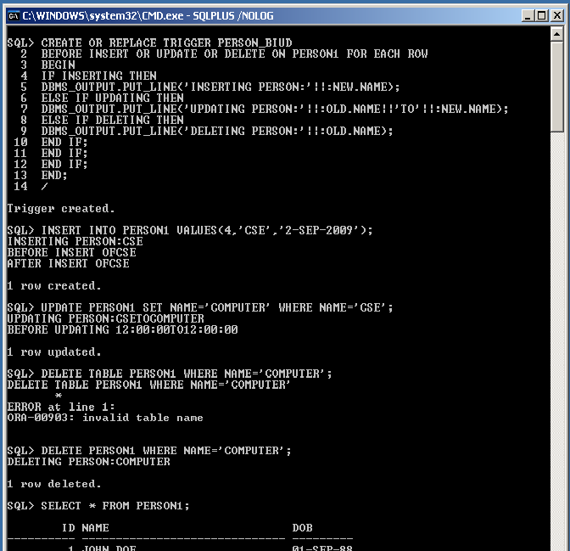

6. Write pl/sql code in Trigger not to accept the existing Empno (Unique no)
CREATE OR REPLACE TRIGGER DUPLEDEPNO8
BEFORE INSERT OR UPDATE ON ANI FOR EACH ROW
DECLARE
CURSOR C IS SELECT * FROM ANI;
BEGIN
FOR I IN C
LOOP
IF I.EMPNO=:NEW.EMPNO THEN
RAISE_APPLICATION_ERROR(-2009,'EMPNO ALREADY EXISTS');
END IF;
END LOOP;
END;
/
Output:
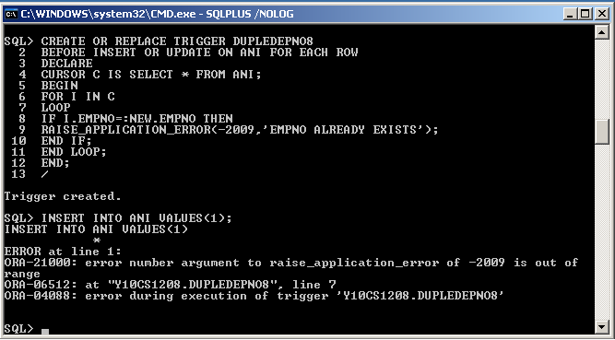
- Write pl/sql code using Trigger to salary with more than old salary.
CREATE OR REPLACE TRIGGER SALUPDATE9
BEFORE UPDATE ON C FOR EACH ROW
BEGIN
IF :NEW.SAL<:OLD.SAL THEN
RAISE_APPLICATION_ERROR(-20005,'NEW SALARY IS LESSER THAN OLD SALARY');
END IF;
END;
/
Output:
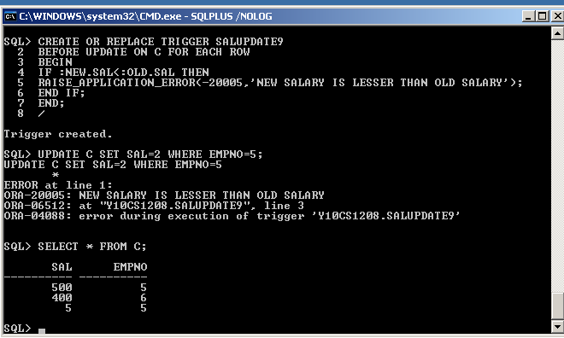

EXP-X User Defined Types
- Creating Objects in pl/sql
- Write PL/SQL Code for creating Objects with an example.
(a) create or replace type person as object ( last_name varchar2(100),
phone varchar2(100), member function get_last_name return varchar2,
member function get_phone_number return varchar2 ) not final
/
Type created.
(b) create or replace
type body person as
member function get_last_name return varchar2 is
begin
return self.last_name;
end;
member function get_phone_number return varchar2 is
begin
return self.phone;
end;
end;
/
Type body created.
(c) declare
l_person person;
begin
l_person := person( 'C', 'B' );
dbms_output.put_line( l_person.last_name );
end;
/
C
PL/SQL procedure successfully completed.

Output:
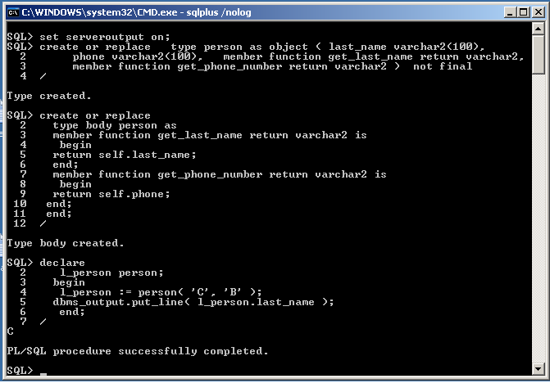
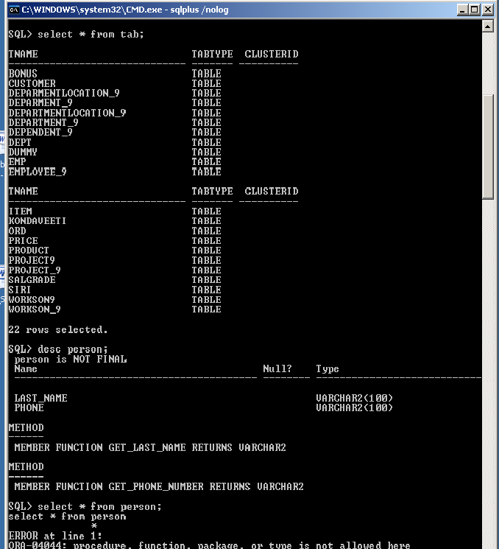

VIVA VOCE QUESTIONS

1. What is RDBMS?
Ans. Relational Data Base Management system is system software that stores and
manages access to data held in relational form, laid down by Dr.E.F.Codd

2. What is meant by integrity constraints?
Ans. An integrity constraint is a rule that restricts the values for one or more columns in a
table.

3. Explain the difference between Primary key and unique key?
Ans. Primary key.
1. It doesn’t allow NULL and DUPLICATE value
2. Table can have only one primary key
Unique Key.
1.It doesn’t allow DUPLICATE value but you can insert any no. of
NULL values
2. Table can have more than one Unique keys.

4. What are responsibilities of a DBA?
Ans.
1. Installing and upgrading the Oracle Server and application tools
2. Allocating system storage and planning future storage requirements for the
database system
3. Creating primary database storage structures (tablespaces) after application
developers have designed an application
4. Creating primary objects (tables, views, indexes) once application developers have
designed an application
5. Modifying the database structure, as necessary, from information given by
application developers
6. Enrolling users and maintaining system security
7. Controlling and monitoring user access to the database
8. Monitoring and optimizing the performance of the database
9. Planning for backup and recovery of database information
10.Maintaining archived data on tape
11.Backing up and restoring the database

5. What is SGA?
Ans.System Global Area or Shared Global Area is a group of shared memory structures
that contain data and control information for one instance. If multiple users are
concurrently connected to the same instance, the data in the instance's SGA is
"shared" among the users.

6. What is instance?
Ans.The combination of the SGA and the Oracle processes (Background Process) is
called an Oracle database instance. Instance will start in NOMOUNT stage.

7. What is DB buffer cache?
Ans.The database buffer cache is a portion of the SGA that holds copies of the data blocks
read from data files. It will maintain two list Least-Recently-Used list (LRU) and
Most-Recently-Used list (MRU).

8. What is Redo log buffer?
Ans.The redo log buffer is a circular buffer in the SGA that holds information about
changes made to the database. This information is stored in redo entries.

9. What is shared pool area?
Ans.The shared pool is an area in the SGA that contains three major areas: library cache,
dictionary cache, and control structures.

10. What are parameters will affect the SGA?
Ans.DB_BLOCK_BUFFERS, DB_BLOCK_SIZE, SHARED_POOL_SIZE, and
LOG_BUFFERS

11. What will be there in Private SQL area?
Ans.A private SQL area is a memory area that contains data such as bind information and
runtime buffers. A private SQL area has a persistent area and a runtime area.

12. What is data dictionary?
Ans.The data dictionary is a collection of database tables and views containing reference
information about the database, its structures, and its users. It will maintain the
following information
a). Names of all tables and views in the database
b) Names and data types of columns in database tables
c) Privileges of all Oracle users

13. What is time out?
Ans.User has waited too long for a resource.

14. What are DBWR, LGWR, PMON, SMON, RECO, CKPT, Dnnn and ARCH?
Ans.DBWR - Database Writer process or Dirty Buffer Writer (DBWR) writes DB
buffers to datafiles
LGWR - Log Writer process (LGWR) writes the redo log buffer to a redo log file
on disk
PMON – Process Monitor (PMON) performs process recovery when a user process
fails. PMON is responsible for cleaning up the cache and freeing resources (Lock)
SMON - System Monitor process (SMON) performs instance recovery at instance
start up. SMON is also responsible for cleaning up temporary segments; it also
coalesces contiguous free extents to make larger blocks. In a Parallel Server
environment, SMON performs instance recovery for a failed CPU or instance.
RECO - Recoverer process (RECO) is a process used with the distributed option that
Automatically resolves failures involving distributed transactions and resolves indoubt
transactions also.
CKPT - When a checkpoint occurs, Oracle must update the header of all data files to
highest SCN to indicate the checkpoint.
Dnnn - Dispatcher processes allow user processes to share a limited number of server
processes.
ARCH - Archiver process (ARCH) copies online redo log files to a designated storage
device once they become full. ARCH is present only when the redo log is used in
ARCHIVELOG mode and automatic archiving is enabled.

15. What is checkpoint?
Ans.When a checkpoint occurs, Oracle must update the headers of all datafiles to indicate
the checkpoint. If you are not enabled CKPT using CHECKPOINT_PROCESS, this
job is performed by LGWR, in oracle 8 CKPT by default enabled.

16. Is checkpoint optional? Then which one will take care of ckpt is not present?
Ans.Yes. Checkpoint is optional. If you are not enabled CKPT using
CHECKPOINT_PROCESS=TRUE, this job is performed by LGWR

17. Which background process you can have more than in an instance?
Ans.Dnnn. You can create multiple dispatcher processes for a single database instance.

18. When the data buffer will be flushed into respective files?
Ans.1. When ever dirty list gets filled.
2. When ever checkpoint is taking place.

19. What is parameter file?
Ans.The parameter file is a text file that contains a list of parameters and a value for each
parameter. This file will read in the NOMOUNT stage. The default parameter file
name is INITORCL.ORA (ORCL is SID).

20. Which parameter can’t be changed after the init file has been set?
Ans.DB_BLOCK_SIZE. If you want change the block size you have to recreate the
database.

21. Explain the steps involved in creating new database?
Ans.a) Create the parameter file say INITTEST.ORA made the needful changes
b) Set SID say oracle_sid = TEST
c) Create a password file using ORAPWD utility.
d) Go to SVRMGR tool startup the database in NOMOUNT stage
e) Execute the script CREATE DATABASE… which already prepared by DBA.
f) After created the database, run two scripts CATALOG.SQL and CATPROC.sql to
create data dictionary views and PL/sql packages.

22. What is the physical layout of the database?
Ans.One or More Data files, Two or more Log files and one or more Control files.

23. What is the logical layout of the database?
Ans.Tablespaces (Collection of Segments called Tablespace.)
Segments (Collection of may or may not contiguous Extents called
Segments.)
Extents (Collection of contiguous Blocks called Extents.)
Blocks (Collection of one or more row pieces called Blocks.)

24. What is content of control file?
Ans.Datafile and logfile information (v$datafile & v$log)
Database and Instance information (v$instance & v$database)
Checkpoint information
Loghistory, Tablespace and Archive information.(V$log_history, dba_tablespaces &
v$archive)

25. What is PGA?
Ans.Program Global Area (PGA) is a memory buffer that contains data and control
information for a server process. A PGA is created by Oracle when a server process is
started.

26. What is tablespace and how to create it?
Ans. A database is divided into one or more logical storage units called tablespaces.
A database administrator can create new tablespaces, add and remove datafiles from
tablespaces, set and alter default segment storage settings for segments created in a
tablespace, make a tablespace read-only or writeable, make a tablespace temporary or
permanent, and drop tablespaces.
Syntax to create tablespce:
SVRMGR> CREATE TABLESPACE <TS.NAME> DATAFILE ‘DATA FILE
NAME WITH PATH’ SIZE 100M;(size can be in terms of kb,mb,gb and etc).

27. What are the different types of segments?
Ans.a) Data segments (tables and cluster)
b) Index segments(Index)
c) Rollback segments
d) Temporary segments
e) Bootstrap segments.

28. How to create rollback segment?
Ans.SVRMGR>CREATE ROLLBACK SEGMENT <RBS NAME> TABLESPACE <TS
NAME> STORAGE
(INITIAL 2
MINEXTENTS 121
MAXEXTENTS 10240
NEXT 10240
PCT_INCREASE 0);

29. What is OPTIMAL parameter and SHRINK?
Ans.Shrink:
Using this parameter, you can manually decrease the size of a rollback
segment in Alter statement
Eg.
The following statement shrinks rollback segment RBS1 to 100K:
ALTER ROLLBACK SEGMENT rbs1 SHRINK TO 100K;
Optimal:
Using this parameter, you can decrease the size of a rollback segment
Automatically. This parameter you can specify either Create or Alter statement for
rollback segments.
Eg.
The following statement shrinks rollback segment RBS1 to 50K
automatically whenever free extents coming down less than 50k:
ALTER ROLLBACK SEGMENT rbs1 storage (OPTIMAL 100K);

30. Explain the functionality of rollback segments?
Ans.1. Rolling back Old Values
2. Providing read consistency and
3. Instance recovery

31. Why temporary segment?
Ans.When processing queries with ORDER BY, DISTINCT, GROUP BY, UNION, and
INTERSECT clause and creating index, oracle requires temporary workspace for
intermediate stages of SQL statement processing. Oracle automatically allocates this
disk space called a temporary segment.

32. When to bring the rollback segment offline?
Ans.i) When you want to take a tablespace offline and the tablespace contains
rollback segments. You cannot take a tablespace offline if it contains rollback
segments that transactions are currently using. To prevent associated rollback
segments from being used, you can take them offline before taking the tablespace
offline.
ii). You want to drop a rollback segment, but cannot because transactions are
currently using it. To prevent the rollback segment from being used, you can take it
offline before dropping it.
Syntax.
ALTER ROLLBACK SEGMENT user_rs_2 OFFLINE;
Note: You cannot take the SYSTEM rollback segment offline.

33. What is deferred rollback segment?
Ans.Deferred rollback segments are rollback segments that were created to hold
rollback entries for tablespaces taken offline until the tablespaces are brought back
online.

34. What is pending offline?
Ans.If you try to take a rollback segment offline that contains rollback data for active
transactions (local, remote, or distributed), Oracle makes the rollback segment
unavailable to future transactions and the rollback segment's status in the
view V$ROLLSTAT is PENDING OFFLINE.

35. What is private and public rollback segments?
Ans. A private rollback segment is acquired explicitly by an instance when the
instance opens the database.
A Public rollback segments form a pool of rollback segments that any instance
requiring a rollback segment can use.

36. What is rollback and rolling forward?
Ans.Rollback :
Undo the uncommitted transactions.
Rolling forward:
While performing Instance recovery rolling forward will take place for
making rollback segments with committed and uncommitted transactions.

37. When system tablespace and system rollback segment will be made offline?
Ans.System tablespace and system rollback segments can’t make offline. Because system
transactions and data dictionary views will take place in the system rollback segments
and system tablespaces.

38. How the extents will grow?
Ans.The extents will grow based on the storage parameters like next and pctincrease i.e.
Next (next*(pctincrease/100)).

39. What is the default value of the growth of tablespace?
Ans.10+(10*(50/100)) k because default value of next=10k,pctincrease=50%

40. What is row migration and row chaining?
Ans.Row migration is, If a row in a data block is updated, so that the overall row length
increases and the block's free space has been completely filled, the data for the entire
row is migrated to a new data block, assuming the entire row can fit in a new block.
Row chaining is Oracle stores the data for the row in a chain of data blocks (one or
more) reserved for that segment. Row chaining most often occurs with large rows.

41. What is pctused and pctfree?
Ans.PCTUSED - After a data block becomes full, as determined by PCTFREE, Oracle
does not consider the block for the insertion of new rows until the percentage of the
block being used falls below the parameter PCTUSED.
PCTFREE parameter is used to set the percentage of a block to be reserved (kept
free) for possible updates to rows that already are contained in that block.

42. What is freelist?
Ans.Specifies the number of free lists for each of the free list groups for the table,
cluster, or index. The default and minimum value for this parameter is 1, meaning that
each free list group contains one free list.

43. What are maxdatafiles, maxlogfiles and maxloghistory?
Ans.Maxdatafiles - Specifies the maximum number of data files that can ever be created
for the database.
Maxlogfiles - Specifies the maximum number of redo log file groups that can ever
be created for the database.
Maxloghistory - Specifies the maximum number of archived redo log files for
automatic media recovery.

44. What is log sequence number?
Ans.Oracle assigns new log sequence number every time that a log switch occurs and
LGWR begins writing to it.

45. What is SCN?
Ans.Whenever a transaction is committed, LGWR writes the transaction's redo entries
from the redo log buffer of the SGA to an online redo log file, and a system change
number (SCN) is assigned to identify the redo entries for each committed transaction.

46. What is log switch and when it will happen?
Ans.The point at which Oracle ends writing to one online redo log file and begins writing
to another is called a log switch.
A log switch always occurs when the current online redoes log file is completely
filled and writing must continue to the next online redo log file.

47. How to switch logfile manually?
Ans.SVRMGR>ALTER SYSTEM SWITCH LOGFILE;

48. What is mirroring?
Ans.Oracle provides the capability to mirroring an instance's online redo log files to
safeguard against damage to its online redo log files. With mirroring online redo log
files, LGWR concurrently writes the same redo log information to multiple identical
online redo log files.

49. What is paging and swapping?
Ans.Paging: Moving part of the program out of memory.
Swapping: Moving complete program out of memory.

50. What is snapshot?
Ans.A snapshot is a table that contains the results of a query of one or more tables or
views, often located on a remote database. Simply you can say Image of table.

51. What is snapshot refresh?
Ans.Because a snapshot's master tables can be modified, the data in a snapshot must
occasionally be updated to ensure that the snapshot accurately reflects the data
currently in its master tables. The process of updating a snapshot for this purpose
is called snapshot refresh.
You can use the FAST or COMPLETE options of the REFRESH clause to specify the
refresh mode.

52. What is the error no ORA-1555?
Ans.Snapshot tool old. (Rollback segment too small)

53. When do you get the error ORA-1555?
Ans.This can happen when the database has many transactions that are changing data, then
committing or rolling back. The rollback data can be overwritten if the rollback
segments are too small for the number and size of the changes being made.

54. What are the different kinds of locks?
Ans.General types are exclusive locks and share locks. But further classifications are
row level and table level.

55. What is dead lock?
Ans.A deadlock is a situation that can occur in multi-user systems that prevents some
transactions from continuing work. A deadlock can occur when two or more users are
waiting for data locked by each other.

56. What is two phase commit?
Ans.Prepare phase and commit phase.
The prepare/commit mechanism guarantees that the nodes participating in a
distributed transaction either all commit or all roll back the transaction, thus
maintaining the integrity of the global database.

57. What is striping of database?
Ans.Striping" is the practice of dividing a large table's data into small portions and
storing these portions in separate datafiles on separate disks. This permits multiple
processes to access different portions of the table concurrently without disk
contention.

58. How to create user?
Ans.SVRMGR> CREATE USER <uname>
IDENTIFIED BY <p.word>
DEFAULT TABLESPACE cases_ts
QUOTA 10M ON cases_ts;

59. Explain the role of connect, resource and dba privileges.
Ans.Connect, resource and dba are default roles which are created by oracle automatically.
Connect role having privileges : ALTER SESSION
CREATE CLUSTER
CREATE DATABASE LINK
CREATE SEQUENCE
CREATE SESSION
CREATE SYNONYM
CREATE TABLE and
CREATE VIEW
Recourse role’s privileges : CREATE CLUSTER
CREATE PROCEDURE
CREATE SEQUENCE
CREATE TABLE and CREATE TRIGGER
Dba role’s privileges. : All systems privileges WITH ADMIN OPTION .

60. What are the types of privileges?
Ans.Object privileges and System privileges.

61. What is role and how to create a role
Ans.A role is a set of privileges that can be granted to users or to other roles.
Syntax.
SVRMGR> CREATE ROLE <R.NAME> IDENTIFIED BY <P.WORD>;

62. On what privileges, with admin option can’t be given.
Ans.Object privileges. Because with admin option only for system privileges.

63. What is cascading effect?
Ans.If you revoke an object privilege from a user who has granted the privilege to
other users or roles, Oracle7 also revokes the privilege from the grantees.

64. What is auditing?
Ans.Auditing keeps track of operations performed by database users. Audit record
containing this information like user performing the operation, type of operation,
object involved in the operation, date and time of the operation.

65. What is object audit, how to enable it and where will you see the result?
Ans.To audit all successful and unsuccessful DELETE statements on the EMP table,
BY SESSION (the default value), enter the following statement:
AUDIT DELETE ON emp;
SELECT * FROM sys.dba_obj_audit_opts;

66. What is statement audit, how to enable it and where will you see the result?
Ans.To audit all successful and unsuccessful connections to and disconnection
from the database BY SESSION (the default and only value for this option), enter the
following statement:
AUDIT SESSION BY Scott, lori;
SELECT * FROM sys.dba_stmt_audit_opts;

67. What is privilege audit, how to enable it and where will you see the result?
Ans.To audit all unsuccessful SELECT, INSERT, and DELETE statements on all
tables and unsuccessful uses of the EXECUTE ANY PROCEDURE system privilege,
by all database users, BY ACCESS, enter the following statement:
AUDIT SELECT TABLE, INSERT TABLE, DELETE TABLE,
EXECUTE ANY PROCEDURE BY ACCESS WHENEVER NOT SUCCESSFUL;
SELECT * FROM sys.dba_priv_audit_opts;

68. What is the initparameter to be enabled before auditing?
Ans.Audit_trail=true

69. Where all the audit information will be stored?
Ans.AUD$ table

70. What is the function of archivelog?
Ans.When you run a database in ARCHIVELOG mode, the archiving of the online
redo log is enabled. Information in a database control file indicates that a group of
filled online redo log files cannot be used by LGWR until the group is archived.

71. How to change from noarchivelog to archivelog? Explain all the steps.
Ans.ALTER DATABASE ARCHIVELOG;
Steps:
a. Shut down the database instance.
b. Start up a new instance and mount but do not open the database.
c. In mount Stage say ALTER DATABASE ARCHIVELOG;
d. Open the database;

72. How to change from archivelog to noarchivelog? Explain all the steps.
Ans.ALTER DATABASE NOARCHIVELOG;
Steps:
e. Shut down the database instance.
f. Start up a new instance and mount but do not open the database.
g. In mount Stage say ALTER DATABASE NOARCHIVELOG;
h. Open the database;

73. How to enable automatic archiving?
Ans.To enable automatic archiving of filled groups each time an instance is started,
include the LOG_ARCHIVE_START parameter, set to TRUE, in the database's
parameter file:
LOG_ARCHIVE_START=TRUE
74. How to view the status of archivelog?
Ans.ARCHIVE LOG LIST;

75. What is startup nomount and mount?
Ans.STARTUP NOMOUNT - You might want to start an instance without mounting a
database; this is usually the case only during database creation.
STARTUP MOUNT - You might want to start an instance and mount a database,
but not open the database because you want to perform renaming datafiles, Adding
, dropping, or renaming redo log files, enabling and disabling redo log archiving
options, performing full database recovery operations.

76. What is startup restricted?
Ans.You might want to start an instance, and mount and open a database in restricted
mode so that the database is available only to administrative personnel who are
all having restricted session privilege (not general database users).

77. What is startup force?
Ans.You can usually solve the problem by starting a new instance (and optionally
mounting and opening the database) using startup force. A database instance should
not be forced to start unless you are faced instance startup problem.

78. How to open the database after mounting is over?
Ans.SVRMGR> ALTER DATABASE OPEN;

79. What is normal shutdown?
Ans.SVRMGR>SHUTDOWN;
Normal database shutdown proceeds with the following conditions:
a). No new connections are allowed after the statement is issued.
b). Before the database is shut down, Oracle7 waits for all currently connected
Users to disconnect from the database.
c). The next startup of the database will not require any instance recovery
Procedures.

80. What is shutdown immediate?
Ans.SVRMGR>SHUTDOWN IMMEDIATE;
Immediate database shutdown proceeds with the following conditions:
a). Current client SQL statements being processed by Oracle7 are terminated
Immediately.
b). Any uncommitted transactions are rolled back.
c). Oracle7 does not wait for users currently connected to the database to
Disconnect; Oracle7 implicitly rolls back active transactions and
Disconnects all connected users.

81. What is shutdown abort?
Ans.Aborting an instance shuts down a database and yields the following results:
a). Current client SQL statements being processed by Oracle7 are immediately
Terminated.
b). Uncommitted transactions are not rolled back.
c). Oracle7 does not wait for users currently connected to the database to
Disconnect; Oracle7 implicitly disconnects all connected users.
d). It’s require instance recovery when restart the database.

82. What is user_dump_dest?
Ans.The pathname for a directory where the server will write debugging user trace
files on behalf of a user process.

83. What is dedicated architecture and MTS?
Ans.Dedicated server - The separate server process created on behalf of each user is a
dedicated server process
MTS - The multi-threaded server configuration eliminates the need for a dedicated
server process for each connection. A single server process may provide service to
more than one connections.

84. What is SQL*NET?
Ans.SQL*Net is Oracle Corporation's latest remote data access software. It enables both
client-server and server-server communications across any network. With SQL*Net,
databases and their applications can reside on different computers and communicate
as peer applications.

85. What are MRU and LRU?
Ans.MRU - Most Recently used list
LRU - Least Recently used list

86. What cache hit and cache miss?
Ans.Fetching data block data buffer cache – cache hit
Fetching data from physical disk – cache miss

87. What is Rowid?
Ans.ROWID is a pseudocolumn that returns a row's address. ROWID values
contain Information necessary to locate a row:
Which data block in the data file?
Which row in the data block (first row is 0)
Which data file (first file is 1)
ROWID value uniquely identifies a row in the database. However, rows in
different tables that are stored together in the same cluster can have the same
ROWID.

88. What is the importance of backup?
Ans.Backups of the database's datafiles and control files are absolutely necessary as
part of the strategy to safeguard data against potential media failures that can damage
these files.

89. What are the kinds of backups?
Ans.Physical backup – Online backup (Hot) and Offline (Cold) backup
Logical backup - Complete, cumulative and incremental backup using export utility.

90. How do you take the backup of control file. Why do you have to take that?
Ans.SVRMGR> ALTER DATABASE BACKUP CONTROL FILE TO TRACE;
Because a control file keeps track of the associated database's physical file
structure, a backup of a database's control file should be made every time a
structural change is made to the database.

91. What is meant by logical backup?
Ans.If you use Export to backup, all data must be exported in a logically consistent
way so that the backup reflects a single point in time. No one should make changes to
the database while the Export takes place. Ideally, you should run the database in
restricted mode while you export the data, so no regular users can access the data.

92. What is online and offline backups?
Ans.Online Backup:
Online backups are taken while the database is Open. Before you make an
online backup, you must do begin and end backup of tablespace. Online backups
allow you to back up all or part of the database while it is running.
Offline Backup:
Offline backups are taken while the database is shut down. Before you make
an offline backup, you must therefore shutdown server.

93. What is hot backup, when do you take it and how do you take it? Explain the steps.
Ans.Online or HOT backups allow you to back up all or part of the database while it is
running.
Syntax
ALTER TABLESPACE <Tablespace name> BEGIN BACKUP;
.... Operating system commands to copy datafiles...
.... Copy completed...
ALTER TABLESPACE < Tablespace name>END BACKUP;

94. What is cold backup, when do you take it and how do you take it? Explain the steps.
Ans.Offline or COLD backups are taken while the database is shut down. Before you
make an offline backup, you must therefore shutdown server.
Steps.
SVRMGR> Shutdown
SVRMGR> ! (goto o/s level)
C:\……….> Copy all the files
C:\……….>exit (back to svrmgr tool)
SVRMGR>startup
95. What is export? Where it will be stored?
Ans.Using EXP tool extract the object definitions and table data from an Oracle
database and store them in an Oracle-binary format export file that is located typically
on tape or on disk. Export files can be used to transfer data between databases that are
on machines not connected via a network or as backups in addition to normal backup
procedures. Default export file name is EXPDAT.DMP

96. What are the kinds of export?
Ans.Database, User and Table

97. What is import and how do you import?
Ans.Import extracts the objects from an Export file and puts them into a Database.
Using IMP tool in o/s level.

98. What is import option Ignore and Destroy?
Ans.Ignore: Specifies how object creation errors should be handled. Specifying
IGNORE=Y causes Import to overlook object creation errors when attempting to
create database objects.
Destroy: Specifies whether the existing data files making up the database should be
reused. That is, the DESTROY option specifies that IMPORT should include the
reuse option in the datafile clause of the CREATE TABLESPACE command.

99. What happens when you issue begin backup and end backup?
Ans.When you say begin backup, checkpoint will take place to update the highest
SCN in the respective Tablespace’s datafile header after that datafile header will be
frozen.
When you say end backup, datafile header frozen will be released.
Checkpoint will not take place.

100.What is recovery?
Ans.If hardware, software, network, process, or system failure affects the
operation of a database system, you must usually recover the databases and return to
normal operations as quickly as possible.

101.What are the types of recovery?
Ans.Complete media recovery, Incomplete media recovery and Instance
Recovery.

102.What is point in time recovery?
Ans.Recovering the database to the particular point in time using this syntax.
RECOVER DATABASE UNTIL TIME;
Statement to begin time-based recovery. The time is always specified using the
following format, delimited by single quotation marks: 'YYYY-MM-DD:HH24:MI:SS'.

103.What is media recovery?
Ans.Media recovery restores a database's datafiles to the most recent point-in-time
before disk failure, and includes the committed data in memory that was lost due to
failure

104.What is complete and incomplete media recovery?
Ans.Complete: Complete media recovery recovers all lost changes; no work is lost.
Complete media recovery is possible only if all necessary redo logs (online and archived)
are available.
Different types of complete media recovery are available, depending on the files
that are damaged and the availability of the database that is required during recovery
operations.
i. Closed Database Recovery
j. Open Database-Offline Tablespace Recovery
k. Open Database-Offline Tablespace-Individual Datafile Recovery
In complete: In complete media recovery is performed to reconstruct the
damaged database to a transaction consistent state before the media failure or user error.
There are different types of incomplete media recovery that might be used,
depending on the situation that requires incomplete media recovery:
i. cancel-based
j. time-based
k. Change-based incomplete recovery.

105.What is tablespace recovery and how do you that?
Ans.TABLESPACE recovery performs media recovery on all datafiles in the
tablespaces listed. To translate the tablespace names into datafile names, the database
must be mounted and open. The tablespaces must be offline to perform the recovery.
Syntax. : SVRMGR> RECOVER TABLESPACE <name>;

106.What is database recovery and how do you that?
Ans.DATABASE recovery performs media recovery on all online datafiles that require
redo to be applied. If all instances were cleanly shutdown, and no backups were restored,
RECOVER DATABASE indicates a no recovery required error.
Syntax : SVRMGR>Recover database;(In mount stage)

107.Why should you tune the system?
Ans.To achieve performance targets of response time, throughput, and constraints
you must tune analysis, design, and implementation.

108.What are the levels of tuning?
Ans.a) Design Level
b) Application level
c) Memory Level
d) I/O level
e) Contention level

109.What is optimizer and it’s types?
Ans.The optimizer's behavior when choosing an optimization approach and goal
for a SQL statement is affected by these factors:
The OPTIMIZER_MODE initialization parameter
Statistics in the data dictionary
The OPTIMIZER_GOAL parameter of the ALTER SESSION command
Hints in the statement
Types : CHOOSE, COST and RULE.

110.When will you create index? Up to what extend it is worth to index.
Ans.As a general guideline, you should create indexes on tables that are often queried
for less than 2% or 4% of the table's rows. This value may be higher in situations where
all data can be retrieved from an index, or where the indexed columns can be used for
joining to other tables.

111.What is cluster and how do you create it?
Ans.Clusters are an optional method of storing table data. A cluster is a group of
tables that share the same data blocks because they share common columns and are often
used together.
Syntax.
CREATE CLUSTER <name>(dno NUMBER(2) );
table is similar in

112.What is Normalization?
Ans.Normalization is basic to designing a high-performance system. It is the process
of breaking down all items to their lowest level, making sure that each piece of data can
be uniquely identified and is not duplicated.

113.What is De-normalization?
Ans.In the real world, a world in which performance may be more important than
abstract perfection, you may find that you need to compromise your commitment to
normalize and be flexible about dealing with real data, for that you may need to embrace
the necessary evil of denormalization.

114.When do de-normalize?
Ans.There are number of situations in which you may improve performance by
denormalizing your data. If you find that your application is performing repetitive SQL
table joins and sort/merges on large tables, you may be able to avoid reducing the need
for these operations if you denormalize some part of your database.

115.What are database triggers?
Ans.A database trigger is a stored PL/SQL block that is associated with a table. Oracle
automatically executes a trigger when a specified SQL statement is issued against the
table.

116.How many database triggers available in oracle V7.x and V8.x?
Ans.In oracle 7.x only 12 types of triggers, but in oracle 8.x 14 types of triggers i.e. 12
database triggers plus two instead of triggers.

117.In one table how many database triggers can be invoked in V7.x and V8.x?
Ans.In oracle 7.x a table can have 12 triggers maximum, but in oracle 8.x any number of
triggers can in be invoked to a table.

118.What is parallel server?
Ans.A database can be access through more than one instance. Parallel processing
divides a large task into many smaller tasks, and executes the smaller tasks concurrently
on several nodes. As a result, the larger task completes more quickly.

119.What is disk array?
Ans.Redundant arrays of inexpensive disks (RAID) can offer significant advantages in
their failure resilience features. They also permit striping to be quite easily achieved, but
do not appear to provide any significant performance advantage.

120.What is parallel query?
Ans.With the parallel query feature, multiple processes can work together
simultaneously to process a single SQL statement. This capability is called parallel query
processing. By dividing the work necessary to process a statement among multiple server
processes, the Oracle Server can process the statement more quickly than if only a single
server process processed it.

121.What is Sql*loader?
Ans.SQL*Loader moves data from external files into tables in an Oracle database.
SQL*Loader loads data in a variety of formats, performs filtering and loads multiple
tables simultaneously.
SQL*Loader can:
. Load data from multiple datafiles of different file types
. Handle fixed-format, delimited-format, and variable-length records
. Manipulate data fields with SQL functions before inserting the data into
database columns
. Load multiple tables during the same run, loading selected rows into each table
. Load data from disk or tape
. Provide thorough error reporting capabilities, so you can easily adjust and load
all records

122.What is remote transaction?
Ans.A remote transaction is a transaction that contains one or more remote statements,
all of which reference the same remote node.

123.What is DDBMS?
Ans.Distributed Database Management Systems:
A distributed database system appears to a user as a single server but is, in fact, a
set of two or more servers. The data on each server can be simultaneously accessed and
modified via a network. Each server in the distributed system is controlled by its local
database administrator (DBA), and each server cooperates to maintain the consistency of
the global database.

124.What is SQL?
Ans.Structured Query Language (SQL), pronounced "sequel," is the set of commands
that all programs and users must use to access data within the Oracle database.

125.What are DDL, DML, TCL and DCL?
Ans.
DDL – Data Definition Language; Create, Alter, Drop and Truncate.
DML – Data Manipulation Language; Insert, Update and Delete.
TCL - Transaction Control Language; Commit, Rollback and Savepoint
DCL - Data Control Language; Grant and Revoke.
126.What is Savepoint?
Ans.To identify a point in a transaction to which you can later roll back.

127.What is truncate command?
Ans.To remove all rows from a table or cluster and reset the STORAGE parameters to
the values when the table or cluster was created.

128.What is PL/sql?
Ans.PL/SQL (Procedural Language/SQL) is set of procedural capabilities that extend
the power of traditional SQL. PL/sql statements can be combined with traditional SQL in
variety of SQL products to increase the ease of application programming, and
considerably overall system performance.
Block Structure:
Declare
<Local declaration>
Begin
<Statements>
Exception
<Error handler>
End;
129.What is ODBC?
Ans.Open Database Connectivity.
A standard protocol for accessing Relational Database around sql.

130.What is referential integrity constraint?
Ans.A referential integrity constraint designates a column or combination of columns
as a foreign key and establishes a relationship between that foreign key and a specified
primary or unique key, called the referenced key. In this relationship, the table containing
the foreign key is called the child table and the table containing the referenced key is
called the parent table.

131.What is stand by database?
Ans.A standby database maintains a duplicate, or standby copy of your primary
database and provides continued primary database availability in the event of a disaster
(when all media is destroyed at your production site).
A standby database is constantly in recovery mode. If a disaster occurs, you can
take the standby database out of recovery mode and activate it for online use. Once you
activate your standby database, you cannot return it to standby recovery mode unless you
re-create it as another standby database.

